PRODUCT CARD COMPLEX CONFIGURATION 47
Cat. no. 1147
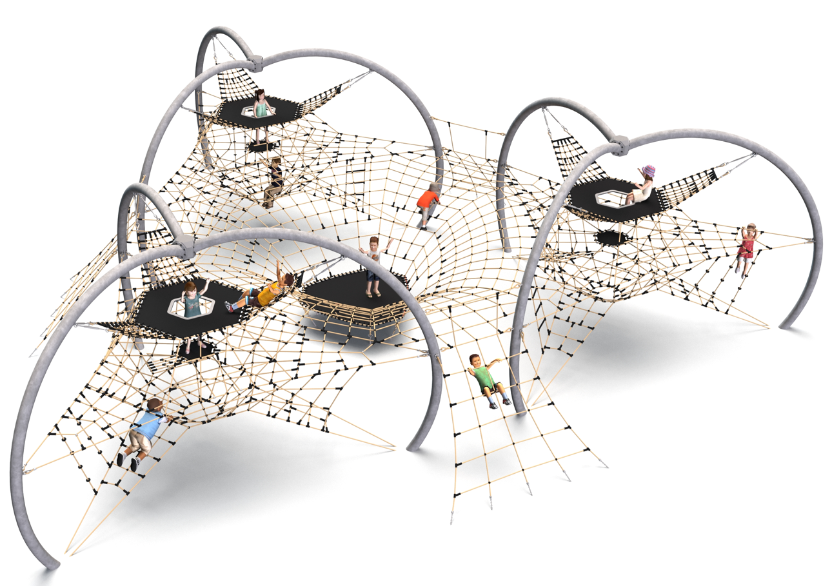
General information about the device:  Length: 15.1m  Width: 14.8m  Height: 4.1m  Minimum space: 18.9 x 18.2m  Foundation depth: 0.8m  Free fall height: 2.0m  Age group: 5 to 14 years old  Heavy construction equipment accessibility is required for the installation.  The fall area of the device should be made on the surface in accordance with PN-EN 1176-1:2017. | 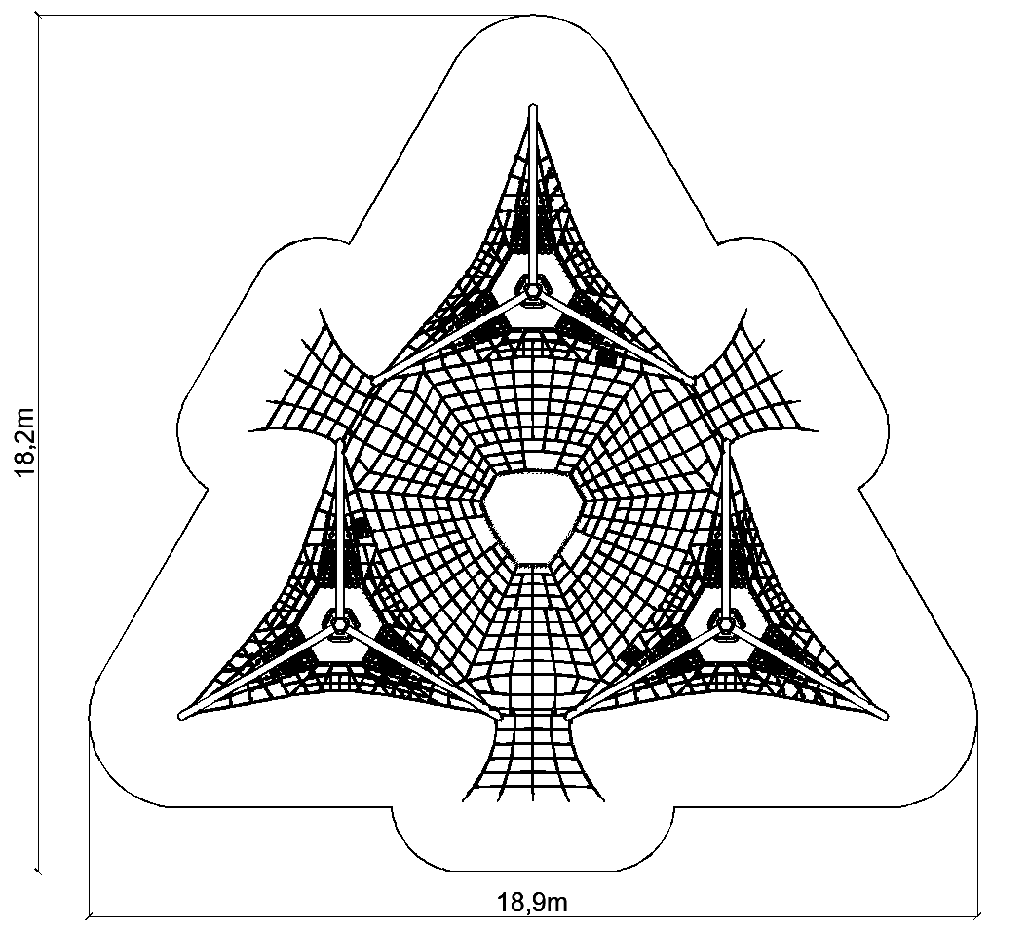

Configuration description.
Complex configuration cat. no. 1147 is a complex configuration consisting of three SPICA devices connected by a central connecting module in the form of a funnel-shaped rope net. Such a solution creates a unified, spatial play structure, allowing children to move freely between the various parts of the device along the net, without having to get down on the ground. The set offers plenty of opportunities for motor activity: climbing inside a spatial rope structure, balancing on nets and traversing hanging passages, which helps develop motor coordination, balance and spatial orientation. The connecting module serves both a communicative and integrative function, encouraging children to interact, cooperate and play together as a group.
The steel structure is made of steel protected against corrosion by hot-dip galvanizing and powder coating. Rope elements were made of 18 mm diameter polyamide ropes (braided and glued), connected with aluminum, stainless steel and plastic connectors. The structure is anchored in the ground with concrete footings, which ensures stability and compliance with safety requirements.

Optional painting.
The structure of the device at the request of the customer can be painted by powder or “wet” spray painting according to RAL.

The configuration consists of the following devices:
- SPICA cat. no. 429 – 3 pieces
- Individual connecting module 426 – 3 pieces.

Finishing standard:
Hot-dip galvanized structure, optional powder-coated.

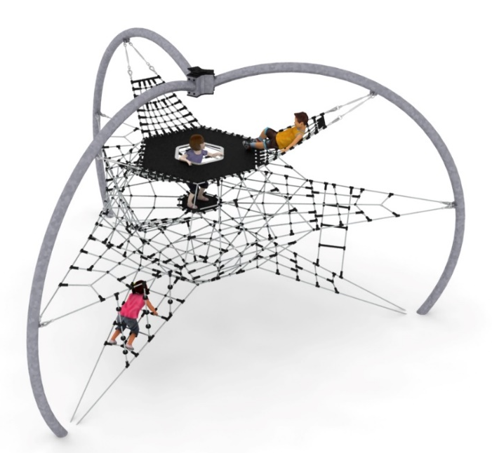
1. Device SPICA cat. no. 429.

Device dimensions:
Length: 6.9 m
Width: 6.0 m
Height: 4.1 m
Age group: 5 to 14 years
Foundation depth: 0.8 m
Free fall height: 2.0 m

Guidelines for materials and technology of construction of the device.
The main structural element is three, top-connected arches made of 168.3 mm diameter steel pipe. They are protected from corrosion by hot-dip galvanizing. A spatial rope net is hanging inside the structure, which consists of:
- diamond-shaped rope block, located in the center of the device
- three triangular entry nets at the bottom of the device
- three rope seats located in the upper part of the device; seats are made of dense nets with a mesh no larger than 120 x 120mm
- the central rope surface, located at a height of 1.9m; a horizontal rope net divides the diamond in half and provides protection against falls from higher up the device
- the upper surface located at a height of 2.7m, made of reinforced rubber mat with a thickness of 9mm
- additional attractions include: 3 climbing ropes, rope ladder and an sloping rope wall, leading to the middle rope floor.
The attachment of the spatial net to the structure is provided by hot-dip galvanized turnbuckles, which enable the correction of the net tension. The foundations are made as reinforced concrete footings located at a depth of 1.0 m. The nets are made of polyamide rope, braided, glued reinforced with galvanized steel strings. The diameter of the rope is 18 mm. The elements connecting the ropes to each other are made of plastic and aluminum.

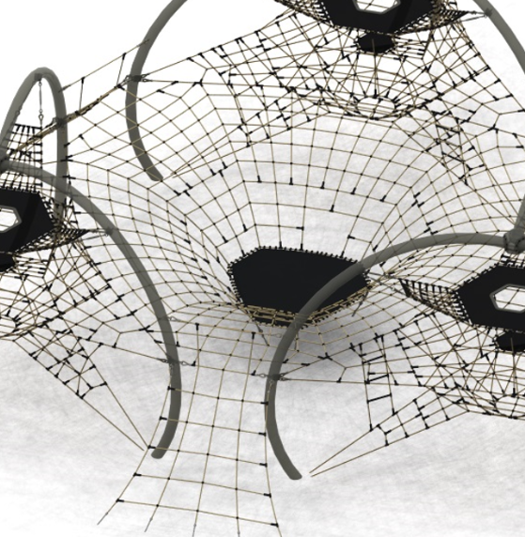
2. Individual connecting module 426 – 3 pieces.

Device dimensions:
Length: 6.9 m
Width: 6.0 m
Height: 4.1 m
Age group: 5 to 14 years
Foundation depth: 0.8 m
Free fall height: 2.0 m

Guidelines for materials and technology of construction of the device.
The connecting module is the central element of the configuration, connecting the three SPICA devices by means of a common funnel-shaped internal rope net installed between them. With this solution, children can move freely between the various devices without having to go down to ground level.
The net serves both a communicative and playful function - it allows climbing, balancing, and moving in different directions. The layout of the ropes and the variable height of the net create, diverse conditions for the development of motor coordination, balance and spatial orientation.
The funnel-shaped net introduces a dynamic, three-dimensional play character and encourages exploration, interaction and group activity.

The net is made of polyamide ropes with a diameter of 18 mm with a steel core, characterized by high resistance to UV radiation and changing weather conditions.
Rope connections were made with aluminum connectors, stainless steel parts and plastic.

The fall area of the equipment should be made on a surface in accordance with PN EN 1176- 1:2017. The possibility of access by heavy construction equipment is required for the installation.
For the safety of children and the quality of the equipment, it is required that the equipment is certified in accordance with standards PN EN 1176-1:2017, PN EN 1176-3:2017, PN EN 1176-11:2014-11 issued by a system accredited by the National Accreditation Centre or the national accreditation body of the other Member States in accordance with Regulation (EC) No 765/2008 of the European Parliament and of the Council of the European Union."

