PRODUCT CARD COMPLEX CONFIGURATION 46
Cat. no. 1146

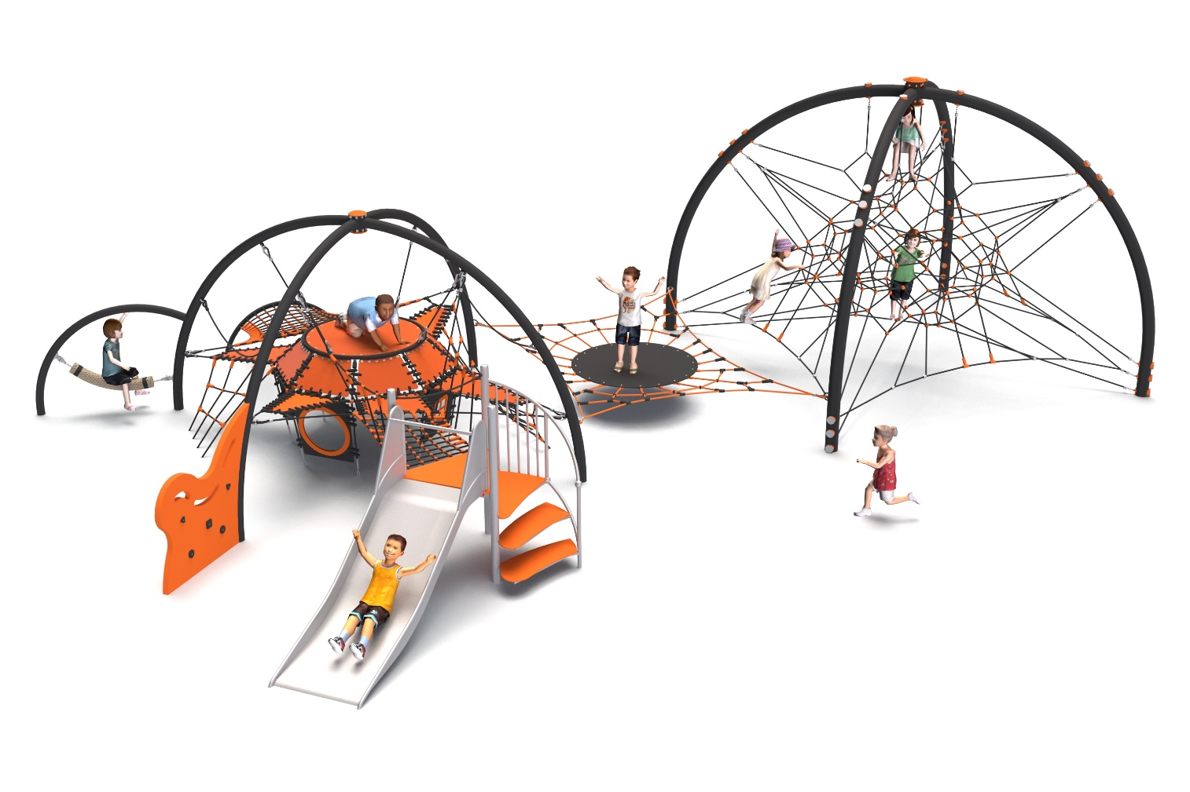
General information about the device:  Length: 12.0m  Width: 8.60m  Height: 3.40m  Minimum space: 15.1 x 11.4m  Depth of foundation: 1.0m  Free Fall Height: 1.3m  Age group: 0 to 14 years old  Heavy construction equipment accessibility is required for the installation.  The fall area of the device should be made on the surface in accordance with PN-EN 1176-1:2017. | 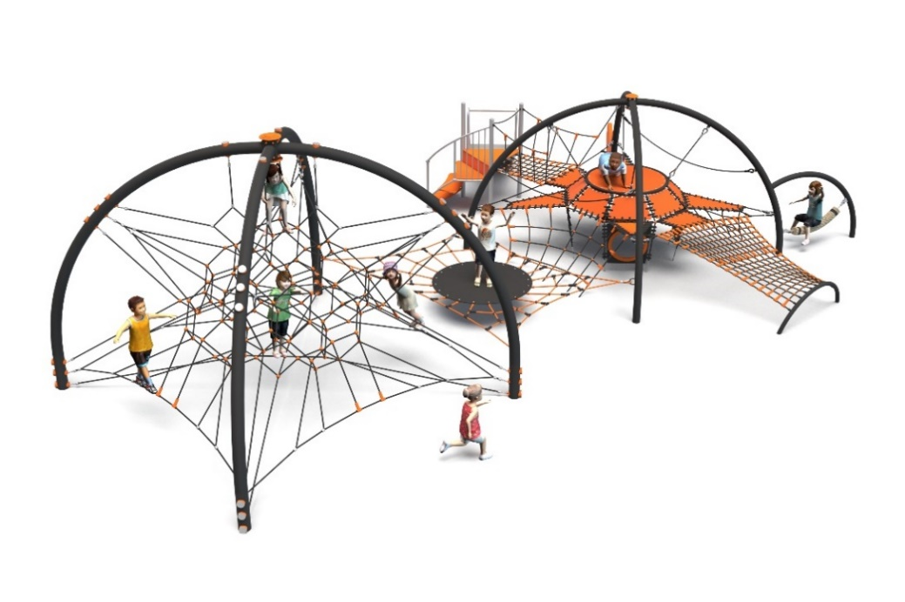

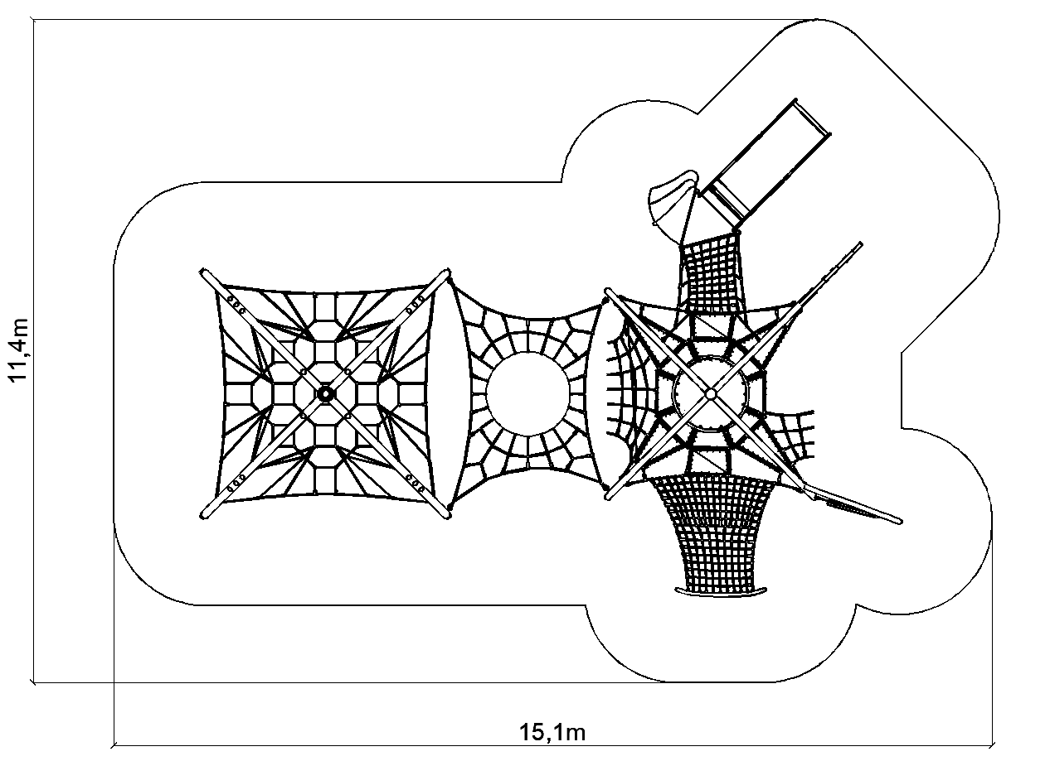

Configuration description.
The configuration consists of FABULON and SABIK devices connected by a BATUT-type connection module. The configuration offers a wide range of physical activities for children: climbing on ropes and wall, sliding down the slide, jumping on the trampoline, balancing on rope elements. This allows multiple users to play at the same time and promotes the development of motor coordination and physical fitness.
The steel structure is made of steel protected against corrosion by hot-dip galvanizing and powder coating. Rope elements are made of 18 mm diameter polyamide ropes (braided and glued), connected with aluminum, stainless steel and plastic connectors. The structure is anchored in the ground with concrete footings, which ensures stability and compliance with safety requirements.

The configuration consists of the following devices:
- SABIK cat. no. 435,
- FABULON cat. no. 436,
- Connecting module cat. no. 435–BATUT-436.

Finishing standard:
Hot-dip galvanized structure, powder-coated according to the colors in the visualization.

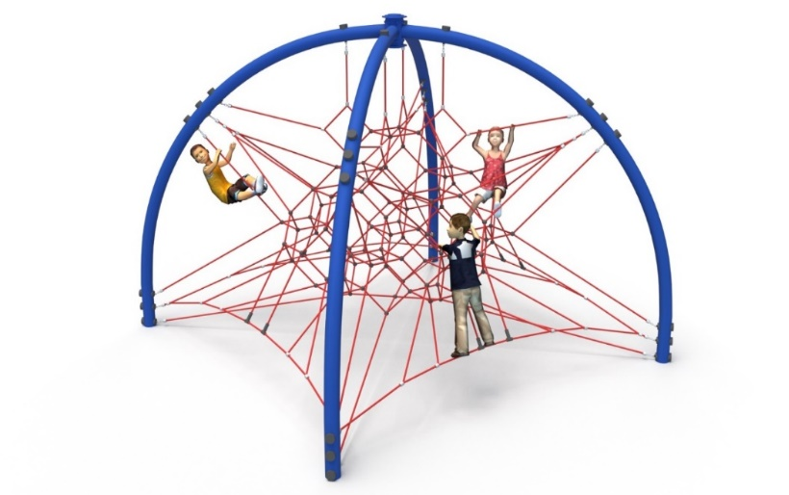
1. Device SABIK cat. no. 435.

General information about the device:
Length: 4.3m
Width: 4.3m
Height: 3.4m
Depth of foundation: 1.0m
Free fall height: 1.3m
Age group: 5 to 14 years old

Guidelines for materials and technology of construction of the device.
The device promotes the development of strength, coordination and balance through active climbing on ropes with varying angles of inclination. The multi-level design allows children to plan the climbing route, developing spatial orientation and decision-making skills. Thanks to the large floor space, it is possible for many children to play at the same time, which promotes integration and cooperation. A well-thought-out spatial rope net provides safe climbing and cushioning in case of loss of balance.

The device consists of four steel arches, made of bent round pipes with a diameter of min. 139.7mm. A rope net is installed to the arches. All rope attachments to the structure have the ability to adjust the tension. Steel structure made of black steel protected against corrosion by hot-dip galvanizing, optional powder coating. The rope elements are made of polyamide, braided, bonded ropes with a diameter of 18mm, connected by connectors made of aluminum, stainless steel and plastic. The top of the structure is finished with an HPL board. Foundation of the steel structure made as reinforced concrete footings.

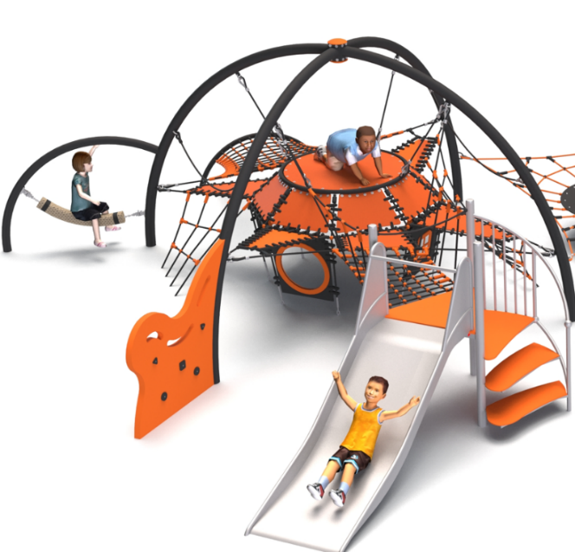
2. Device FABULON cat. no. 436.

General information about the device:
Length: 9.20m
Width: 7.54m
Height: 2.65m
Depth of foundation: 1.0m
Free fall height: 1.0m
Age group: 0 to 14 years old

Guidelines for materials and technology of construction of the device.
FABULON is a multifunctional play structure in the form of a dome, designed to provide children with a wide range of climbing and movement activities. The main element is an installed platform made of reinforced rubber matting, hung inside a spatial structure formed of four bent steel arches made of Ø108 mm black steel pipes. The platform is surrounded by rope nets, stretched horizontally and at an angle between the arches, creating an environment for multi-directional climbing.
Rubber mats are attached to the ropes near the central platform for additional balancing and climbing functions. Children can move around inside the dome, climbing ropes, interlacing, balancing on stretched ropes and mats, discovering a variety of paths of passage.
The integrated play elements include:
- stainless steel slide with a starting height of 1.0 m, with access via a spiral staircase of stainless steel construction; the steps are made of HPL boards,
- a balance beam in the form of a hanging rope with a cross section of min. 120x120 mm, made of polypropylene,
- climbing wall made of HPL panels on a steel substructure.
Steel structure made of black steel protected against corrosion by hot-dip galvanizing, optional powder coating. Rope elements are made of polyamide ropes, braided, glued with a diameter of 18mm, connected with connectors made of aluminum, stainless steel and plastics. PFoundation of the steel structure made as reinforced concrete footings.

3. Connecting module 435-BATUT-436.

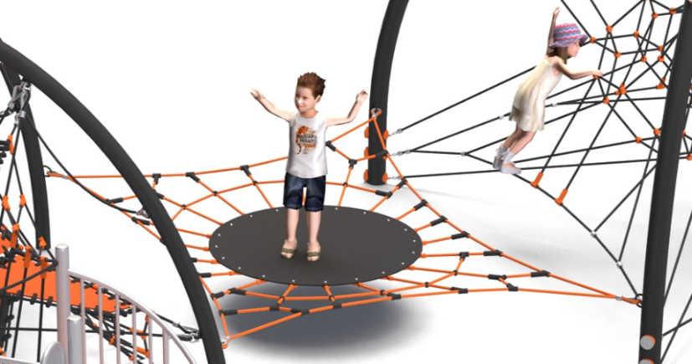
General information about the device:
Length: 4.3m
Width: 4.3m
Height: 3.4m
Depth of foundation: 1.0m
Free fall height: 1.3m
Age group: 5 to 14 years old

Guidelines for materials and technology of construction of the device.
The module consists of a rope net equipped with a rubber mat, attached to the structure of SABIK and FABULON devices by means of cybants made of stainless steel. Rope elements are made of polyamide ropes, braided, glued with a diameter of 18mm, connected with connectors made of aluminum, stainless steel and plastics.
The module supports the development of children's balance and motor coordination through dynamic play on an unstable surface. The use of elastic ropes and a balancing platform promotes the formation of large motor skills and supports sensory integration. The structure allows for gentle, controlled jumps similar to a light bounce as on a trampoline, without the effect typical of bouncing devices - increasing the safety of play and reducing the risk of injury. This solution encourages children to interact and play as a team, teaching communication and spatial awareness. The platform can also serve as a rest area or observation point during playtime. The use of this module enriches the playground with an interactive, movable element, increasing the attractiveness of the entire structure.

The fall area of the equipment should be made on a surface in accordance with PN EN 1176- 1:2017. The possibility of access by heavy construction equipment is required for the installation.
For the safety of children and the quality of the equipment, it is required that the equipment is certified in accordance with standards PN EN 1176-1:2017, PN EN 1176-3:2017, PN EN 1176-11:2014-11 issued by a system accredited by the National Accreditation Centre or the national accreditation body of the other Member States in accordance with Regulation (EC) No 765/2008 of the European Parliament and of the Council of the European Union."

