PRODUCT CARD COMPLEX CONFIGURATION 45
Cat. no. 1145

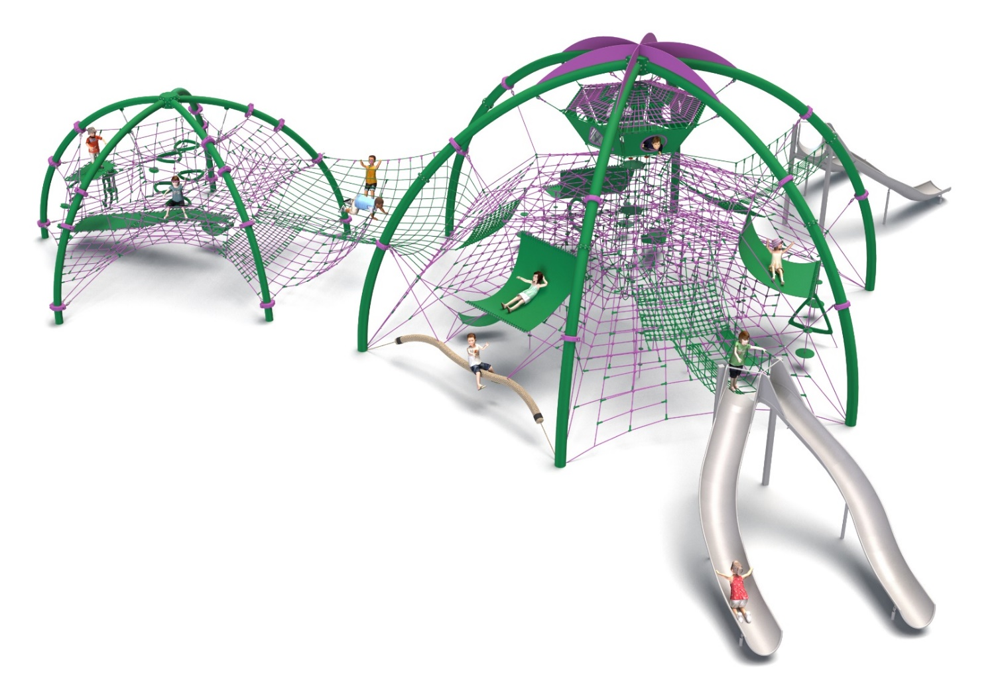
General information about the device:  Length: 22.0m  Width: 20.8m  Height: 6.4m  Minimum space: 26.1 x 25.2m  Depth of foundation: 1.0m  Free fall height: 3.0m  Age group: 5 to 14 years  Heavy construction equipment accessibility is required for the installation.  The fall area of the device should be made on the surface in accordance with PN-EN 1176-1:2017. | 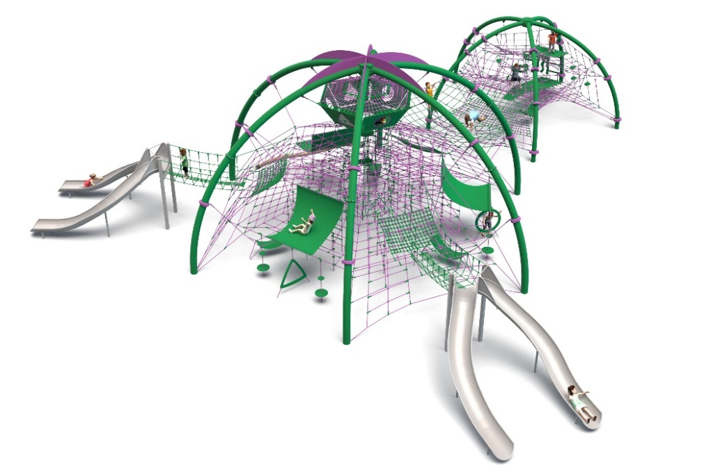

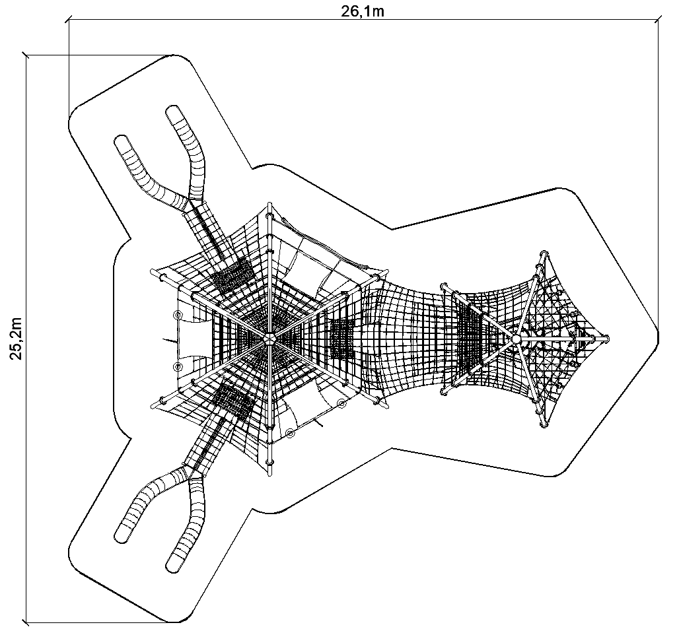
Configuration description.
An impressive modular configuration that combines two rope domes with an extensive climbing zone, rubber mats, slides and rope passages. The structure offers uninterrupted fun for children on many levels - from balancing and climbing, to descending and walking, to relaxing in central observation areas.
The device is ideal for large playgrounds, schools and public spaces - it provides fun for many children at once, while developing their physical fitness, coordination and social skills. Solid steel construction and high-quality ropes guarantee durability and safety. The device offers complex play opportunities, including climbing, sliding, balancing and overcoming rope obstacles, which supports the all-round psychomotor development of children. Attractive, modern design effectively attracts the attention of children and adults, providing a visual focal point of the recreational space. The modular design of the system allows for future expansion or modification, allowing the device to adapt to changing user needs and site conditions.

The configuration consists of the following devices:
- MEDOOZA cat. no. 432,
- KOCHAB cat. no. 433,
- Addition DOUBLE SLIDE cat. no. 426u – 2 pieces.,
- Passage cat. no. 432-PRZEJŚCIE-433

Finishing standard:
Hot-dip galvanized structure, powder-coated according to the colors in the visualization.

1. Device MEDOOZA cat. no. 432.

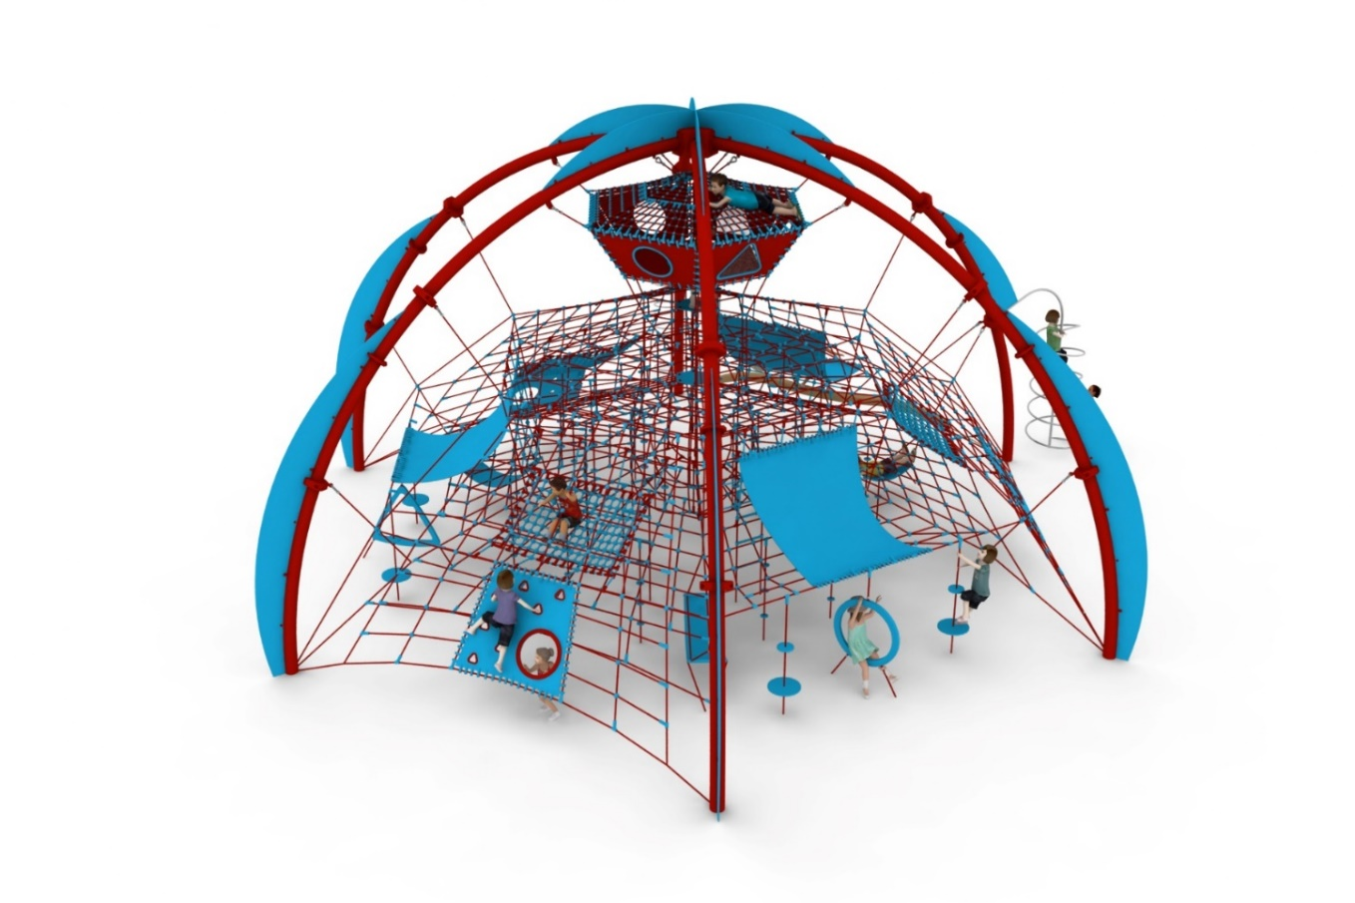

General information about the device:
Length: 11.9m
Width: 12.7m
Height: 6.4m
Minimum space: 15.2 x 15.5m
Age group: 5 to 14 years
Foundation depth: 1.0m
Free fall height: 2.0m

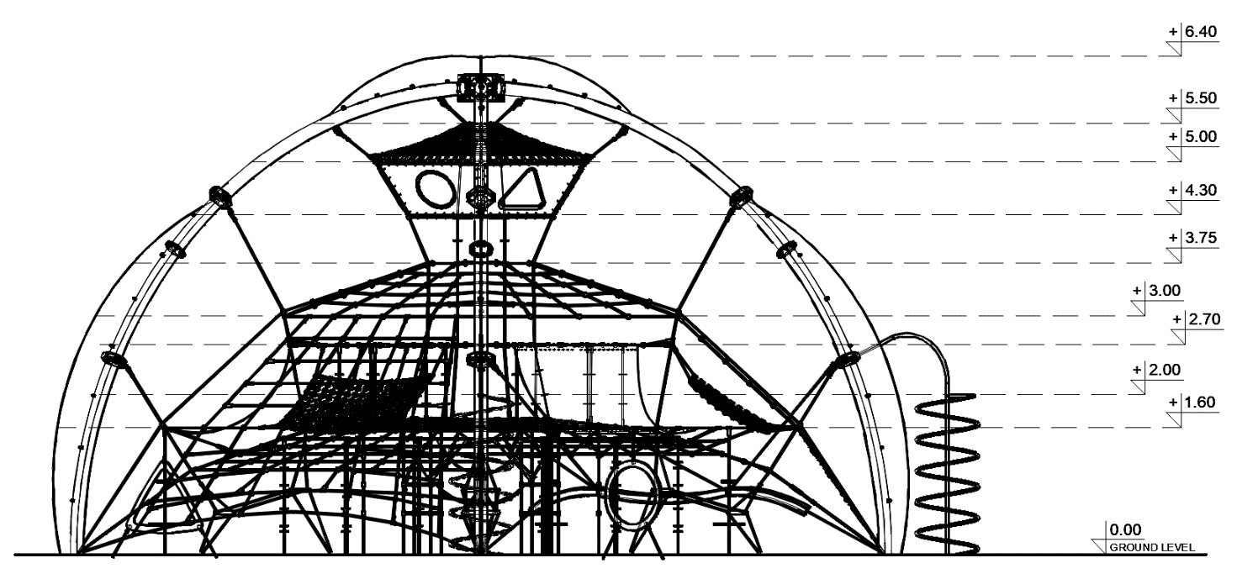

Guidelines for materials and technology of construction of the device.
The MEDOOZA device consists of six steel arches, on which a rope net is hung, the central part of which is a rope shaft, hanging to the steel structure.
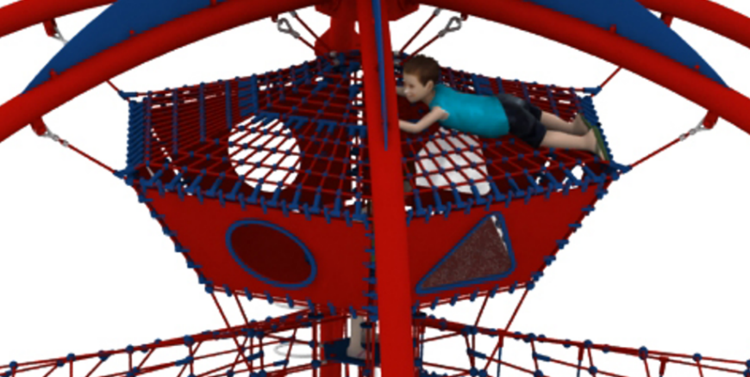
At the top of the shaft is a “House” with a floor made of rubber and walls encased in rubber mats, the roof of the house is a dense rope net. The mats on the walls of the house are equipped with windows in the shape of triangles (3pcs) and circles (3pcs). The triangle-shaped windows are blanked off with polycarbonate panels, the circle-shaped windows are open and provide an entrance to the house. Access to the house is additionally provided by a circular entrance in the floor mat, fenced with rope barriers. The floor of the “ House ” is at a level of 4.30m above ground level.

House on top of the shaft

There are three rope floors attached to the rope shaft, the highest is at 3.75 m above ground level, the middle at 2.70 m above ground level, and the lowest at 1.60 m above ground level. Between the highest and lowest floors there are 3 rope hammocks, 3 large rubber hammocks and 18 climbing ropes.

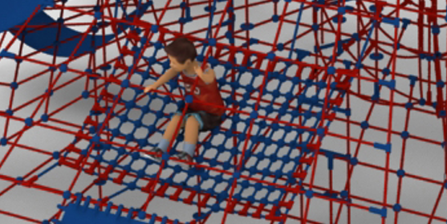 | 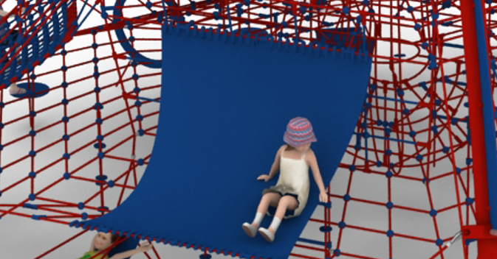
Rope hammock | Large rubber hammock

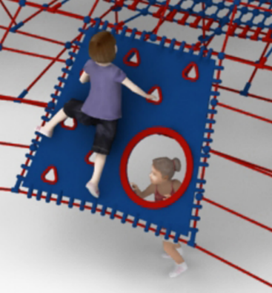
Between the top floor and the steel structure there are three rope climbing walls equipped with rubber mats. Climbing and play variety elements made of HPL are attached to the mats.

Rubber mat with
climbing elements

On one side of the device, a polypropylene balance rope with a minimum cross-section of 120x120mm is hung between two arches. The rope can be used as a balance beam, seat or other play element. Between the lowest floor and the area below are hanging 16 climbing ropes, six rope ladders, three small rubber hammocks and three sensory-motor panels.

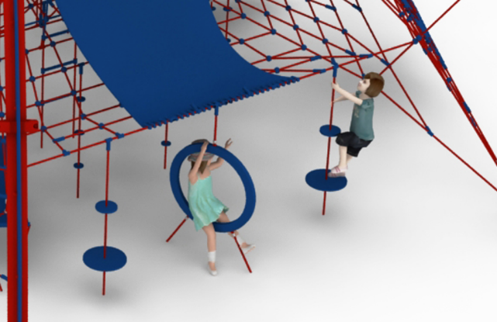 | 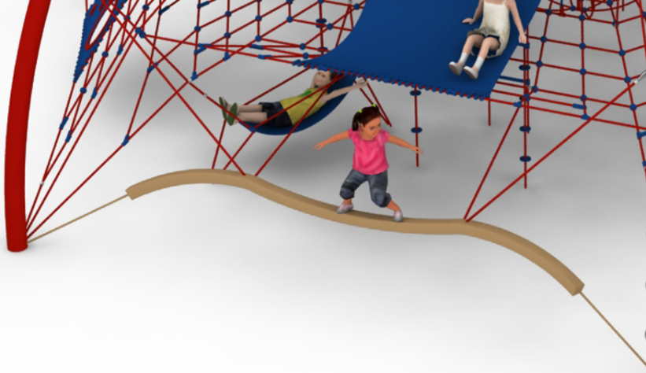
Climbing ropes and sensory-motor panel | Balance rope with a cross section of  min. 120x120 mm

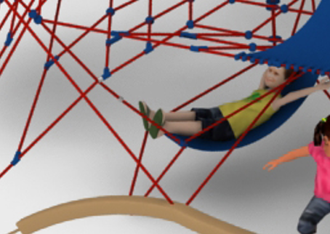
Small rubber hammock
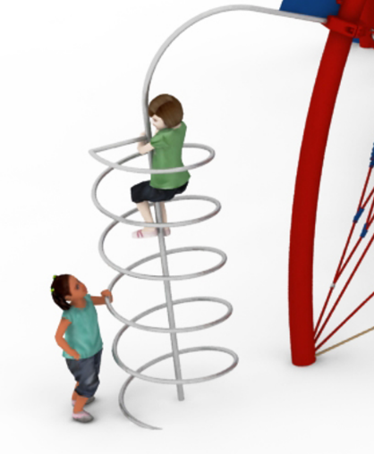
Fireman's pipe

On the outside of the device, two fireman's pipes are attached to the steel structure, made of acid-resistant steel bent pipes, whose design allows climbing and sliding. The steel structure is protected against corrosion by hot-dip galvanizing and additionally powder coated. The rope elements are made of polyamide ropes, braided, glued 18mm in diameter, connected with connectors made of aluminum, stainless steel and plastic. Connections of the rope net to the steel structure are provided by hot-dip galvanized shackles or clamps made of cast steel painted with chlorine-rubber enamel. The tension of the rope section is provided by hot-dip galvanized turnbuckles anchored to the steel structure. Foundation of the steel structure made as reinforced concrete footings.

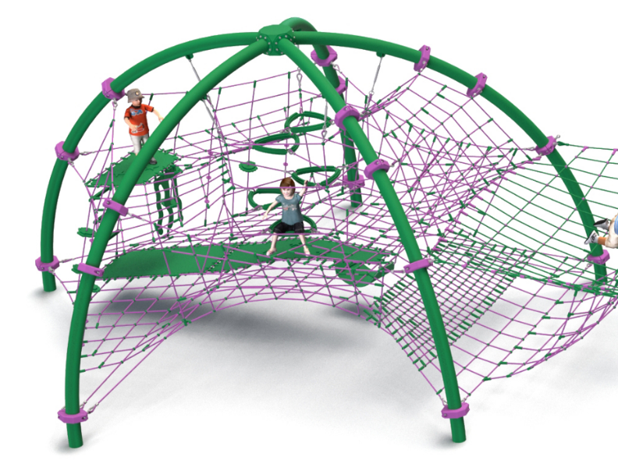
2. Device KOCHAB cat. no. 433.

Device dimensions:
Length: 9.0 m
Width: 9.0 m
Height: 4.3 m
Minimum space: 12.8 x 12.6 m
Age group: 5 to 14 years
Free fall height: 2.9 m
Depth of foundation: 1.0 m

Guidelines for materials and technology of construction of the device.
The main structural element is five circularly placed arches, made of 168.3 mm diameter steel pipe. They are protected from corrosion by hot-dip galvanizing. Inside the structure, a spatial rope net is installed, which consists of nets in different shapes, fixed in different planes. An additional attraction of the device is:
- 3 membranes made of 9mm thick rubber, reinforced with four layers of polyamide mesh,
- 8 climbing ropes, equipped with climbing handles of different diameters and shapes,
- 5 triangular seats, located in the middle of the device, allowing climbing and resting with other children,
- 1 seat-hammock made of reinforced rubber mat, located at the bottom of the device,
- fireman's pipe made of stainless steel.

The rope net is attached to the structure with clamps made of cast steel. The clamps are protected against corrosion by painting with chlorinated rubber paints. At the top of the device, the attachment of the space net is provided by hot-dip galvanized turnbuckles, which allow the net tension to be corrected.
The rope elements are made of polyamide, braided, bonded ropes with a diameter of 18mm, connected by connectors made of aluminum, stainless steel and plastic. The connection of the rope net to the steel structure is provided by means of elements made of stainless steel, galvanized steel and plastics. Foundation of the steel structure made as reinforced concrete footings.

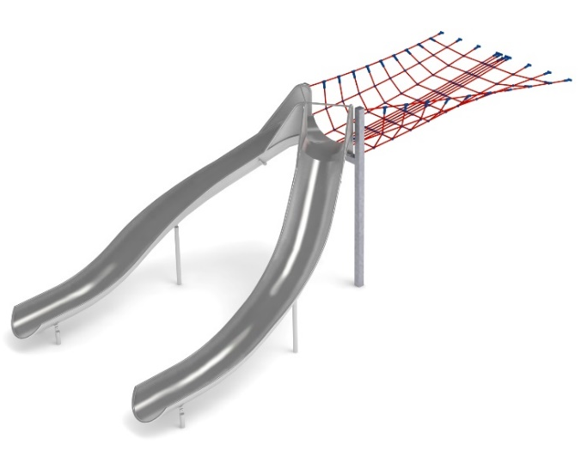
3. Addition DOUBLE SLIDE cat. no. 425u.

Device dimensions:
Length: 8.2 m
Width: 3.3 m
Height: 3.0 m
Age group: 5 to 14 years
Foundation depth: 1.0 m
Free fall height: 3.0 m

Guidelines for materials and technology of construction of the device.
The main element of the addition is a double gutter slide made entirely of 0H18N9 grade acid-resistant steel. The start of the launch section is 2.0 meters above ground level. The construction elements of the addition are made of 100x100 mm square pipe, which are protected from corrosion by hot-dip galvanizing. The foundations are made as reinforced concrete footings placed at a depth of 1m.
The passage connecting the slide to the pyramid is made of polyamide rope, braided, glued reinforced with galvanized steel strings. The diameter of the rope is 18 mm. The elements connecting the ropes to each other are made of plastic and aluminum.

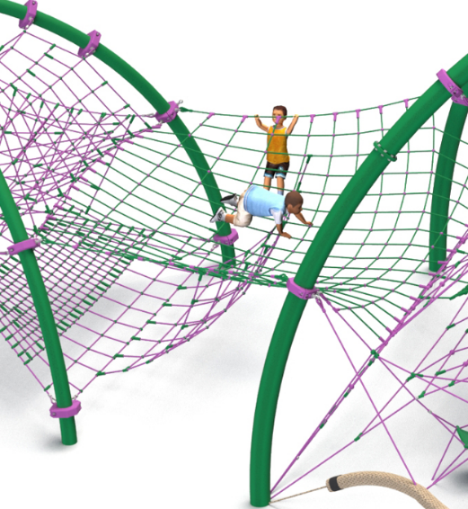
4. Connecting module 432-PASSAGE-433.

Device dimensions:
Length: 3.2m
Width: 5.4m
Height: 2.5m
Age group: 5 to 14 years
Free fall height: 2.5m

Guidelines for materials and technology of construction of the device.
The module is a rope net attached at a height of 2.5m, to which the lower net, which is an extension of the KOCHAB device net, is hanged. The passage connecting the slide to the pyramid is made of polyamide rope, braided, glued reinforced with galvanized steel strings. The diameter of the rope is 18 mm. The elements connecting the ropes to each other are made of plastic and aluminum.

The fall area of the equipment should be made on a surface in accordance with PN EN 1176- 1:2017. The possibility of access by heavy construction equipment is required for the installation.
For the safety of children and the quality of the equipment, it is required that the equipment is certified in accordance with standards PN EN 1176-1:2017, PN EN 1176-3:2017, PN EN 1176-11:2014-11 issued by a system accredited by the National Accreditation Centre or the national accreditation body of the other Member States in accordance with Regulation (EC) No 765/2008 of the European Parliament and of the Council of the European Union."

