PRODUCT CARD SABIK
Cat. no. 435
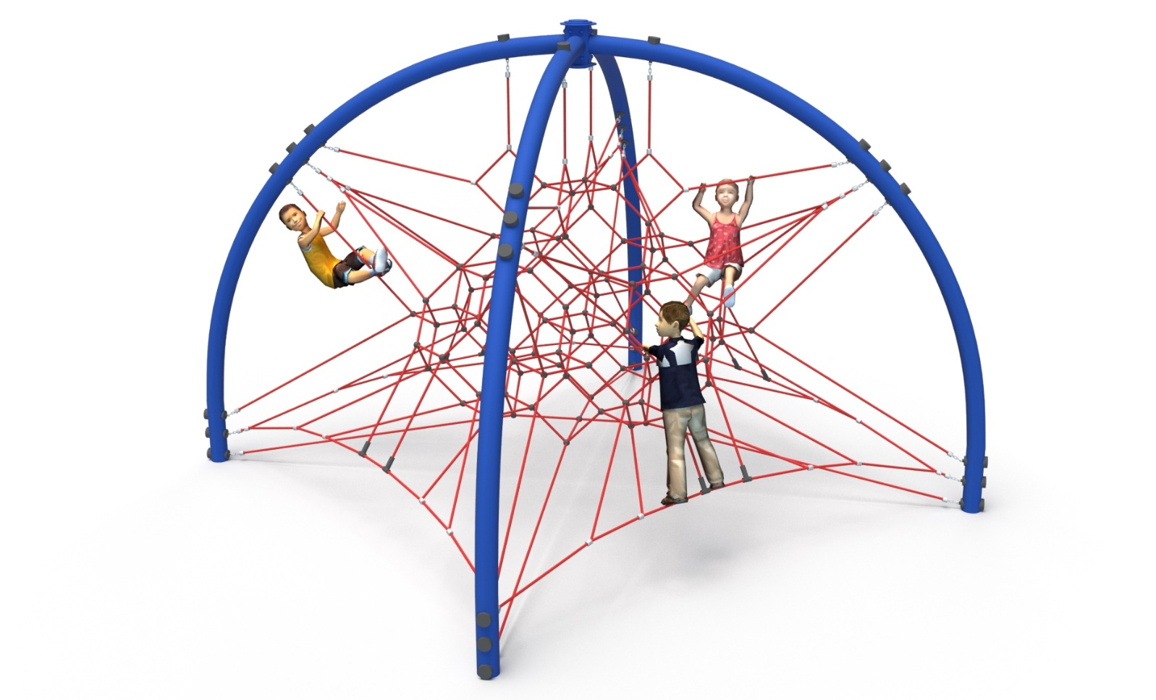
General information about the device:  Length: 4.3m  Width: 4.3m  Height: 3.4m  Minimum space: 7.3 x 7.3m  Foundation depth: 1.0m  Free fall height: 1.3m  Age group: 5 to 14 years old  Amount of rope used - 160 m.  Heavy construction equipment accessibility is required for installation.  The fall area of the device should be made on a surface in accordance with EN 1176-1:2017. | 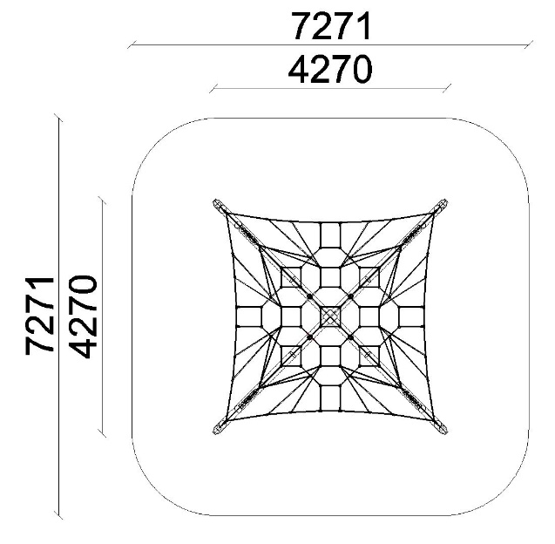

Guidelines for materials and technology of construction of the device.
The device consists of four steel arches, made of bent round pipes of min. 139.7mm. A rope net is attached to the arches. All rope attachments to the structure have the ability to adjust the tension. The amount of rope used - 160 m.
Steel structure made of black steel protected against corrosion by hot-dip galvanizing, optional powder coating. The rope elements are made of polyamide, braided, bonded ropes with a diameter of 18mm, connected by connectors made of aluminum, stainless steel and plastic. The element on top of the structure is made of HPL. Foundation of the steel structure made as reinforced concrete footings.

For the safety of children and the quality of the equipment, it is required that the equipment is certified in accordance with standards PN EN 1176-1:2017, PN EN 1176-3:2017, PN EN 1176-11:2014-11 issued by a system accredited by the National Accreditation Centre or the national accreditation body of the other Member States in accordance with Regulation (EC) No 765/2008 of the European Parliament and of the Council of the European Union."

