PRODUCT CARD
FABULON, cat. no. 436
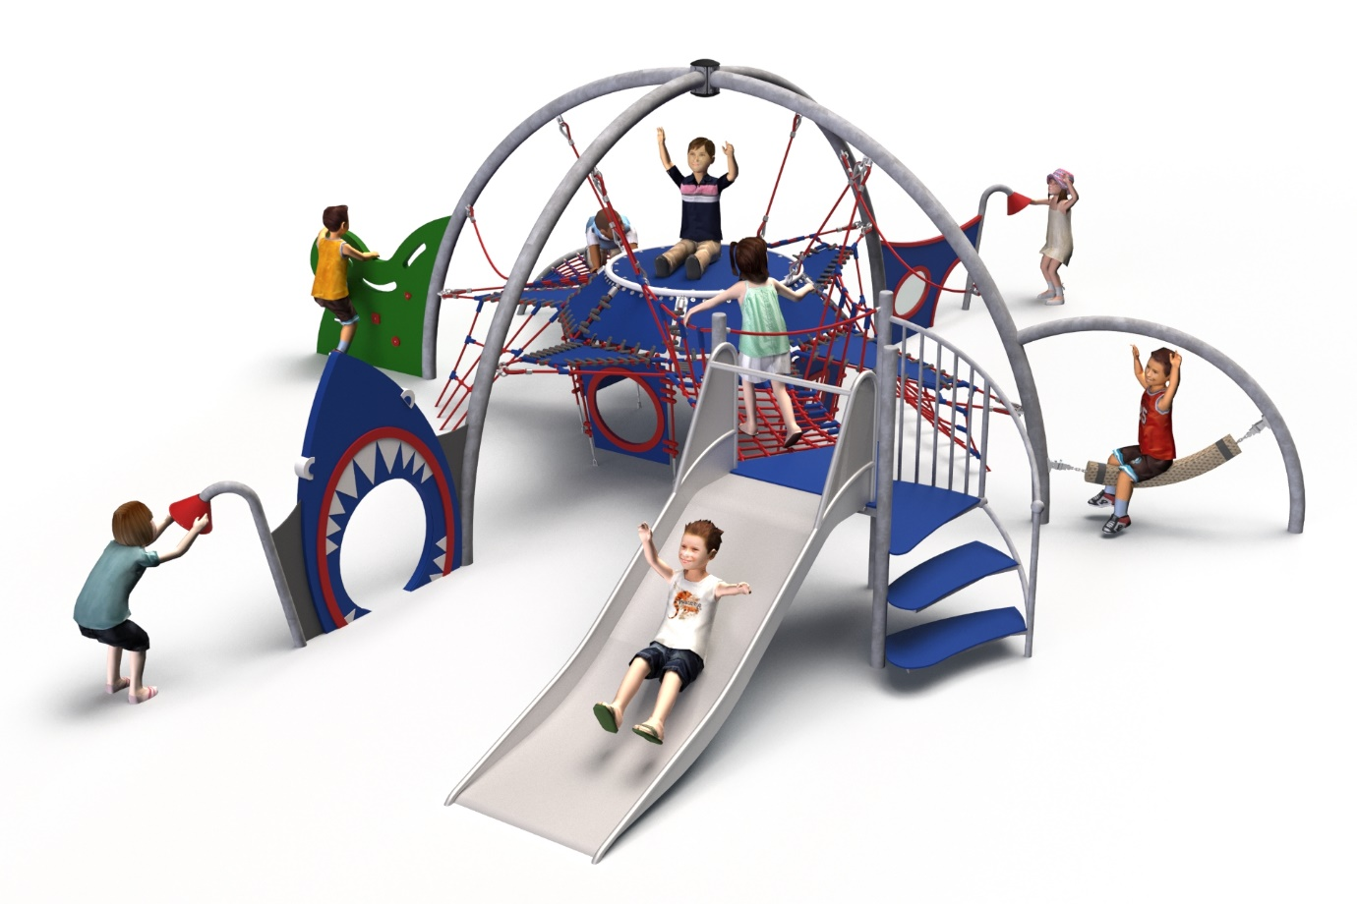
General information about the equipment:  Length: 9.20 m  Width: 7.54 m  Height: 2.65 m  Minimum area required: 12.44 x 10.67 m  Foundation depth: 1.0 m  Free fall height: 1.0 m  Age group: 0 to 14 years  Access for heavy construction equipment is required to carry out the installation.  The impact area of the equipment should be made with a surface compliant with the PN-EN 1176-1:2017 standard. | 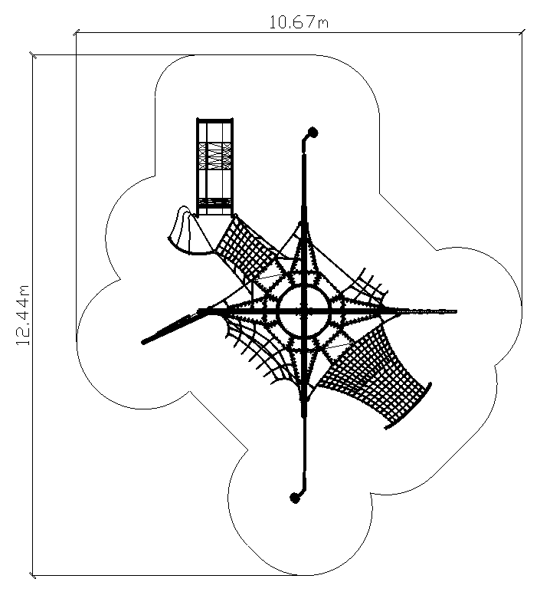

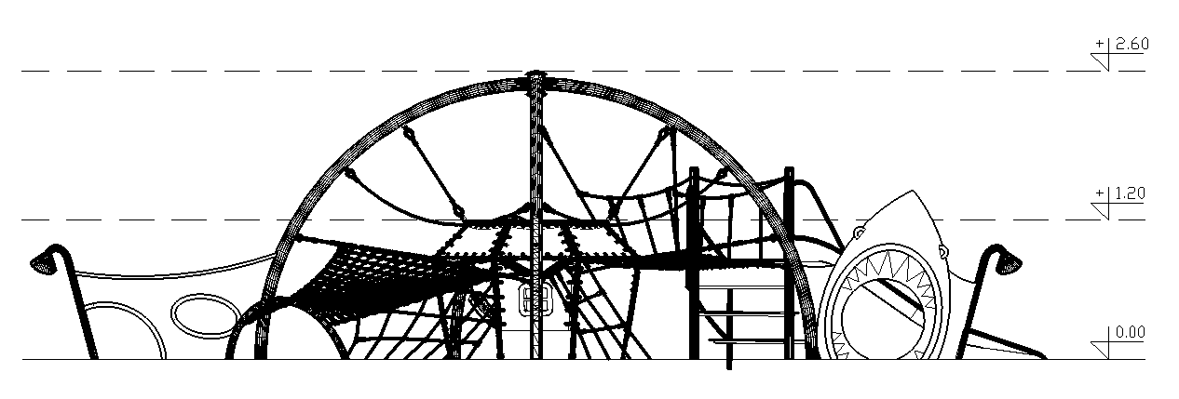

Guidelines for materials and manufacturing technology of the equipment

FABULON is a multifunctional dome-shaped play structure designed to provide a wide range of climbing and play activities for children. The central feature is a suspended platform constructed from a reinforced rubber mat, supported within a spatial frame formed by four bent steel arches made of Ø108 mm black steel tubing. The platform is encircled by polyamide rope nets arranged both horizontally and diagonally between the arches, creating a multi-directional climbing environment.
Rubber mats are affixed to the surrounding ropes adjacent to the central platform, enabling additional balancing and climbing functions. Children can navigate through the interior of the dome by climbing rope nets and braided rope elements, balancing on suspended lines and rubber surfaces, and discovering various movement routes within the structure.
Integrated play elements include:
- A stainless steel slide with a launch height of 1.0 m, accessed via spiral stairs,
- A thematic entry panel in the shape of a shark’s jaw,
- A balancing element in the form of a suspended rope beam with a minimum cross-section of 120x120 mm,
- A climbing wall,
- An acoustic play device (speaking tube).
Decorative and thematic panels with integrated graphics enhance the structure’s visual appeal and stimulate imaginative play.
The steel structure is made of black steel protected against corrosion by hot-dip galvanizing, with an optional powder coating finish. The rope components are made of 18 mm diameter braided and bonded polyamide ropes, connected using fittings made of aluminum, stainless steel, and synthetic materials. The steel structure is anchored with reinforced concrete footings.

