PRODUCT CARD AIR DOME
Cat. no. 434
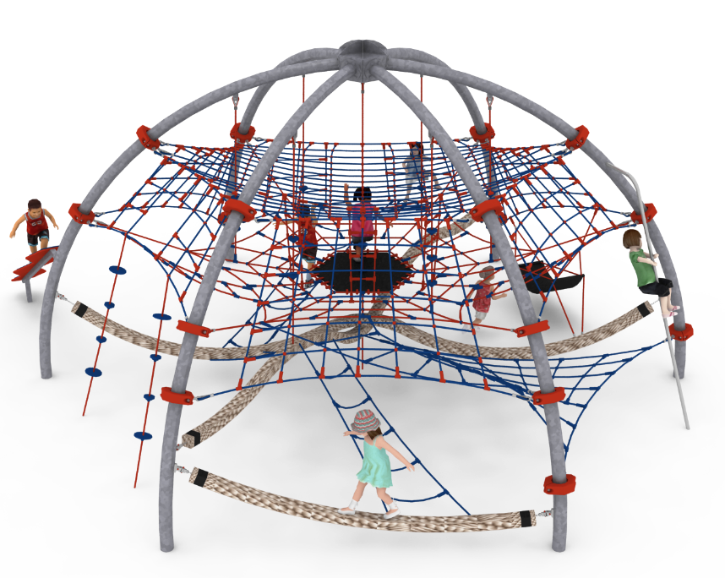

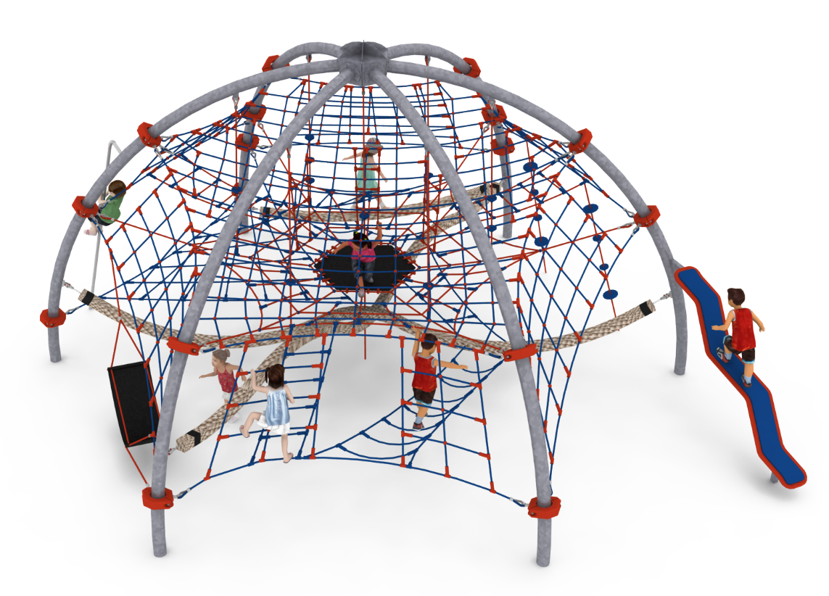
General information about the device:  Length: 9.1m  Width: 7.2m  Height: 4.35m  Minimum space: 12.7 x 11.3m  Foundation depth: 1.0m  Free fall height: 3.0m  Age group: 5 to 14 years old  Heavy construction equipment accessibility is required for installation.  The fall area of the device should be made on a surface in accordance with EN 1176-1:2017. | 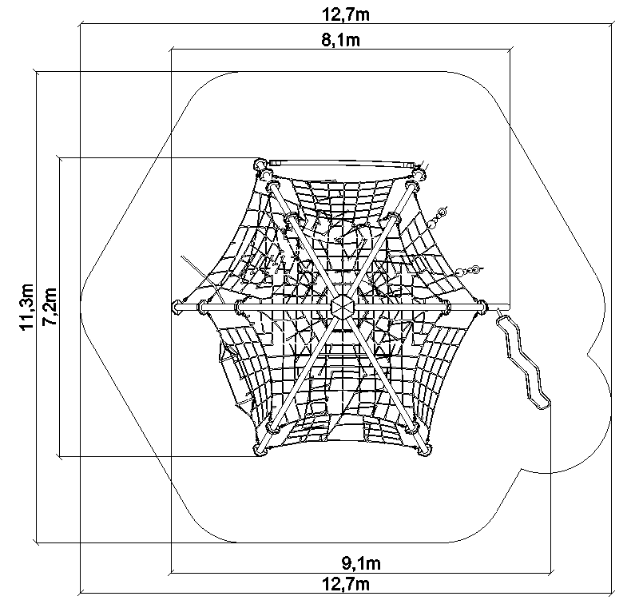
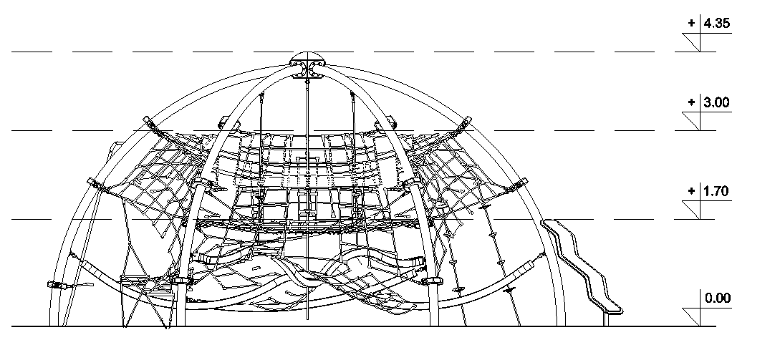

Guidelines for materials and technology of construction of the device.
The device consists of six steel arches, made of bent round pipes of min. 139mm. Rope net is attached to the arches, which includes:
- top horizontal net, hung at a height of 3.0m,
- six inclined nets hung between adjacent pairs of arches,
- a horizontal rope plane with a rubber mat located in the center with a size of min. 1.0x1.0m, located at a height of 1.7m,
- three vertical rope ladders connecting the horizontal nets together,
- six climbing ropes, attached to steel arches, connecting horizontal nets to each other,
- two climbing ropes attached to one of six inclined nets anchored to the ground,
- rope and rubber hammock, attached to one of six inclined nets,
- two thick ropes of min. 140x140mm, polypropylene, length min. 7.0m, attached between two different pairs of opposite steel arches at a height of 0.35 to 1.20m; ropes are attached to the structure with a chain and a bearing sling, made of stainless steel,
- horizontal rope net stretched between a long thick rope and a steel structure,
- six horizontal rope ladders, hung at different points in the net.
In addition, a 3.0m long stainless steel fireman's tube and a balance beam are installed to the structure.
Steel structure is made of black steel protected against corrosion by hot-dip galvanizing, optional powder coating. The rope elements are made of polyamide ropes, braided, glued 18mm in diameter, connected with connectors made of aluminum, stainless steel and plastic. Foundation of the steel structure made as reinforced concrete footings.

For the safety of children and the quality of the equipment, it is required that the equipment is certified in accordance with standards PN EN 1176-1:2017, PN EN 1176-3:2017, PN EN 1176-11:2014-11 issued by a system accredited by the National Accreditation Centre or the national accreditation body of the other Member States in accordance with Regulation (EC) No 765/2008 of the European Parliament and of the Council of the European Union."

