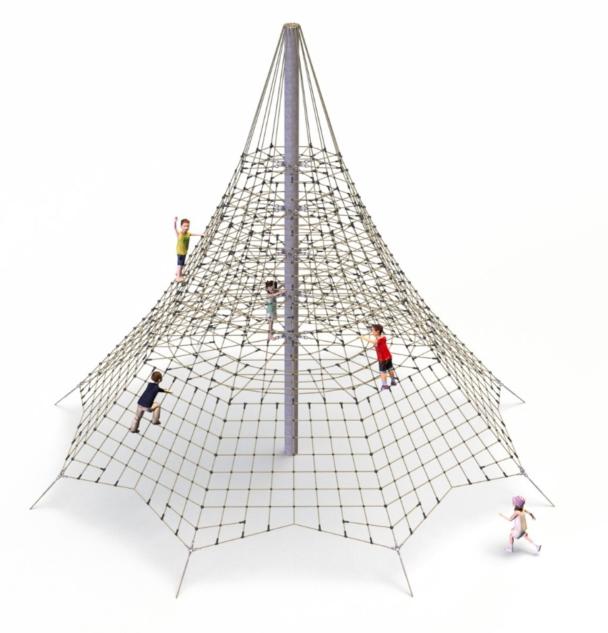
PRODUCT CARD PROSPERO ROPE PYRAMID
Cat. no. 219

Device dimensions:
Length: 11,0 m
Width: 11,0 m
Height: 9.0 m
Minimum space: a circle
with a diameter of 14.0 m
Age group: 5 to 14 years old
Free fall height: 2,7 m
Depth of foundation: 1,0 m
Length of rope used: 1100 m

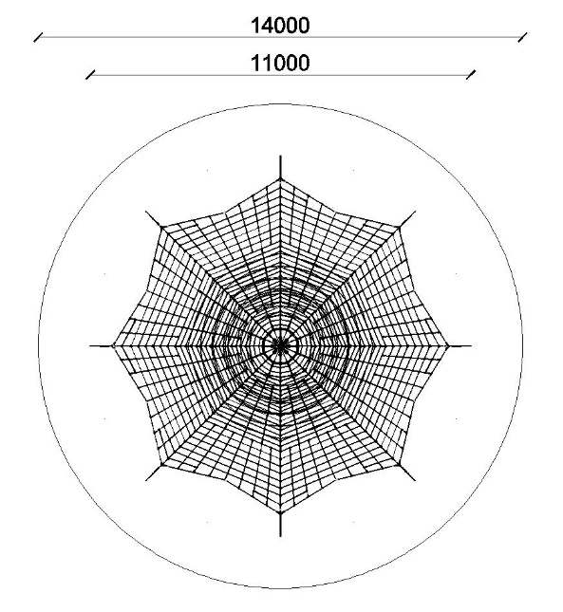
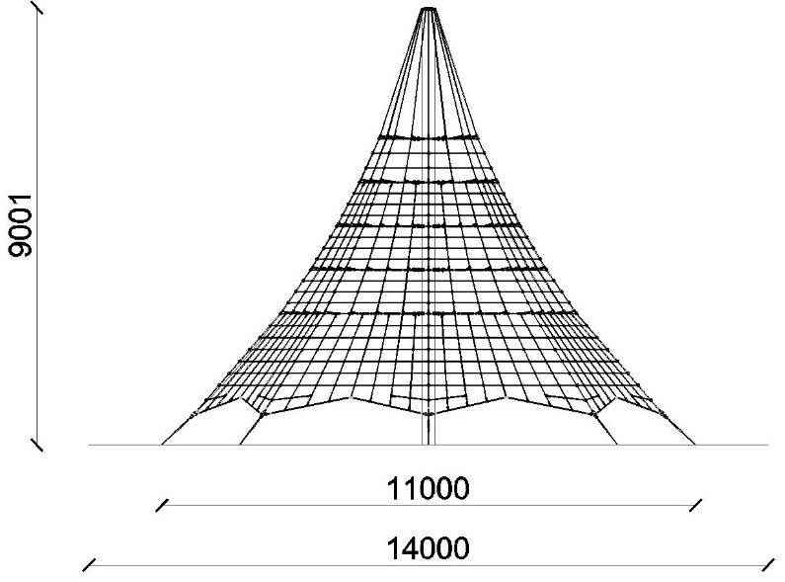

Guidelines for materials and technology of construction of the device.
The main structural element is a 9-meter steel pole with a diameter of 273 mm, which is protected against corrosion by hot-dip galvanizing. The rope structure is formed by eight main ropes anchored in the ground with reinforced concrete feet. Tension adjustment is provided by hot-dip galvanized turnbuckles. Eight rope walls are stretched between adjacent supporting ropes. Additional attractions are horizontal rope planes at heights of 2,7, 3,6, 4,5, 5,4 and 6,3 meters. The net is made of polyamide rope, braided, glued reinforced with galvanized steel strings. The diameter of the rope is 18 mm. The elements connecting the ropes to each other are made of plastic and aluminum. The elements connecting the ropes to the pole are made of stainless steel and hod-dip galvanized.

The fall area of the equipment should be made on a surface in accordance with PN EN 1176- 1:2017. The possibility of access by heavy construction equipment is required for the installation.
For the safety of children and the quality of the equipment, it is required that the equipment is certified in accordance with standards PN EN 1176-1:2017-12, PN EN 1176-11:2014-11 issued by a system accredited by the National Accreditation Centre or the national accreditation body of the other Member States in accordance with Regulation (EC) No 765/2008 of the European Parliament and of the Council of the European Union."

