PRODUCT CARD
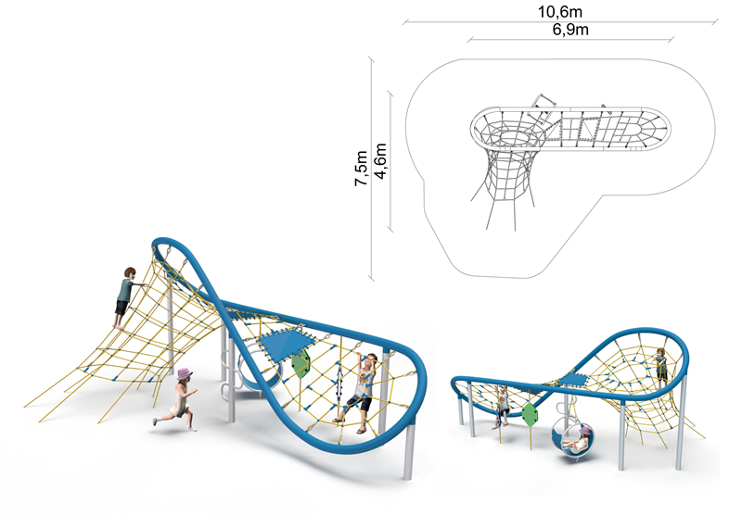
EIGHT nr kat. 1423

Device dimensions:
Length: 6.9m
Width: 4.6m
Height: 3.1m
Minimum space: 10.6 x 7.5m
Age group: form 5 to 14
Free fall height: max. 3.0 m
Depth of foundation: 1.0m

Guidelines for materials and technology of construction of the device.
The main structural elements are a steel loop made of bent 139.7mm diameter pipes, installed on steel poles made of 114,3mm diameter pipes. The structure is protected from corrosion by hot-dip galvanizing and powder coating. The device is anchored in the ground through footings, which are planted at a depth of 1.0m. The foundation footings are made of C20/25 concrete. A rope tunnel is connected to the structure, which is attached to the steel structure and anchored to the ground. The device is also equipped with an 8mm thick rubber mat. Rope nets are made of polyamide rope, braided, glued reinforced with galvanized steel strings. The diameter of the rope is 18 mm. The components connecting the ropes to each other are made of plastic, stainless steel and aluminum. The device is additionally equipped with seat on a structure made of steel circles, steel ladder attached to pole and two visual panels.

The fall area of the equipment should be made on a surface in accordance with PN EN 1176- 1:2017. The possibility of access by heavy construction equipment is required for the installation.
For the safety of children and the quality of the equipment, it is required that the equipment is certified in accordance with standards PN EN 1176-1:2017, PN EN 1176-3:2017, PN EN 1176-11:2014-11 issued by a system accredited by the National Accreditation Centre or the national accreditation body of the other Member States in accordance with Regulation (EC) No 765/2008 of the European Parliament and of the Council of the European Union."

