PRODUCT CARD TUTTI FRUTTI
Cat. no. 434

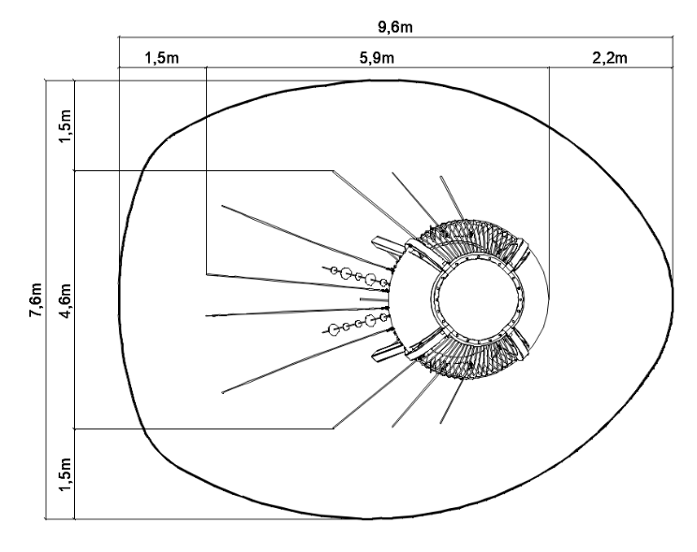

Device dimensions:
Length: 5.9 m
Width: 4.6 m
Height: 4.3 m
Minimum space: 9.6 x 7.6 m (58,6 m²)
Age group: 5 to 14 years old
Free fall height: 2.4 m
Foundation depth: 1.0 m
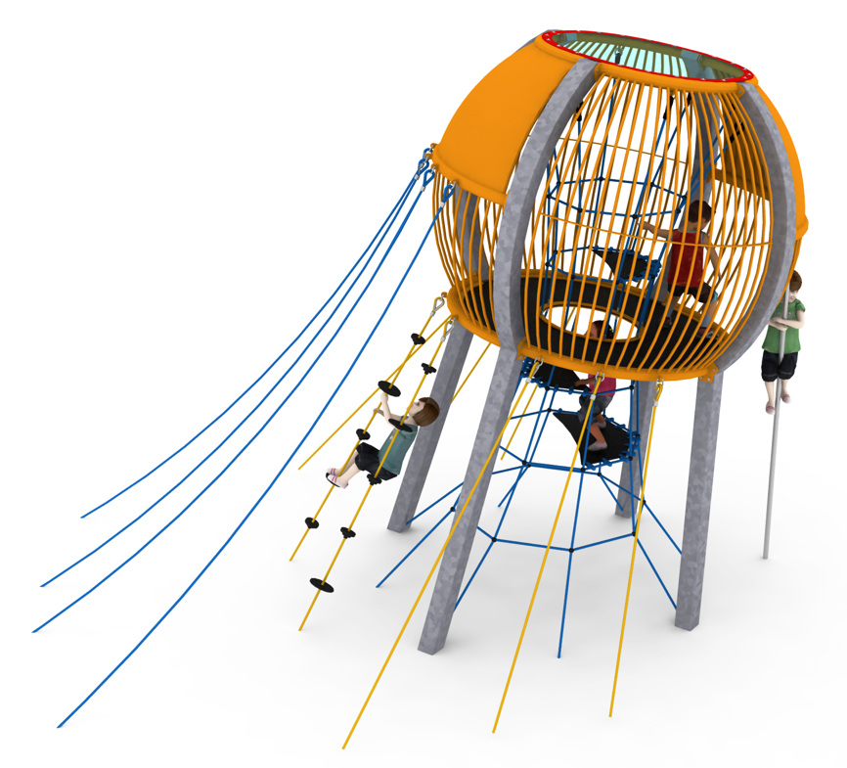
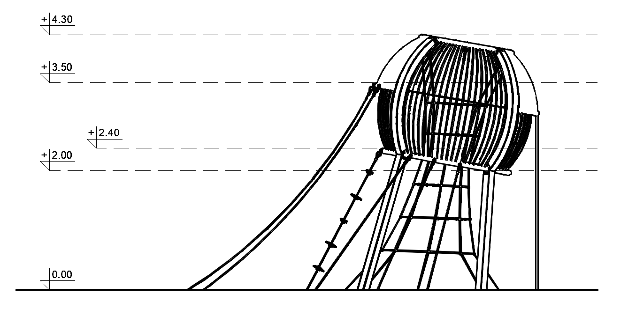

General information about the device
Acceptable number of users: 20
Labor intensity of installation: approx. 72 man-hours
Concrete quantity: approx. 8.0 m³

Guidelines for materials and technology of construction of the device.
The TUTTI FRUTTI device consists of four inclined steel poles, made partly from straight and partly from bent 140x140 square pipes. The bent parts of the poles are connected to each other by steel bent-pipe covers, completely surrounding the inclined platform except for the access holes. The platform is made of flexible rubber mat. A vertical rope shaft, equipped with rubber half-steps, provides access to the inside of the device. The second access hole accessed by two climbing ropes is located on the front of the device. At the back of the device is a vertical fire pipe.
The steel structure is protected against corrosion by hot-dip galvanizing and/or powder-coated. The rope elements are made of polyamide ropes, braided, glued in diameter of 18mm, connected with connectors made of aluminum, stainless steel and plastic. Foundation of the steel structure made as a plate or reinforced concrete footings.

The fall area of the equipment should be made on a surface in accordance with PN EN 1176- 1:2017. The possibility of access by heavy construction equipment is required for the installation.
For the safety of children and the quality of the equipment, it is required that the equipment is certified in accordance with standards PN EN 1176-1:2017, PN EN 1176-3:2017, PN EN 1176-11:2014-11 issued by a system accredited by the National Accreditation Centre or the national accreditation body of the other Member States in accordance with Regulation (EC) No 765/2008 of the European Parliament and of the Council of the European Union."

