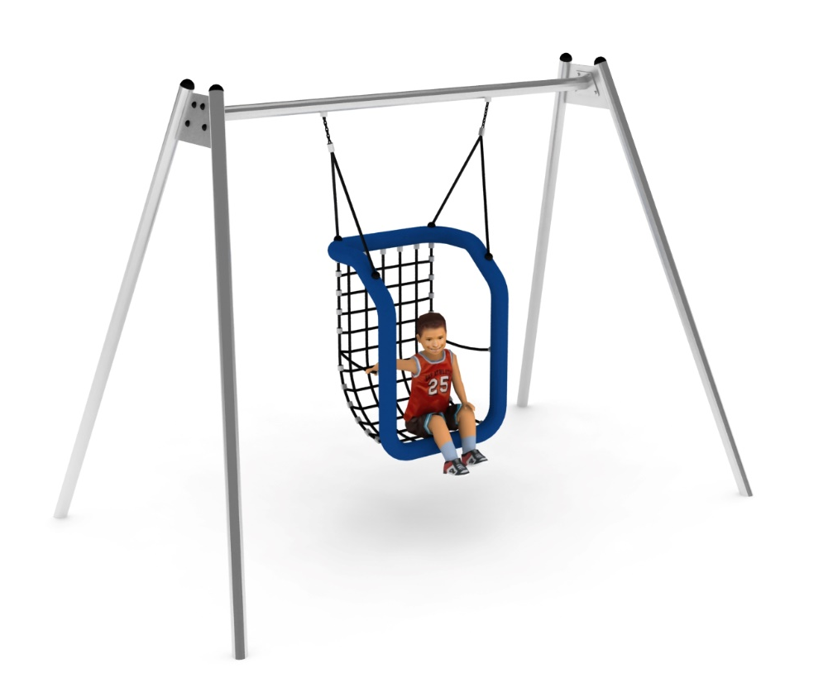
PRODUCT CARD SWING BIANKA
Cat. no. 614

Swing dimensions:
Długość: 3,5 m
Szerokość: 2,2 m
Wysokość: 2,5 m
Przestrzeń minimalna: 2,2 x 8,0 m
Grupa wiekowa: od 5 do 14 lat
Wysokość swobodnego upadku: 1,6 m

Guidelines for materials and technology of construction of the device.
The struts and top beam, which form the swing structure, are made of 76.1 mm diameter stainless steel tube. The stainless steel is grade 0H18N9. The foundations are made as concrete footings placed at a depth of 0.6 m. Swing seat designed for children who cannot use normal seats. Seat frame made of steel, wrapped with polypropylene rope. Base and seat back made of woven rope mesh fitted with a steel core. The size of the seat mesh eye is 100x100mm. Recommended for use under adult supervision. Connectors, chains and slings are made of stainless steel. A maintenance-free rolling bearing is used in the slings. The plugs are made of plastic.

The fall area of the equipment should be made on a surface in accordance with PN EN 1176- 1:2017. The possibility of access by heavy construction equipment is required for the installation.
For the safety of children and the quality of the equipment, it is required that the equipment is certified in accordance with standards PN EN 1176-1:2017, PN EN 1176-3:2017, PN EN 1176-11:2014-11 issued by a system accredited by the National Accreditation Centre or the national accreditation body of the other Member States in accordance with Regulation (EC) No 765/2008 of the European Parliament and of the Council of the European Union."

