PRODUCT CARD ZOSMA
Cat. no. 1415
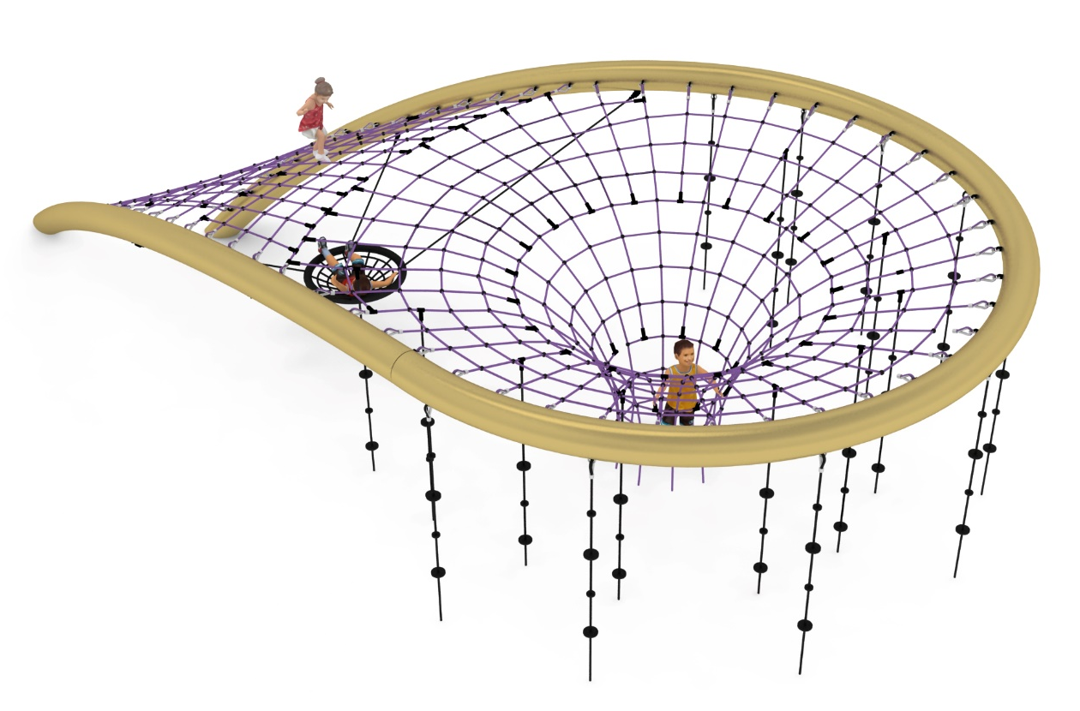
Device dimensions:
Length: 11.7m
Width: 6.1m
Height: 2.7m
Minimum space: 16.9 x 10.9m
Age group: 5 to 14 years
Foundation depth: 1.1m
Free fall height: 2.7m

Guidelines for materials and technology of construction of the device.
The device consists of a steel frame bent from pipes of a minimum diameter of 300mm and rope nets hung inside the frame. The net consists of a near-flat net going from the bottom of the steel structure to its highest point, which at the highest part of the structure transitions into a rope funnel anchored in the ground. To the net, a minimum of 18 climbing ropes are hanging around the rope funnel. In addition, a ‘stork's nest’ type seat is attached in front of the rope funnel. The seat is hanging at 4 points, with no swing possibility.
Rope nets made of polyamide, braided, bonded ropes with a minimum diameter of 18mm, connected with connectors made of aluminium, stainless steel and plastic. The connection of the rope net to the steel structure is ensured by elements made of acid-resistant steel and hot-dip galvanised steel. Rope funnel and climbing ropes anchored into the ground with precast concrete blocks.
The steel structure is protected against corrosion by hot-dip galvanising and powder coating. Connections of steel structure components shall be made in such a way as to ensure the continuity of the external surface of the pipe bends, butt connections with the location of connectors outside the outside diameter of the pipe bend section are not permitted and others that change the cross-section of the steel structure in steps along its length. This requirement is to avoid the danger to users posed by protruding hard parts and to maintain a satisfactory visual effect of the device. Steel structure placed on reinforced concrete footings.

The fall area of the equipment should be made on a surface in accordance with PN EN 1176- 1:2017. The possibility of access by heavy construction equipment is required for the installation.
For the safety of children and the quality of the equipment, it is required that the equipment is certified in accordance with standards PN EN 1176-1:2017, PN EN 1176-3:2017, PN EN 1176-11:2014-11 issued by a system accredited by the National Accreditation Centre or the national accreditation body of the other Member States in accordance with Regulation (EC) No 765/2008 of the European Parliament and of the Council of the European Union."

