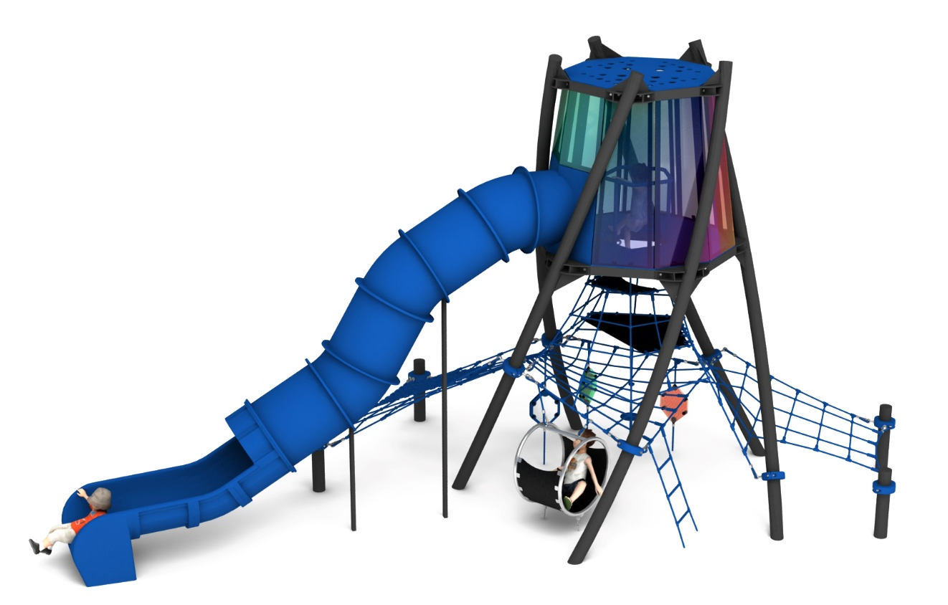
Product card TWIST TOWER
Cat. no. 1631

Device dimensions:
Length: 9.3m
Width: 5.0m
Height: 5.0m
Minimum space: 13.0m x 8.4m
Age group: 5 to 14 years
Depth of foundation: 1,0m
Free fall height: 1,8m

Guidelines for materials and technology.
TWIST TOWER is a twisted tower-shaped device. The main steel structure consists of 5 steel arches, made of 139.7mm diameter tube. The arches are top-mounted to two steel decagons made of 100x100mm steel yokes. Steel structure protected against corrosion by hot-dip galvanising and powder coating. Platform and roof made of 10mm thick HPL board for outdoor use. Polycarbonate panels in the colours of the rainbow are installed between the decagon, creating an indoor viewing area with amazing light reflections. The main attraction of the viewing area is a tube slide made of polyethylene with a starting section at a height of 3.0m. A stainless steel railing is installed inside to prevent users from falling. An irregularly shaped rope net extends from the bottom of the platform, divided by two planes made of 10mm thick reinforced rubber matting. On the outside of the tower, two entrance nets are designed in the form of rope trusses. Down to the rope structure additional play accessories are installed:
- 1x climbing rope
- 1x rope ladder
- 3 x visual panels
- 1 x seat made of stainless steel circles, with an infill of reinforced rubber matting.
The rope elements are made of polyamide, braided, bonded ropes with a diameter of 18mm, connected with fittings made of aluminium, stainless steel and plastic. The connection of the cable net to the steel structure is ensured by elements made of stainless steel, galvanised steel and plastic. The foundation of the steel structure is made as reinforced concrete footings.

The fall area of the device should be constructed on a pavement in accordance with PN EN 1176- 1:2017-12. The access of heavy construction equipment is necessary for the assembly.
For the sake of children's safety and the quality of the equipment, it is required that the equipment is certified in accordance with standards PN EN 1176-1:2017-12, PN EN 1176-11:2014-11, PN EN 1176-3:2017-12, issued by a system accredited by the National Accreditation Centre or the national accreditation body of the other Member States, in accordance with Regulation (EC) No 765/2008 of the European Parliament and of the Council of the European Union."

