PRODUCT CARD
TIPI TOWER
Device dimensions:  Length: 13.5m  Width: 8.3m  Height: 7.5m  Minimum space: 17.1m x 12.0m  Age group: 5 to 14 years  Depth of foundation: 1,0m  Free fall height: 1,5m | 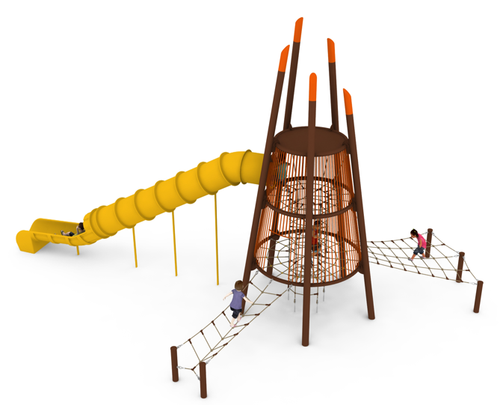

Guidelines for materials and technology.
TIPI TOWER is a device in the shape of a truncated pyramid, consisting of 5 steel poles made of tubes with a diameter of 168.3mm of different length, which are the load-bearing structure for bent steel arches made of tubes with a diameter of 88.9mm, forming circles on which rope nets are suspended. The steel structure is protected against corrosion by hot-dip galvanising and powder coating. Horizontal rope nets are located at heights of 1.50m and 3.30m above ground level. A rope shaft is suspended inside the structure, fixed at the top at 4.70m and running through both horizontal rope grids to ground level. At the bottom the shaft is anchored in the ground with turnbuckles to allow for tensioning. The shaft is equipped with 4 mezzanine ropes to prevent falling from a height of more than 1.50m.
Additionally, on the outside of the device there is a rope net and rope bridge, which are additional entrances to the rope level attached at the height of 1.50m, attached on one side to the arches of the steel construction of the device, on the other side to steel poles with diameter of 139.7mm. The rope elements are made of polyamide ropes, braided, bonded with a diameter of 18mm, connected with fittings made of aluminium, stainless steel and plastic. The connection of the rope net to the steel structure is ensured by elements made of aluminium, stainless steel and galvanised steel.
At the level of 3.30 m there is an inlet of a tube slide. The slide is made of polyethylene.
The foundation of the steel structure is made of reinforced concrete footings

The fall area of the device shall be made on a surface in accordance with PN EN 1176- 1:2017-12. The accessibility of heavy construction equipment is required for the installation.

For the sake of children's safety and the quality of the equipment, it is required that the equipment be certified for compliance with PN EN 1176-1:2017-12, PN EN 1176-3:2017-12, PN EN 1176-11:2014-11 issued by a system accredited by the National Accreditation Centre or the national accreditation body of the other Member States in accordance with Regulation (EC) No 765/2008 of the European Parliament and of the Council of the European Union."

