PRODUCT CARD MINIROODIX
Cat. no. 1411
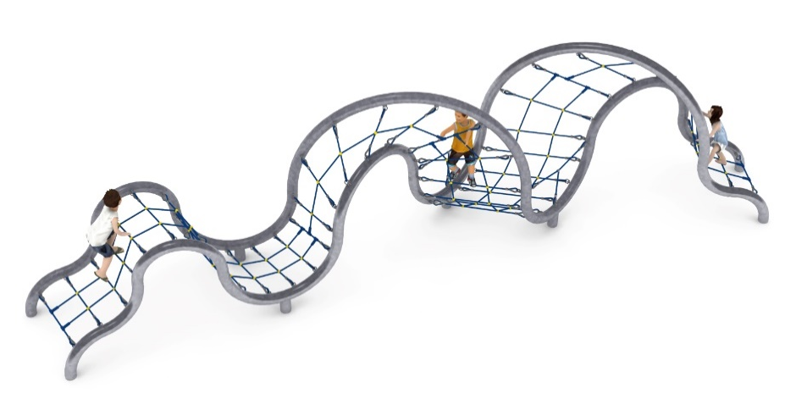
Device dimensions:
Length: 10.0 m
Width: 2.9 m
Height: 2.6 m
Minimum space: 13.1 x 6.0 m
Age group: 3 to 14 years
Free fall height: 2.6 m
Foundation depth: 1.0 m
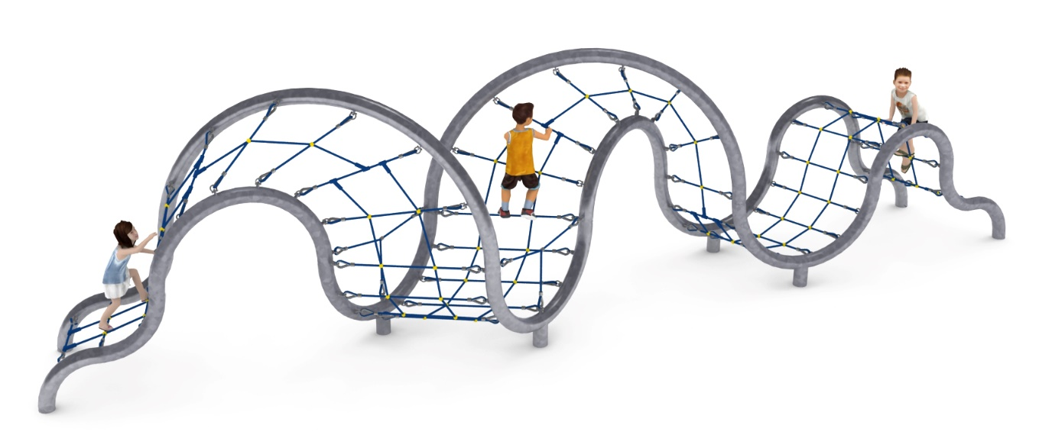

Guidelines for materials and technology of construction of the device.
The main structural element is a steel frame made of 139.7 mm diameter pipe, which is protected against corrosion by hot-dip galvanising. The frame is formed by interconnected tubular arches connected at different angles. A rope construction is stretched over the support structure thus created. The rope construction is made of polyamide rope, braided, bonded and reinforced with galvanised steel strings. The rope diameter is 18 mm. The elements connecting the ropes to each other are made of plastic and aluminium. Connection of the ropes to the steel structure by: hot-dip galvanised shackle, stainless steel thimble. The device is anchored in the ground with reinforced concrete feet.

The fall area of the equipment should be made on a surface in accordance with PN EN 1176- 1:2017. The possibility of access by heavy construction equipment is required for the installation.
For the safety of children and the quality of the equipment, it is required that the equipment is certified in accordance with standards PN EN 1176-1:2017, PN EN 1176-3:2017, PN EN 1176-11:2014-11 issued by a system accredited by the National Accreditation Centre or the national accreditation body of the other Member States in accordance with Regulation (EC) No 765/2008 of the European Parliament and of the Council of the European Union."

