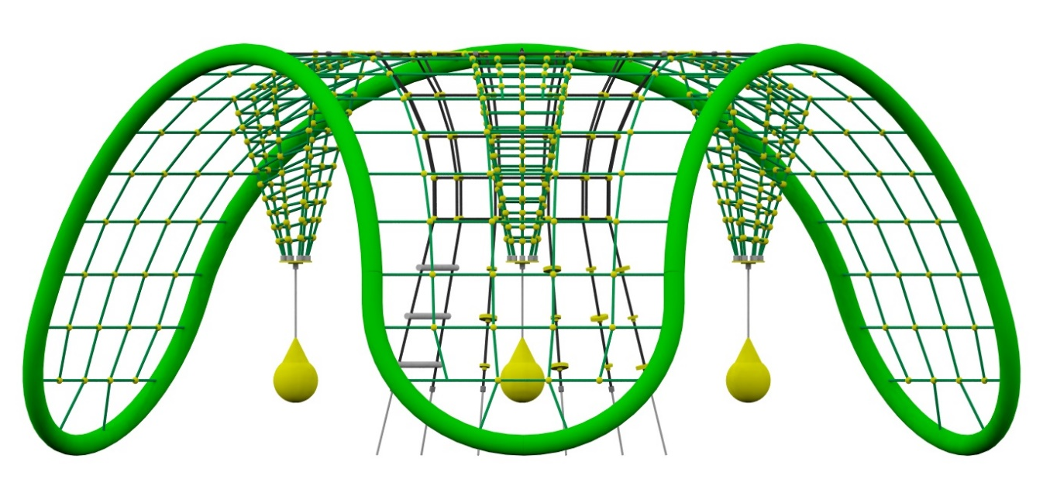
PRODUCT CARD EVOLO
Cat. no. 1410
Device dimensions:
Length: 6.7 m
Width: 6.0 m
Height: 2.75 m
Minimum space: 9.1x9.6 m
Age group: 5 to 14 years
Free fall height: 2.75 m
Foundation depth: 1.0 m

Device description.
Rope device based on a structure made of bent steel tubes. The steel structure, together with the ropes, forms an openwork spatial dome, which is supported on three supports. The device is enriched with elements: a centrally positioned tunnel net with integrated discs, a rope ladder and suspended movable balls.
Guidelines for materials and technology of construction of the device.
The main structure is made of 139.7 mm tube. The structure is protected against corrosion by hot-dip galvanising and powder coating. The net is made of polyamide rope, braided, six-strand, glued reinforced with galvanised steel strings. The diameter of the rope is 18 mm. The 8 mm thick membranes are made of rubber which is reinforced with 4 layers of polyamide mesh. The material is characterised by high resistance to friction and UV rays. The elements connecting the ropes to each other are made of plastic, aluminium and stainless steel. Foundations made as reinforced concrete footings.

Components of the device:
- climbing net,
- hopper net,
- climbing ropes,
- ladder,
- hanging balls 3 pcs.
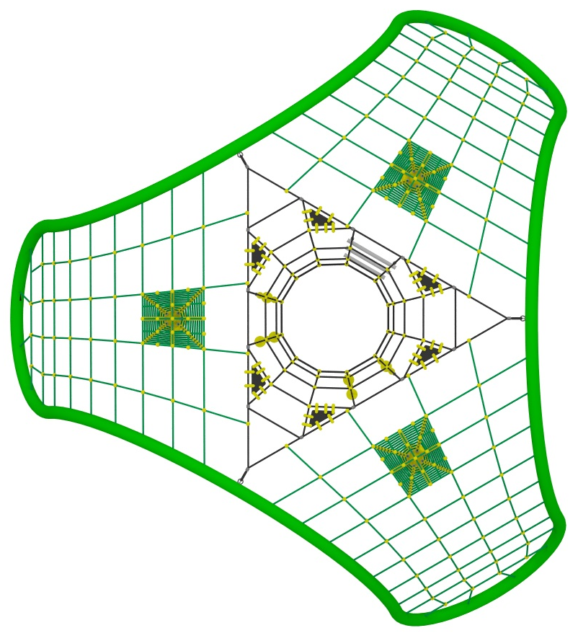

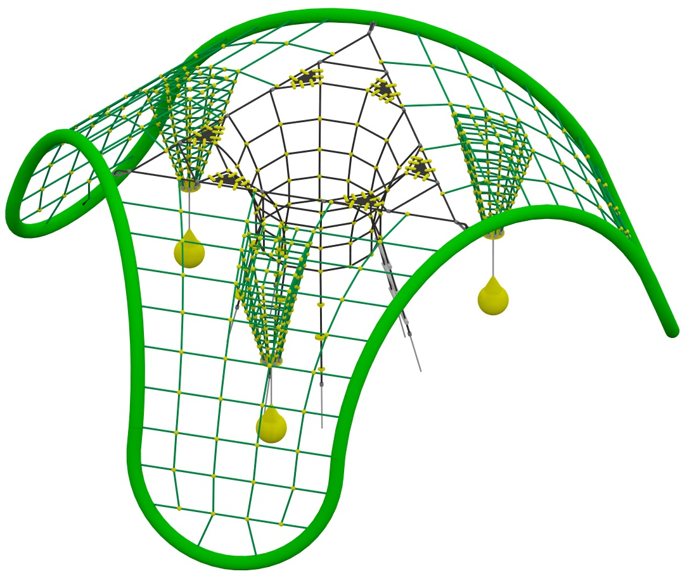
The cables to the steel structure will be connected by means of a hot-dip galvanised shackle and a stainless steel causesh.

