PRODUCT CARD TIAKI
Cat. no. 1409

Device dimensions:
Length: 26.5 m
Width: 20.4 m
Height: 2.9 m
Minimum space: 30.6 x 25.4 m
Age group: 5 to 14 years old
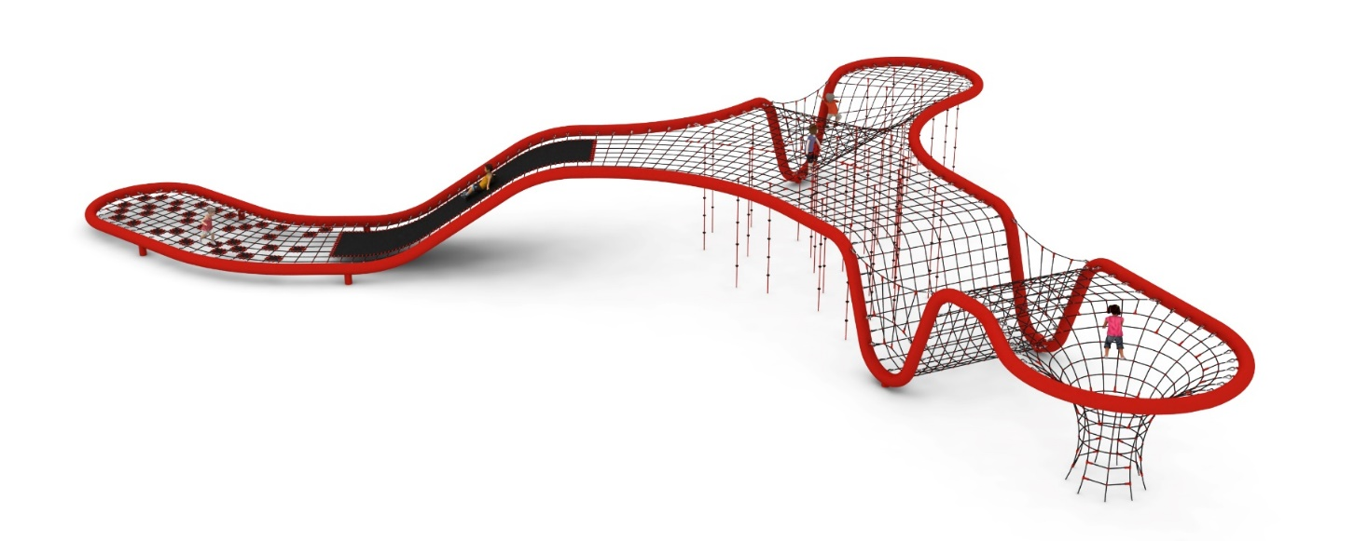
Free fall height: 2.9 m
Foundation depth: 1.0 m

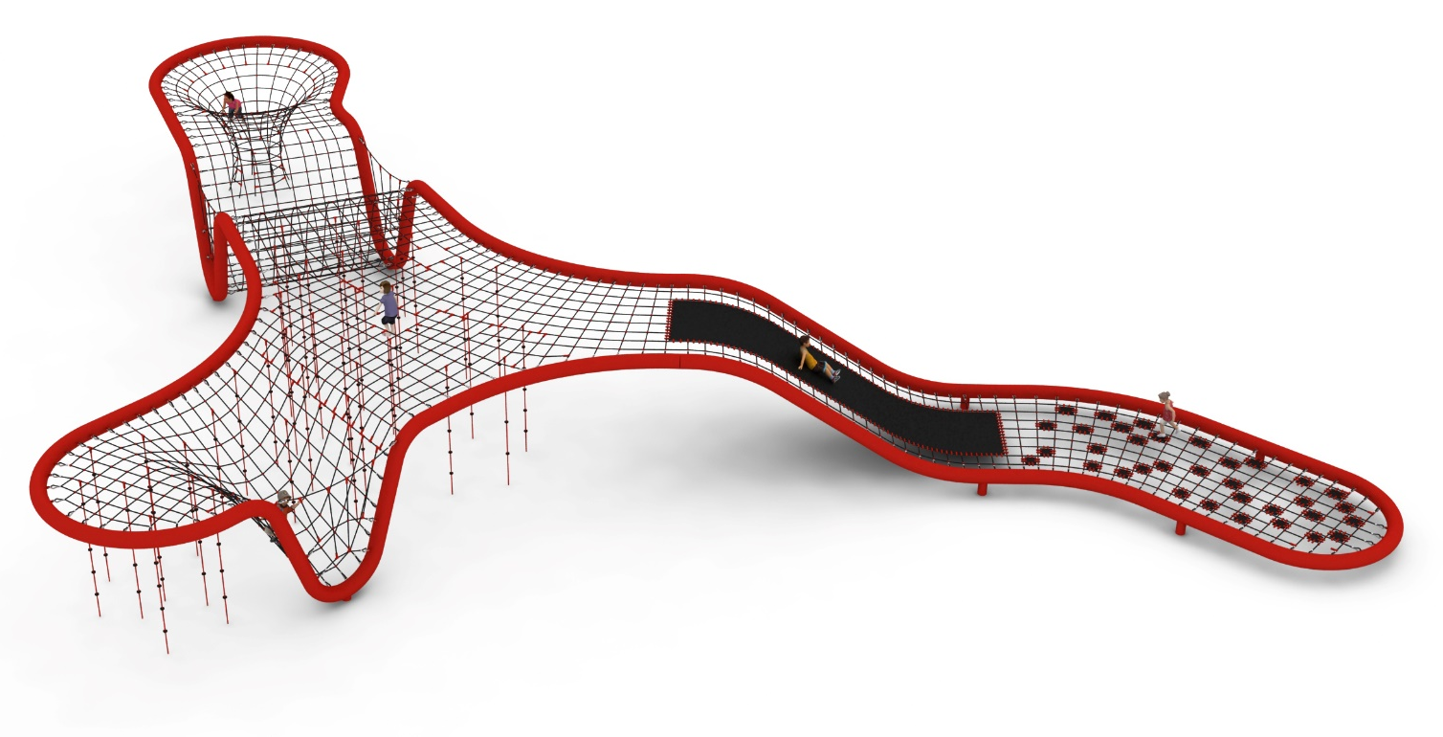

Guidelines for materials and technology of construction of the device.
The main structural element is a 273 mm diameter steel pipe, which is protected against corrosion by hot-dip galvanizing and painting. The device is anchored in the ground with reinforced concrete feet. The nets are made of polyamide rope, braided, glued reinforced with galvanized steel strings. The diameter of the rope is 18 mm. The connectors used are made of polyamide. Press crimped elements made of aluminum. Connection of ropes to the steel structure by : hot-dip galvanized shackle, stainless steel caoutchouc. The average size of the mesh eye is 350 x 350 mm.
Additional attractions of the toy are:
- mats are made of 8 mm thick rubber reinforced with four layers of polyamide mesh. There are two types of mats: one longitudinal with a width of about 1.5m, and 33 small mats that fill individual fields of the mesh,
- 40 climbing ropes equipped with plastic handles.

The fall area of the equipment should be made on a surface in accordance with PN EN 1176- 1:2017. The possibility of access by heavy construction equipment is required for the installation.
For the safety of children and the quality of the equipment, it is required that the equipment is certified in accordance with standards PN EN 1176-1:2017, PN EN 1176-3:2017, PN EN 1176-11:2014-11 issued by a system accredited by the National Accreditation Centre or the national accreditation body of the other Member States in accordance with Regulation (EC) No 765/2008 of the European Parliament and of the Council of the European Union."

