PRODUCT CARD SNAKE
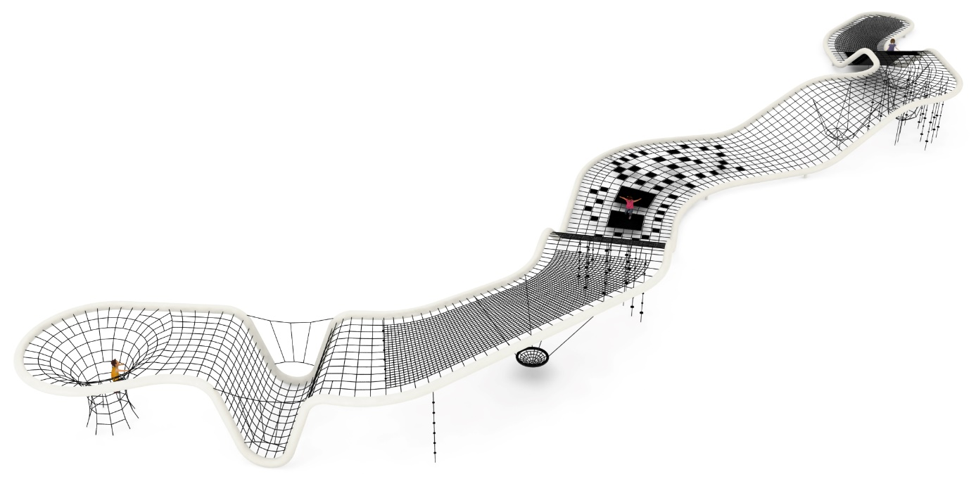
Cat. no.1406

Device dimensions:
Length: 51.1 m
Width: 12.8 m
Height: 2.8 m
Minimum space: 55.4 x 12.8 m
Age group: 5 to 14 years old
Free fall height: 2.8 m
Foundation depth: 1.0 m

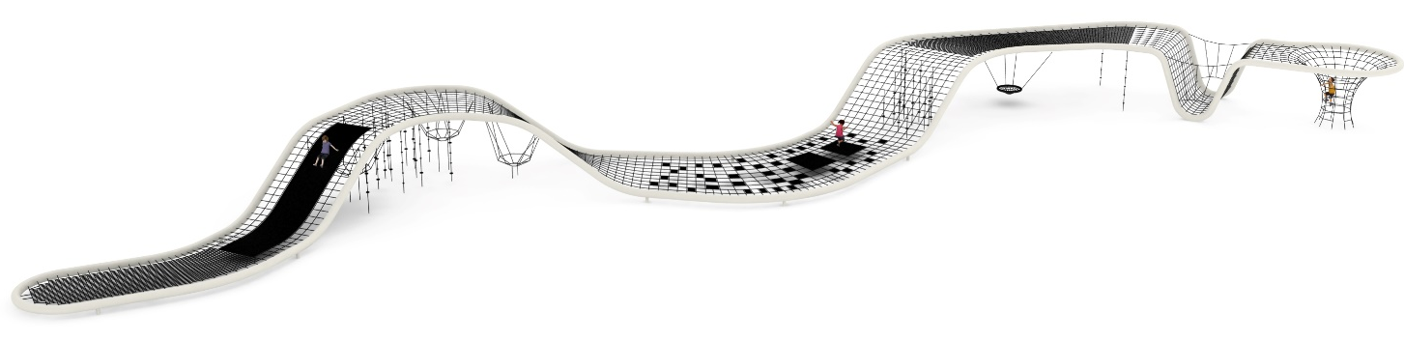

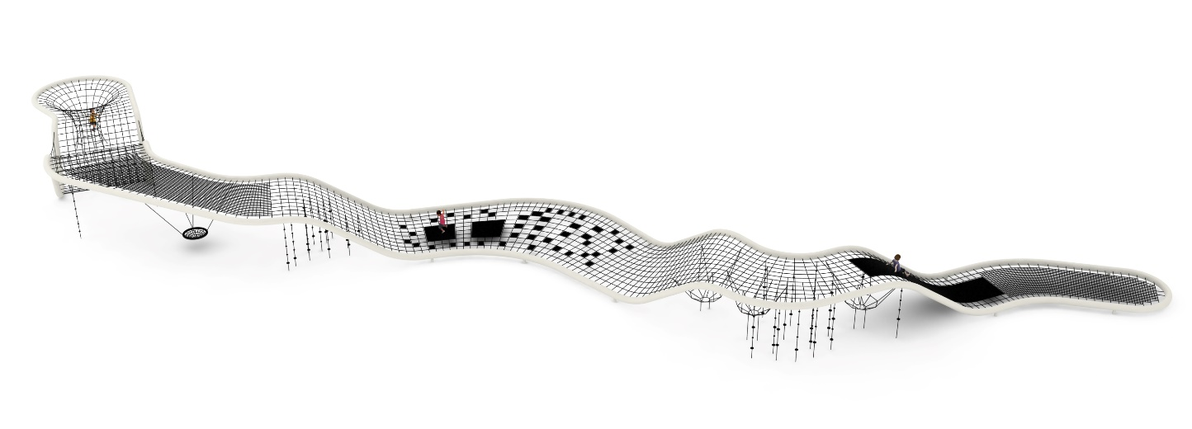

Guidelines for materials and technology of construction of the device.
The main structural element is a steel pipe with a diameter of 273 mm, which is protected against corrosion by hot-dip galvanizing and painting. The device is anchored in the ground with reinforced concrete feet. The nets are made of polyamide rope, braided, glued reinforced with galvanized steel strings. The diameter of the rope is 18 mm. The connectors used are made of polyamide. The press crimped elements are made of aluminum. Connection of ropes to the steel structure by : hot-dip galvanized shackle, stainless steel caoutchouc. The stork's nest seat used has a diameter of 1000 mm. The mats are made of 8 mm thick rubber reinforced with four layers of polyamide mesh. There are the following types of mats: one longitudinal , two trampoline and 42 small ones. An additional attraction is 28 climbing ropes equipped with two types of knots made of plastic: 41 with a diameter of 120 mm, 87 with a diameter of 70 mm. The average size of the mesh eye is 350 x 350 mm.
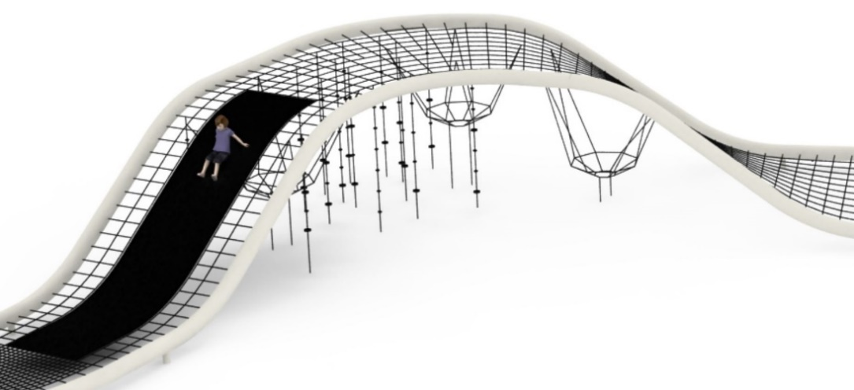

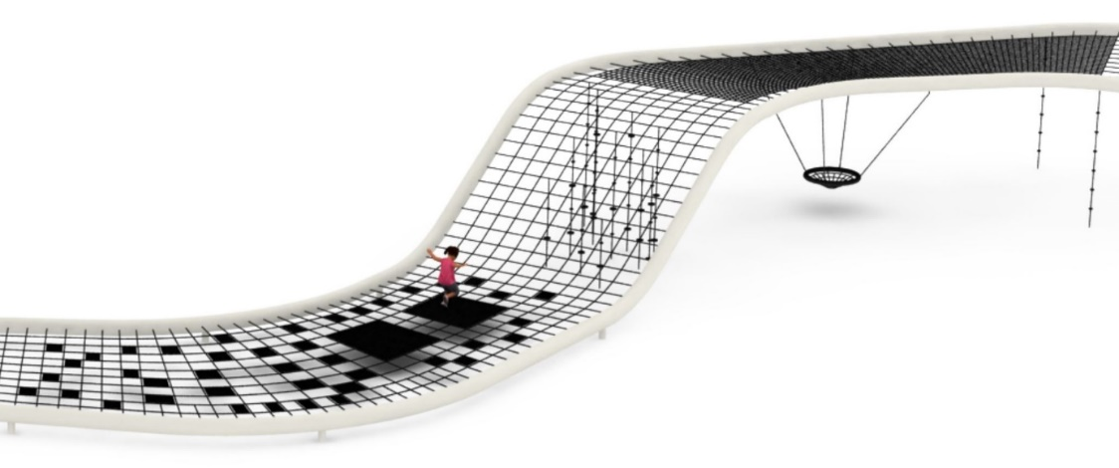

The fall area of the equipment should be made on a surface in accordance with PN EN 1176- 1:2017. The possibility of access by heavy construction equipment is required for the installation.
For the safety of children and the quality of the equipment, it is required that the equipment is certified in accordance with standards PN EN 1176-1:2017, PN EN 1176-3:2017, PN EN 1176-11:2014-11 issued by a system accredited by the National Accreditation Centre or the national accreditation body of the other Member States in accordance with Regulation (EC) No 765/2008 of the European Parliament and of the Council of the European Union."

