PRODUCT CARD LUPI
Cat. no. 1408

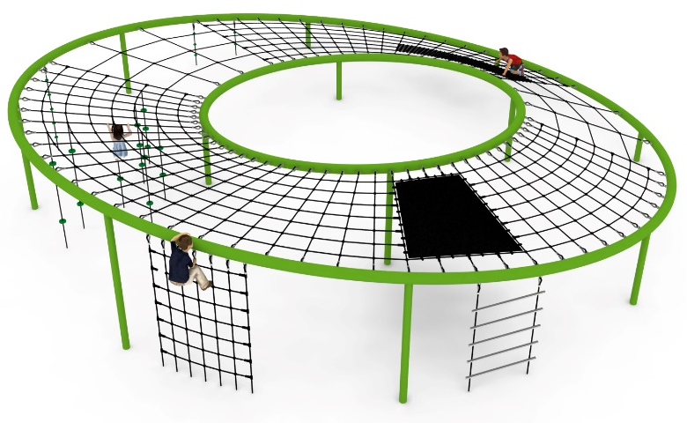

Device dimensions:
Length: 12.17 m
Width: 11.94 m
Height: 2.79 m
Minimum space: 15.8 x 15.43 m
Age group: 5 to 14 years old
Free fall height: 2.8 m
Foundation depth: 1.0 m
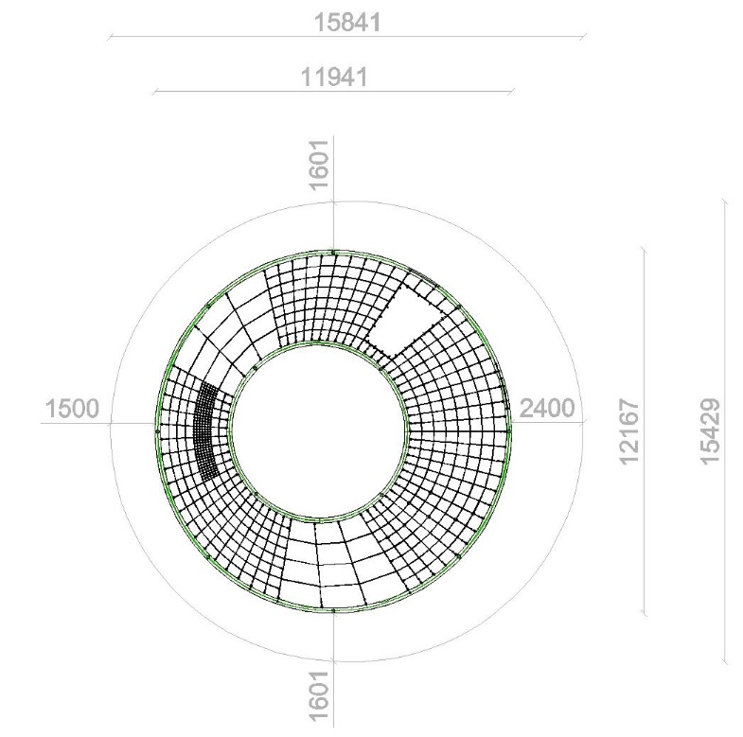

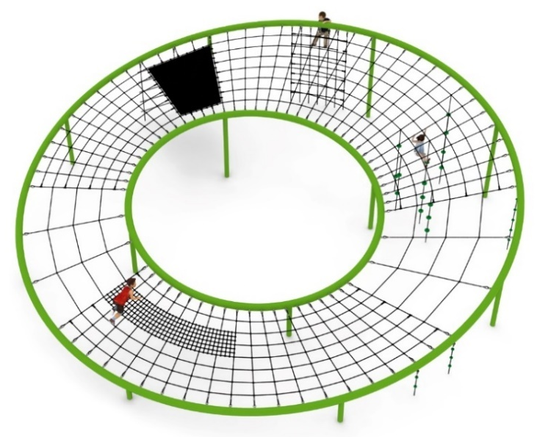

Guidelines for materials and technology of construction of the device.
The main structural elements are a 168.3 mm diameter circular steel pipe (S235 steel, 4 mm wall thickness) and a 114.3 mm steel pipe (S235 steel, 5 mm wall thickness), which are protected against corrosion by hot-dip galvanizing and painting. The device is anchored in the ground with reinforced concrete feet. The nets are made of polyamide rope, braided, glued reinforced with galvanized steel strings. The diameter of the rope is 18 mm. The connectors used are made of polyamide. The press crimped elements are made of aluminum. Connection of ropes to the steel structure by : hot-dip galvanized shackle, stainless steel caoutchouc. The mat is made of 8 mm thick rubber reinforced with four layers of polyamide mesh and measures 2.3 x 1.4 m.

An additional attraction is:
- 10 climbing ropes equipped with two types of knots: 4 with a diameter of 250 mm made of HDPE plastic, and 22 with a diameter of 70 mm made of polypropylene,
- vertical climbing net with dimensions of 2.6 x 1.5 m - the eye of the net is 325 x 260 mm,
- vertical ladder. Ladder rungs made of 0H18N9 stainless steel pipe with a diameter of 42.4 mm - number of rungs 5 pcs.
All ropes entering the ground are terminated with DIN 766 stainless steel chain, link diameter 6 mm.

The fall area of the equipment should be made on a surface in accordance with PN EN 1176- 1:2017. The possibility of access by heavy construction equipment is required for the installation.
For the safety of children and the quality of the equipment, it is required that the equipment is certified in accordance with standards PN EN 1176-1:2017, PN EN 1176-3:2017, PN EN 1176-11:2014-11 issued by a system accredited by the National Accreditation Centre or the national accreditation body of the other Member States in accordance with Regulation (EC) No 765/2008 of the European Parliament and of the Council of the European Union."

