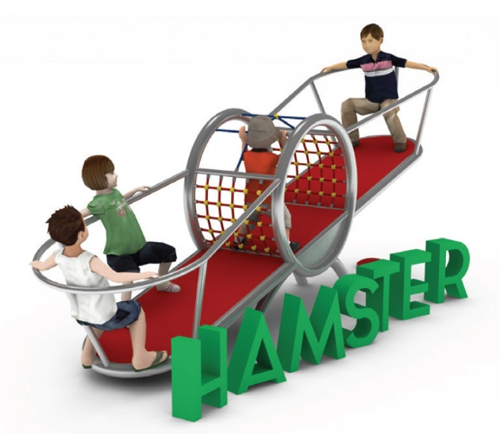
PRODUCT CARD HAMSTER
Cat. no. 610

Swing dimensions:
Length: 4.5m
Width: 1.2m
Height: 1.5m
Minimum space: 7.5 x 4.2m
Free fall height: 1,5 m
Foundation depth: 0.7m

Guidelines for materials and technology of construction of the device.
The HAMSTER swing consists of two steel circles bent from 88.9mm diameter tubes connected to each other by steel crossbars. Between the circles is suspended a rope net made of 18mm diameter polyamide ropes, braided, glued, reinforced with galvanised steel strings. The fittings are made of polyamide, aluminium and stainless steel. Attached to the steel circles are two platforms, the structure of which is made of bent steel pipes of diameter 88.9. The surface of the platform is a cast EPDM layer with a minimum thickness of 10mm. The platforms are equipped with a cover around the entire perimeter of the platform. The entire steel structure of the unit is made of 304 grade acid-resistant steel.

The fall area of the device should be made on a surface in accordance with EN 1176-1:2017.

