PRODUCT CARD TRICERATOPS
Cat. no. 1237

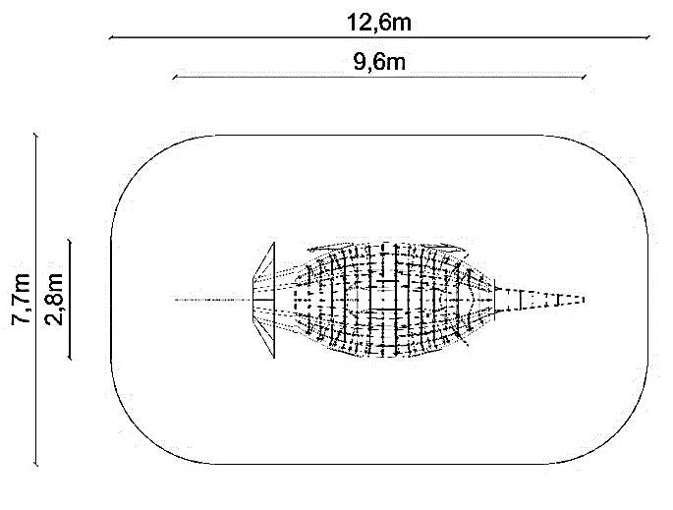

Device dimensions:
Length: 9.6 m
Width: 2.8 m
Height: 3.2 m
Minimum space: 12.6 x 7.7 m
Free fall height: max. 3.0 m
Depth of foundation: 1.0 m

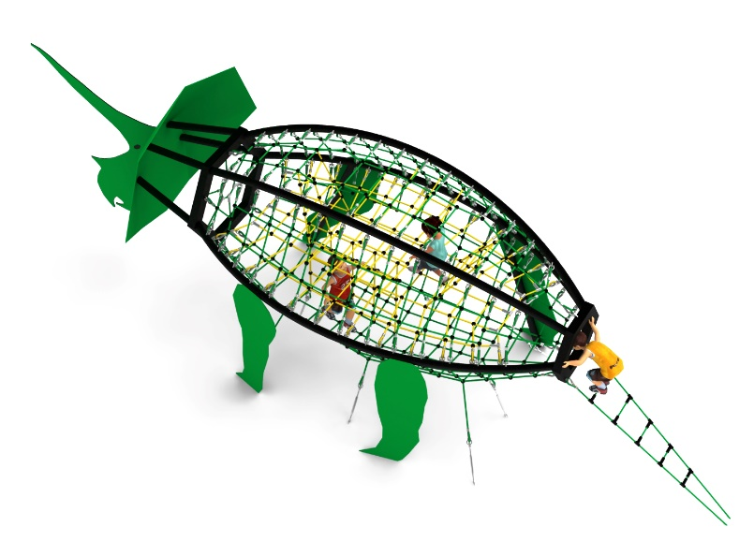

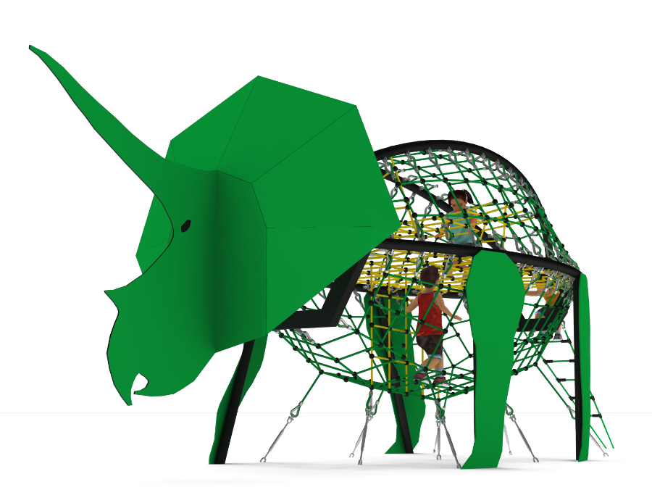

Guidelines for materials and technology of construction of the device.
The main structural elements are 88.9 mm diameter steel tubes, protected against corrosion by hot-dip galvanising and powder coating. The device is anchored in the ground through foundation footings, which are placed at a depth of 1.0 m. The footings are made of C25/30 concrete. The dinosaur's head is made of steel sheet. The legs are made of steel tube decorated with HPL panels for external use and 10 mm thick. The rope nets are made of polyamide rope, braided, glued reinforced with galvanised steel strings. The rope diameter is 18 mm. The elements connecting the ropes to each other are made of plastic, stainless steel and aluminium.

The fall area of the equipment should be made on a surface in accordance with PN EN 1176- 1:2017. The possibility of access by heavy construction equipment is required for the installation.
For the safety of children and the quality of the equipment, it is required that the equipment is certified in accordance with standards PN EN 1176-1:2017, PN EN 1176-3:2017, PN EN 1176-11:2014-11 issued by a system accredited by the National Accreditation Centre or the national accreditation body of the other Member States in accordance with Regulation (EC) No 765/2008 of the European Parliament and of the Council of the European Union."

