PRODUCT CARD STADIUM
Cat. no. 1236
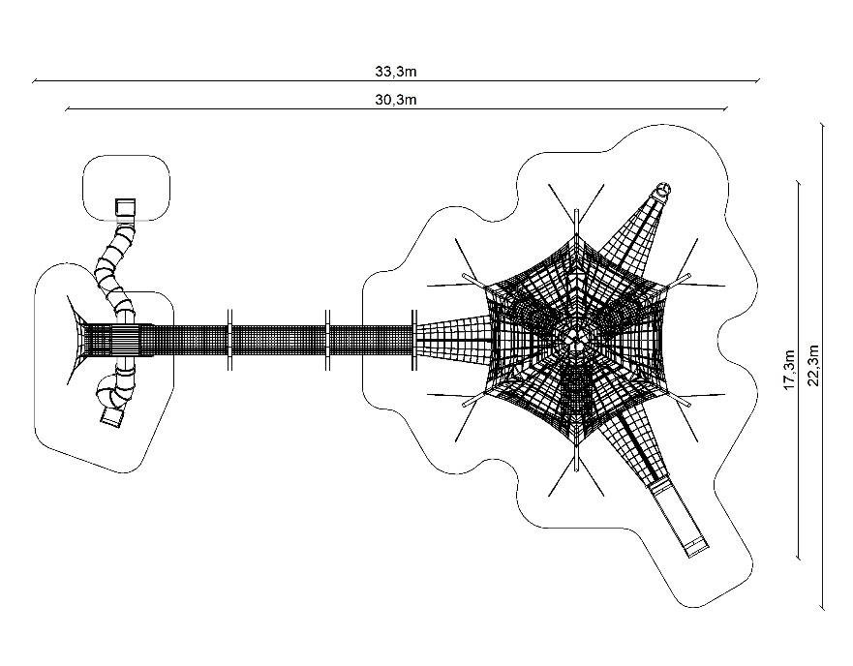
Device dimensions:
Length: 30.3 m
Width: 17.3 m
Height: 7.0 m
Minimum space: 33.3m x 22.3m
Age group: 5 to 14 years
Foundation depth: 1.0 m
Free fall height: 3.0 m
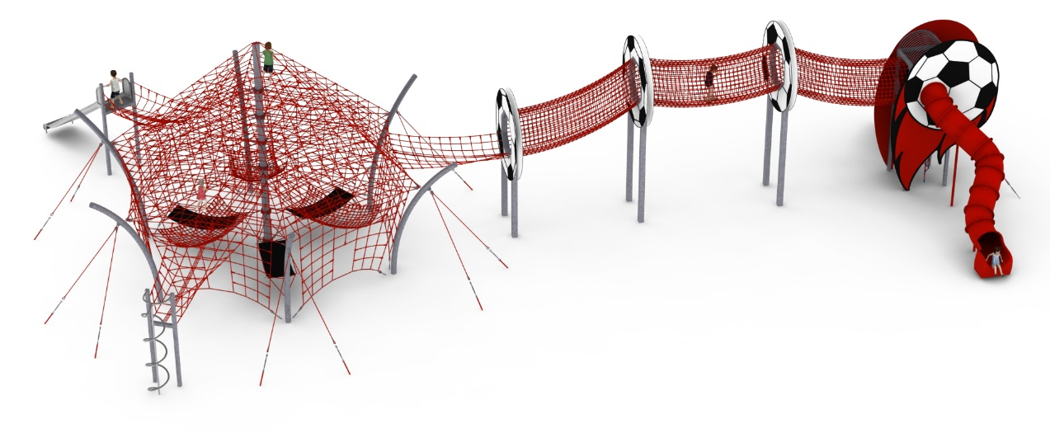

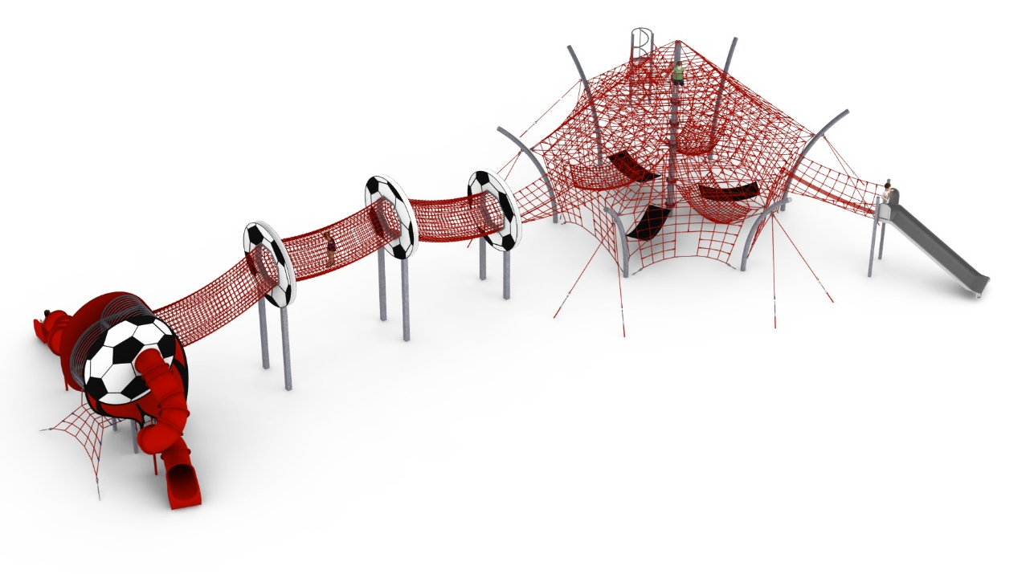

The configuration consists of:
- Device STADIUM cat. no. 426
- Addition FIREMAN PIPE cat. no. 426c
- Addition WIDE SLIDE cat. no. 426m
- Passage FOOTBALL TUNNEL
- Tower BALL WITH FIRE

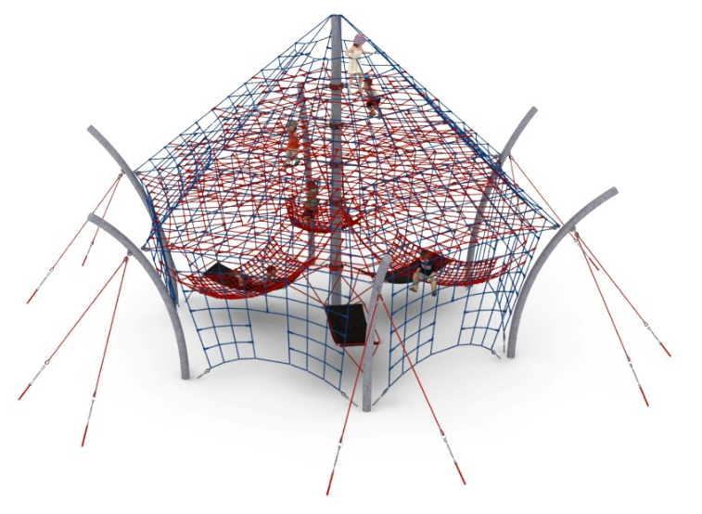
1. Device STADIUM cat. no. 426
Device dimensions:
Length: 14.3 m
Width: 13.7 m
Height: 7.0m
Minimum space: 17.3m x 16.6m
Age group: 5 to 14 years
Depth of foundation: 1.0m
Free fall height: 3.0 m

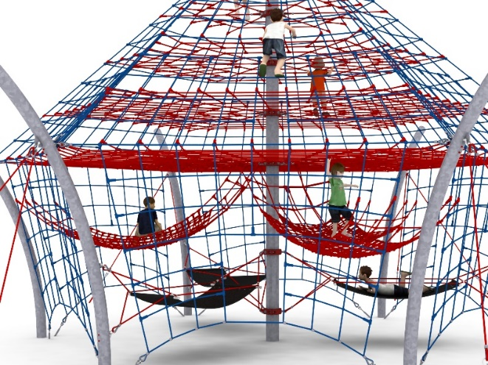
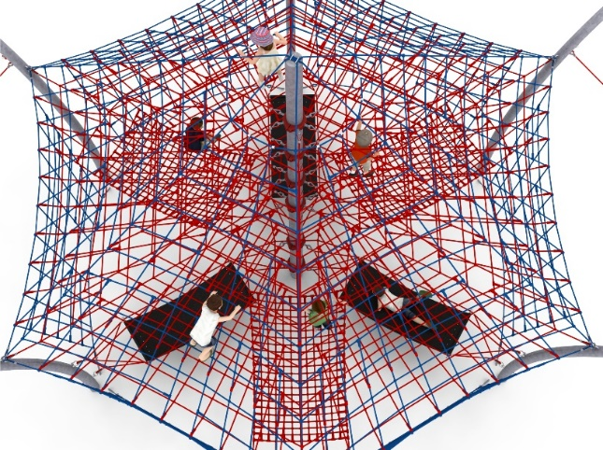

Device description.
The device consists of a 7-metre high mast seated in the centre and six curved steel arches seated around the perimeter of the device. A net consisting of six rope walls is stretched over the structure. An additional attraction are the horizontal rope planes at heights of 3.0m, 3.85m, 4.70m and 5.55m, as well as 6 hammocks suspended in the lower part of the device, which have a play and recreational function. 3 hammocks made of reinforced rubber, suspended at a height of 1m measuring 2m x 0.9m with access from the ground and 3 rope hammocks suspended at a height of 1.5m measuring 2.3m x 1.5m with access from the main rope network.

Guidelines for materials and technology of construction of the device.
The main structural element is a 219.1mm diameter steel column and 168.3 diameter side columns protected against corrosion by hot-dip galvanising. The foundations are made as reinforced concrete footings founded at a depth of 1 m. The rope structure is fixed to the steel posts by means of turnbuckles allowing the tension to be corrected. The net is made of polyamide rope, spliced, glued, reinforced with galvanised steel strings. Rope diameter is 18 mm. The elements connecting the ropes to each other are made of plastic and aluminium. The elements connecting the ropes to the pole are made of stainless steel and cast steel. The steel is protected against corrosion by being painted with chlorine rubber paint.

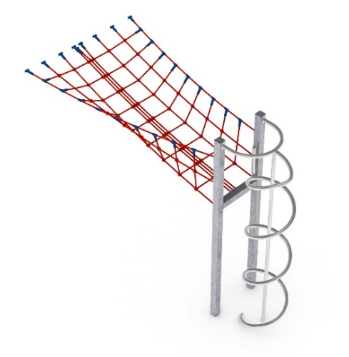
2. Addition FIREMAN PIPE cat. no. 426c

Device dimensions:
Length: 4.4 m
Width: 2.3 m
Height: 3.0 m
Minimum space area of the device + 17.0 m²
Age group: 5 to 14 years
Foundation depth: 1.0 m
Free fall height: 3.0 m

Guidelines for materials and technology of construction of the device.
The main element of the addition is a spiral fireman's tube made entirely of acid-resistant steel of grade 0H18N9. The diameter of the spiral is 0.65 m. The launching platform is located 2 m above ground level. The structural elements of the addition are made of 100x100 mm square tube, which are protected against corrosion by hot-dip galvanisation. The foundations are made as reinforced concrete footings founded at a depth of 1m. The passage connecting the slide to the stadium is U-shaped and made of polyamide rope, braided, glued reinforced with galvanised steel strings. The diameter of the rope is 18 mm. The elements connecting the ropes to each other are made of plastic and aluminium.

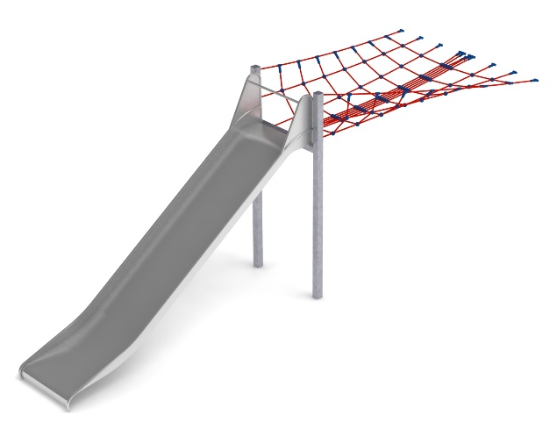
3. Addition WIDE SLIDE cat. no. 426m
Device dimensions:
Length: 7.7 m
Width: 2.4 m
Height: 3.25 m
Minimum space area of the device + 29.0 m²
Age group: 5 to 14 years
Foundation depth: 1.0 m
Free fall height: 3.0 m

Guidelines for materials and technology of construction of the device.
The main element of the addition is a slide made entirely of 0H18N9 grade acid-resistant steel. The start of the launching section is 2.25m above ground level. The width of the slide is 1m. The structural elements of the addition are made of 100x100 mm square tube, which are protected against corrosion by hot-dip galvanising. The foundations are made as reinforced concrete footings founded at a depth of 1m. The passage connecting the slide to the stadium is made of polyamide rope, braided, glued reinforced with galvanised steel strings. The diameter of the rope is 18 mm. The elements connecting the ropes to each other are made
of plastic and aluminium.

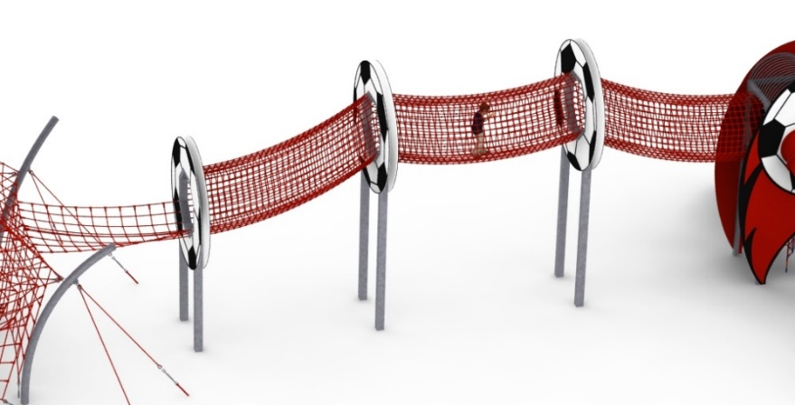
4. Passage FOOTBALL TUNNEL

Device dimensions:
Length: 16.1 m
Width: 2.8 m
Height: 5.9 m
Age group: 5 to 14 years
Foundation depth: 1.0 m
Free fall height: 3.0 m

Guidelines for materials and technology of construction of the device.
The main structural element is 160mm x 160mm hot-dip galvanised steel yecks. The yecks are encased on both sides with 10mm thick HPL imitating a football. Suspended from the posts, the rope walkway consists of: 2 tunnels 1.4m in diameter and 4m long, a tunnel 1.4m in diameter and 4.5m long and a passage from the STADIUM to the tunnels 3.4m long and 2.3m wide. The tunnels are made of dense netting to prevent users from moving around the outside of the facility. The foundations are made as reinforced concrete footings founded at a depth of 1m. The rope nets are made of polyamide rope, braided, glued reinforced with galvanised steel strings. The diameter of the rope is 18 mm. The elements connecting the ropes to each other are made of plastic and aluminium.

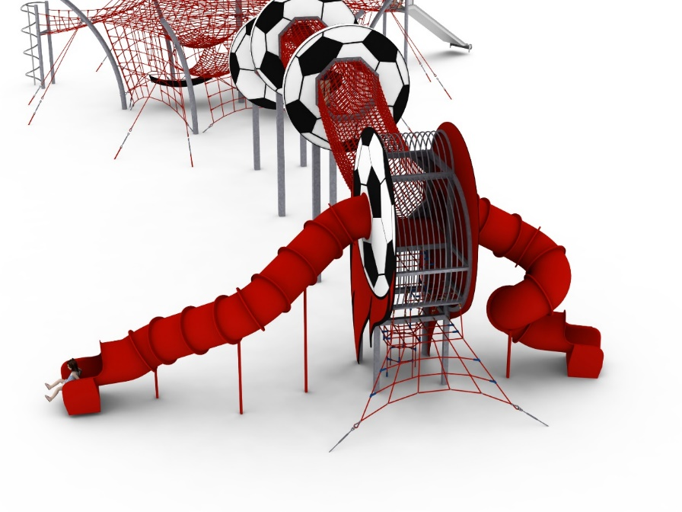
5. Tower BALL WITH FIRE
Device dimensions:
Length: 10.5 m
Width: 4.0 m
Height: 5.1 m
Age group: 5 to 14 years
Foundation depth: 1.0 m
Free fall height: 1.5 m

Guidelines for materials and technology of construction of the device.
The main structural elements of the tower are 100mm x 100mm steel yokes. At a height of 3m there is a platform made of HPL. There are 2 rope entrances to the platform located at the bottom of the unit. A third entrance to the platform is provided by a ball tunnel. The 2 opposite sides of the unit are decorated with 13mm-thick HPL panels imitating a football with a flame. Two tube slides, closed, made of polyethylene, take off from the tower platform. The remaining walls of the tower are covered by an openwork steel structure. All parts of the structure are protected against corrosion by hot-dip galvanising. The foundations are made as reinforced concrete footings founded at a depth of 1m. Rope nets made of polyamide rope, braided, glued reinforced with galvanised steel strings. Rope diameter is 18mm. The elements connecting the ropes to each other are made of plastic and aluminium.

The fall area of the equipment should be made on a surface in accordance with PN EN 1176- 1:2017. The possibility of access by heavy construction equipment is required for the installation.
For the safety of children and the quality of the equipment, it is required that the equipment is certified in accordance with standards PN EN 1176-1:2017, PN EN 1176-3:2017, PN EN 1176-11:2014-11 issued by a system accredited by the National Accreditation Centre or the national accreditation body of the other Member States in accordance with Regulation (EC) No 765/2008 of the European Parliament and of the Council of the European Union."

