PRODUCT CARD SPIDER
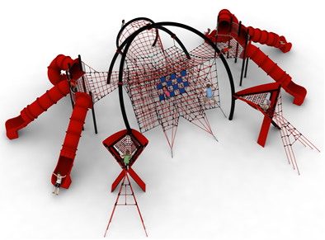
Cat. no. 1226
Device dimensions:  Length: 16.7m  Width: 20.5m  Height: 4.1m  Minimum space: 19.4m x 24.6m  Age group: 5 to 14 years  Depth of foundation: 1.0 m  Free fall height: up to 3 m | 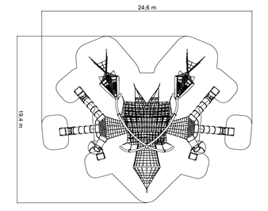

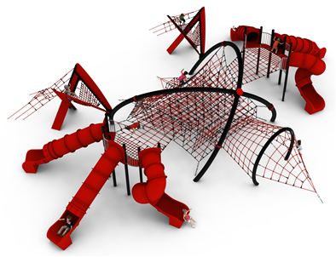

Guidelines for materials and technology of construction of the device.
SPIDER is a device with a spider-like appearance.

SPIDER device consists of:
- a main steel structure in the shape of a sloping dome, inside which an irregularly shaped spatial net is suspended. The eyes of the net are shaped like cuboids. On the front wall of the web in twelve fields, blue rubber plates are attached, imitating the eyes of a spider. In addition, two rope nets in the shape of pyramids, imitating spider's fangs, are attached to the front wall of the net. The nets are tensioned by hot-dip galvanised turnbuckles anchored in the ground,
- two steel structures on the sides of the main structure, each providing a platform structure made of HPL panels at least 12mm thick and a support structure for three tubular slides - two straight and one curved, imitating the side legs of a spider. The slides are made of polyethylene. The platform height for the slides is 2.2m. The side structures are connected to the main structure network by horizontal flat grids. The platforms, apart from the points of entry of the slides and the entrance to the horizontal net, are surrounded by barriers made of acid-resistant steel,
- two steel structures imitating the front legs of a spider, in the shape of an X. The steel structure is clad on the outside with HPL panels at least 12mm thick. Inside the structure is suspended a seat made of dense rope web with an eye no larger than 130x130mm. The seat is accessed by an X-shaped rope entrance fixed to the steel leg structure on one side and anchored to the ground on the other,
- a rear steel structure imitating an arch-shaped abdomen 2.5m high, to which a rope net is attached on both sides, one side leading to the net on the main structure, the other tightened by means of a hot-dip galvanised turnbuckle anchored in the ground.

The steel structure made of black steel is protected against corrosion by hot-dip galvanising and powder coating. The rope elements are made of polyamide, braided, bonded ropes with a diameter of 18mm, connected with fittings made of aluminium, stainless steel and plastic. The connection of the rope net to the clamps is provided by stainless steel eyebolts. The tension on the cable section is provided by hot-dip galvanised turnbuckles. The foundation of the steel structure is made as reinforced concrete footings.

The fall area of the equipment should be made on a surface in accordance with PN EN 1176- 1:2017. The possibility of access by heavy construction equipment is required for the installation.

For the safety of children and the quality of the equipment, it is required that the equipment is certified in accordance with standards PN EN 1176-1:2017, PN EN 1176-3:2017, PN EN 1176-11:2014-11 issued by a system accredited by the National Accreditation Centre or the national accreditation body of the other Member States in accordance with Regulation (EC) No 765/2008 of the European Parliament and of the Council of the European Union."

