PRODUCT CARD LINARIUM BLACHARSKA
Cat. no. 1223

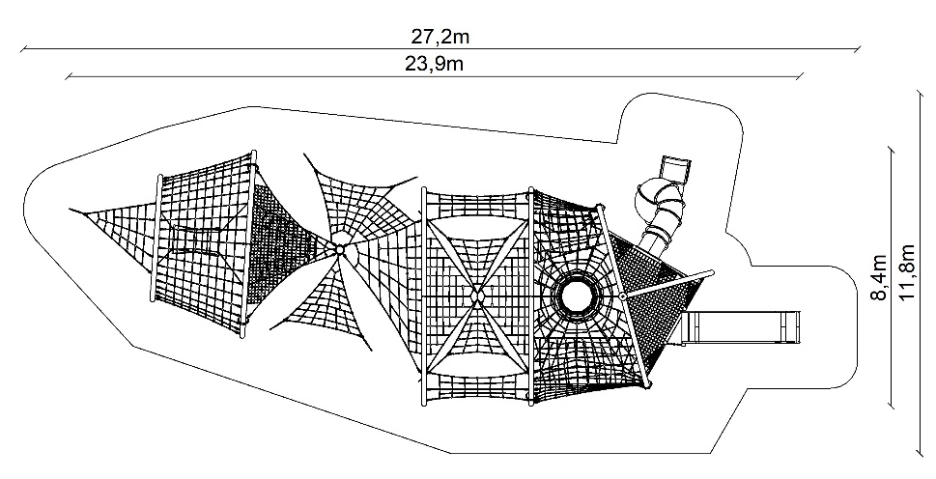
Device dimensions:
Length: 23.9 m
Width: 8.4 m
Height: 4.2 m
Minimum space: 27.2 x 11.8 m
Age group: 5 to 14 years
Free fall height: 3.0 m
Foundation depth: 1.0 m

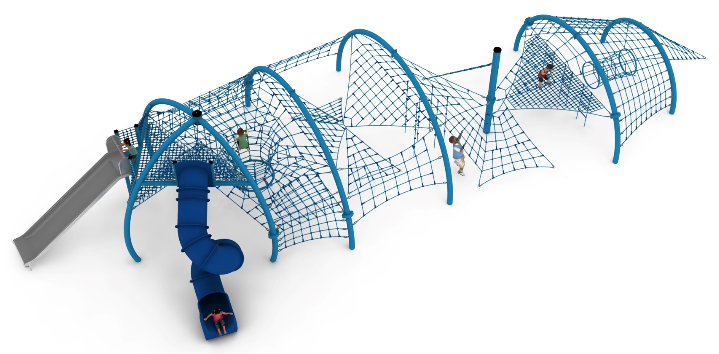

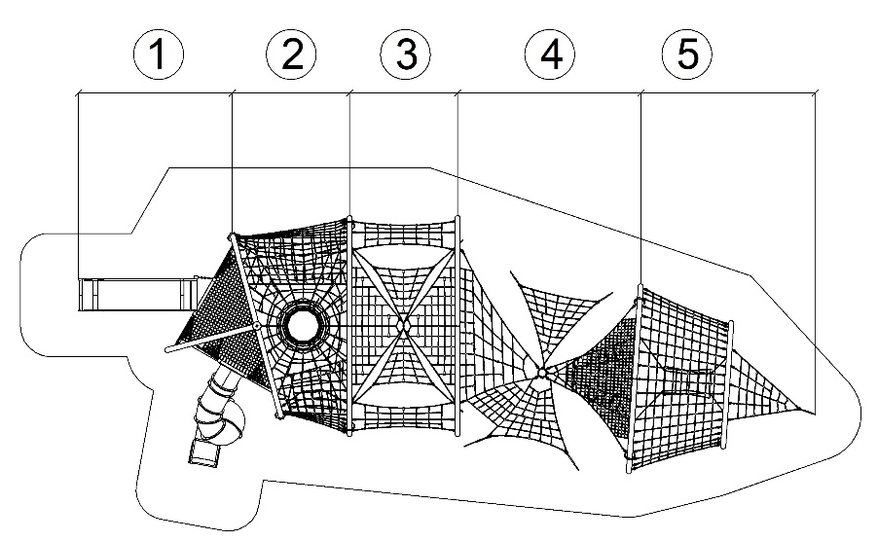
Guidelines for materials and technology of construction of the device.
The main structural elements are steel arches made of 168.3mm diameter pipe and substructures made of 100 x 100mm square pipe. The arches are fixed in the ground with reinforced concrete footings. The structure is protected against corrosion by hot-dip galvanising and powder coating. A cable jacket is attached to the steel structure, which consists of five sections.

SECTION 1
Section 1 consists of 9 nets:
1. Two triangular, close-meshed platform nets (mesh size less than 120 x 120mm) installed at a height of 2.2 and 3.0m, which are the launching sections for the slides.
2. A cable grating installed between the platform nets to enable communication between the nets. 3. a cable grating underneath the platform nets to enable communication between the nets.
3. A cable grating suspended from the steel arch dividing the sections, which allows access from section 2 to the platform grid of the tube slide.
4. Five vertical dense mesh nets (mesh smaller than 120 x 120mm) installed on the sides of the slides. The nets act are barriers to prevent falls.
The main attraction of the first section are two slides:
- slide with a width of 1m and a starting section at a height of 2.2m, made entirely of 0H18N9 grade stainless steel.
- closed tube slide with a full loop with a starting section at a height of 3.0m. Slide made of polyethylene.

SECTION 2
The second section consists of four nets:
1. The main net in the form of a flat, horizontal rope truss passing into a shaft extending to "level 0". The tension of the net is adjusted by hot-dip galvanised turnbuckles.
2. Two rectangular rope trusses stretched between the steel arches and the main net. The trusses allow access to the main net from level "0".
3. A horizontal floor at a height of 1.4m stretched between the steel arches and the cable shaft.

SECTION 3
The third section consists of:
1. A main net made up of four triangular grids installed in different planes. The meshes are connected by one of the vertices. Adjustment of the tension of the net is made possible by hot-dip galvanised turnbuckles.
2. Two rope trusses with approximate dimensions of 3.2 x 1.7m installed between the steel arches, on both sides of the unit.
SECTION 4
Section four consists of nine elements:
1. Three triangular nets installed between the steel arch of section three and the central column. The meshes are installed in different planes and are connected by one of the sides. Sparse mesh nets (smaller than 420 x 420mm).
2. An independent, triangular net stretched between the top of the central post and the ground with a sparse mesh (smaller than 420 x 420mm).
3. An independent triangular mesh stretched between the middle post and the steel arch of section 5 with sparse mesh (smaller than 420 x 420mm).
4. An independent triangular net stretched between the centre post and the steel arch of section 5 with a dense mesh (smaller than 120 x 120mm).
5. Three 1.5m long rope ladders suspended from the dense mesh triangular net.

SECTION 5
The section consists of 3 elements:
1. A mesh installed between steel arches, surrounding the entire section 5.
2. A suspended rope tunnel with a diameter of 0.9-0.75m and a length of 1.5m.
3. A triangular net at the end of the device installed between the steel arch of section five and the ground. The tension of the net is adjusted by a hot-dip galvanised turnbuckle.

Rope sheathing technology.
Adjustment of the tension of the device is made possible by hot-dip galvanised turnbuckles. The nets are made of polyamide rope, braided, glued reinforced with galvanised steel strings. Rope diameter is 18 mm. The elements connecting the ropes to each other are made of plastic and aluminium. Elements connecting the ropes to the pole are made of stainless steel and cast steel painted with chlorine rubber.

The fall area of the equipment should be made on a surface in accordance with PN EN 1176- 1:2017. The possibility of access by heavy construction equipment is required for the installation.
For the safety of children and the quality of the equipment, it is required that the equipment is certified in accordance with standards PN EN 1176-1:2017, PN EN 1176-3:2017, PN EN 1176-11:2014-11 issued by a system accredited by the National Accreditation Centre or the national accreditation body of the other Member States in accordance with Regulation (EC) No 765/2008 of the European Parliament and of the Council of the European Union."

