PRODUCT CARD DRAGON
Cat. no. 1231

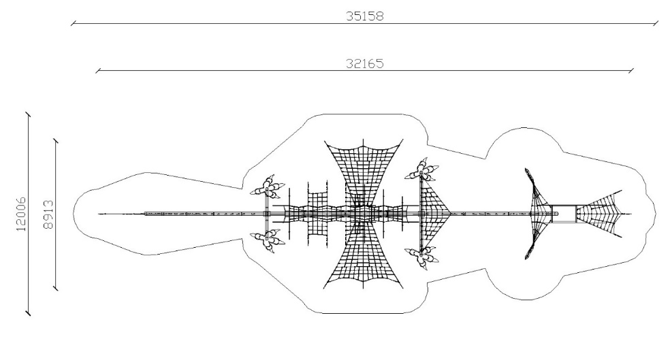

Device dimensions:
Length: 32.2 m
Width: 9.0 m
Height: 4.5 m
Minimum space: 35.2 x 12.0 m
Free fall height: max. 3.0 m
Depth of foundation: 0.8 m

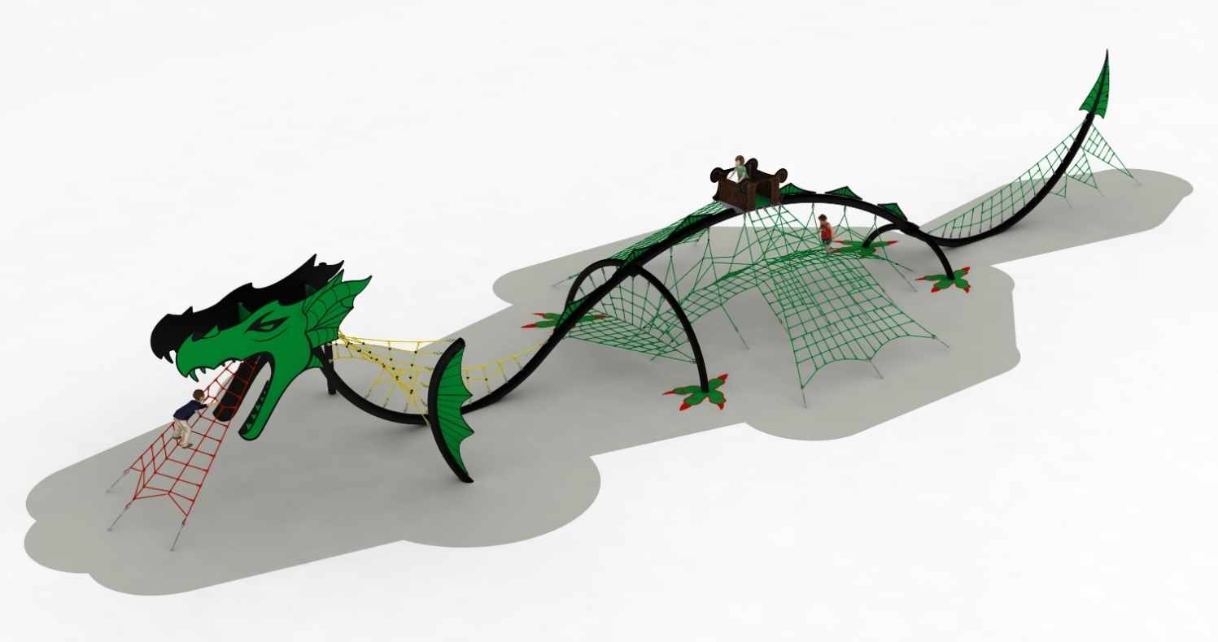

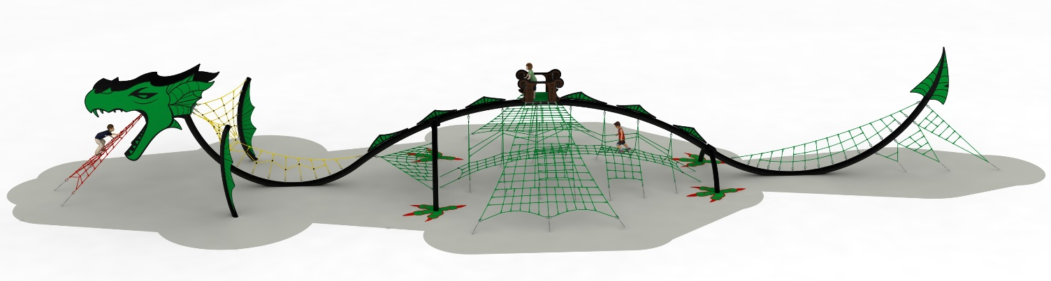

Guidelines for materials and technology of construction of the device.
The main structural elements are steel pipes with a diameter of 219 mm (spine) and 168.3 mm (limbs), which are protected against corrosion by hot-dip galvanising and powder coating. The device is anchored in the ground through foundation footings, which are placed at a depth of 0.8 m. The footings are made of C25/30 concrete. The rope nets are made of polyamide rope, braided, bonded and reinforced with galvanised steel strings. The rope diameter is 18 mm. Quantity of rope used 550 m. Rope connecting elements are made of plastic, stainless steel and aluminium. The decorations are made of HPL board with external application and a thickness of 10 mm.

NOTE: footings are only made when implemented together with a poured synthetic surface.

The fall area of the equipment should be made on a surface in accordance with PN EN 1176- 1:2017. The possibility of access by heavy construction equipment is required for the installation.
For the safety of children and the quality of the equipment, it is required that the equipment is certified in accordance with standards PN EN 1176-1:2017, PN EN 1176-3:2017, PN EN 1176-11:2014-11 issued by a system accredited by the National Accreditation Centre or the national accreditation body of the other Member States in accordance with Regulation (EC) No 765/2008 of the European Parliament and of the Council of the European Union."

