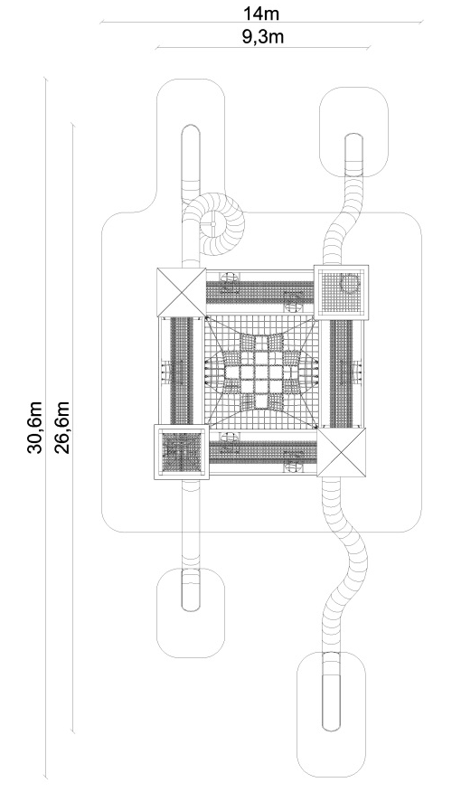
PRODUCT CARD CASTLE
Cat. no. 1228

Device dimensions:
Length: 26.6 m
Width: 9.3 m
Height: 8.3 m
Minimum space: 30.6m x 14m
Age group: 5 to 14 years
Free fall height: 3.0 m
Depth of foundation: 1.0 m

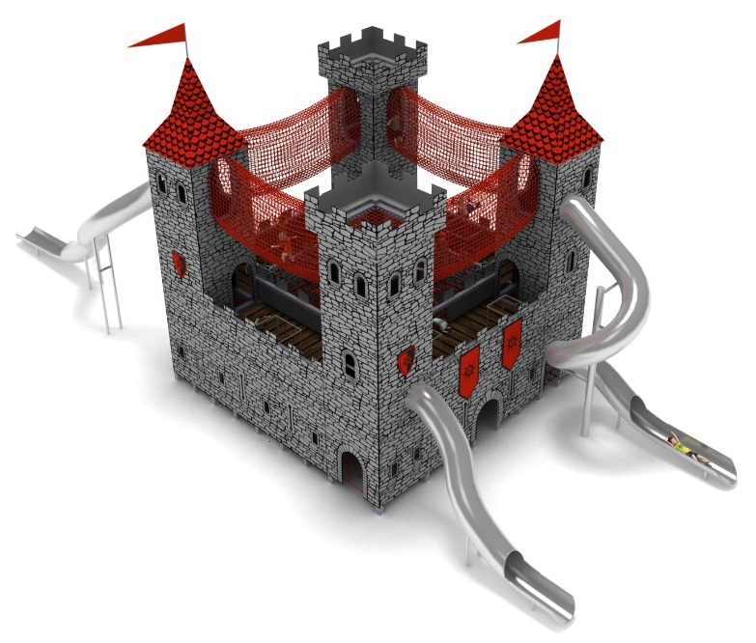
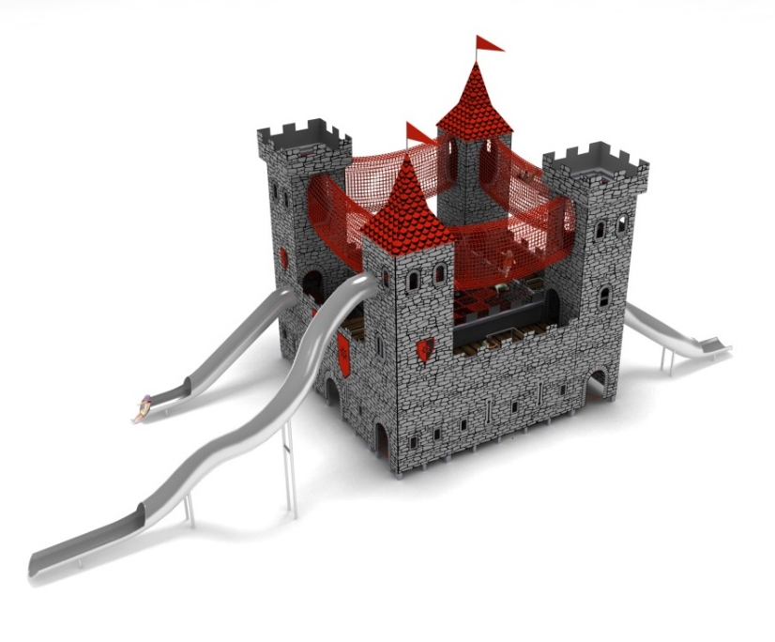
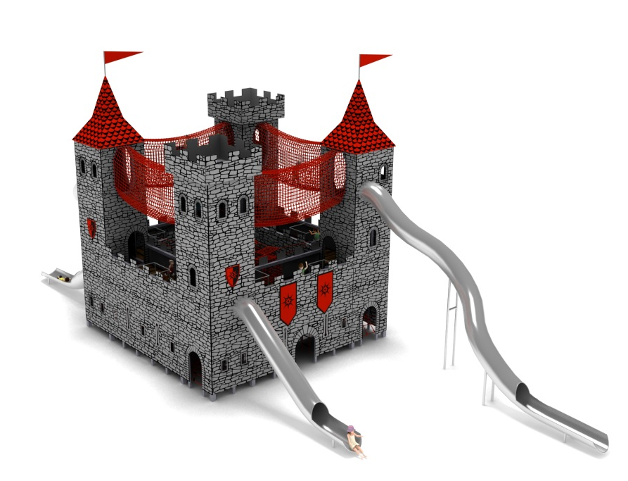

Device description.
A device reminiscent of a medieval castle. The whole device is kept in the red-grey-black colour scheme.

Guidelines for materials and technology of construction of the device.
The main structural element is 4 steel towers made of 160mm x 160mm square tube. The structure is clad with 12mm thick HPL panels imitating respectively: natural stone on the walls, tile on the roofs and wooden floor on the platforms. The unit is founded in the ground with reinforced concrete footings. Structure protected against corrosion by hot-dip galvanising. Various types of nets and walkways are attached to the steel structure to allow users to communicate and play.

The device consists of:
1. Tower with slide with curves with starting section at 3m.
The interior of the tower consists of an entrance rope net leading to the first level of play and horizontal rubber mats providing the entrance to the 2nd level.

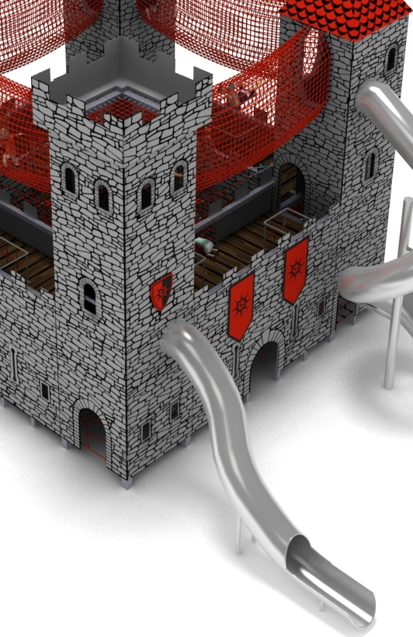
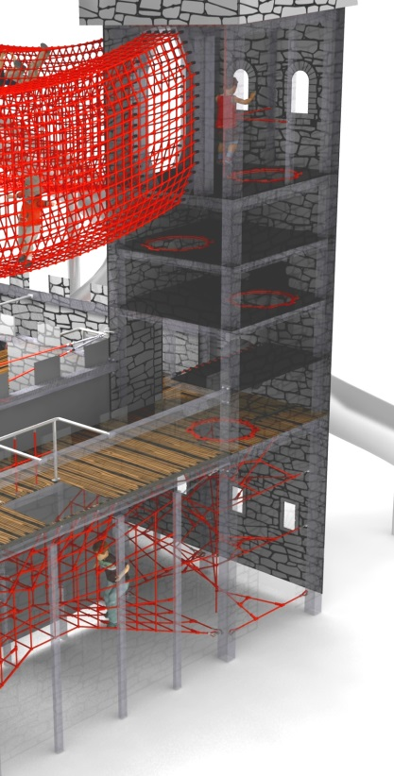

2. Tower with a slide with loop with a starting section at 6.2m.
The interior of the tower consists of a network leading from level zero to level 2 of play. It is formed by a spiral entrance around the axis of the tower.

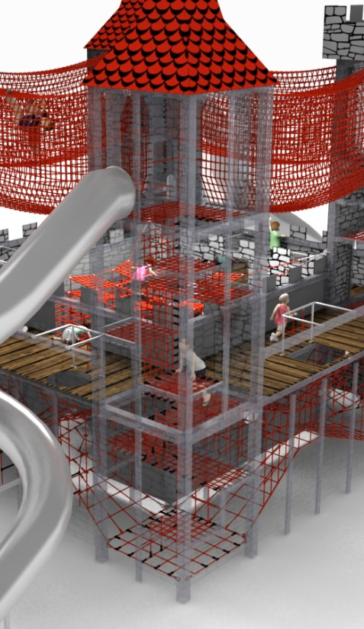
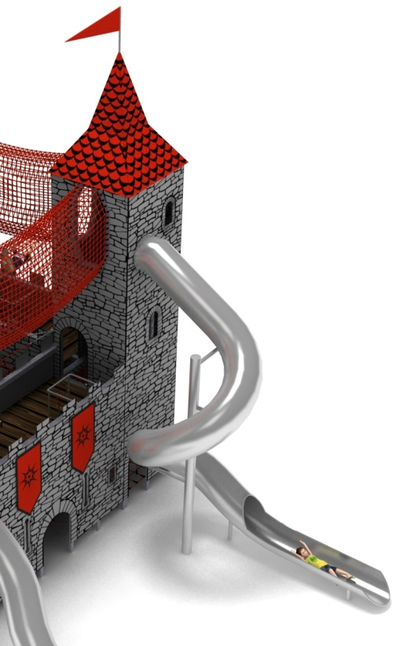

3. Tower with straight slide with starting section at 3m.
The interior of the tower consists of an entrance rope net leading to the first level of play and horizontal rope platforms providing access to the 2nd level.
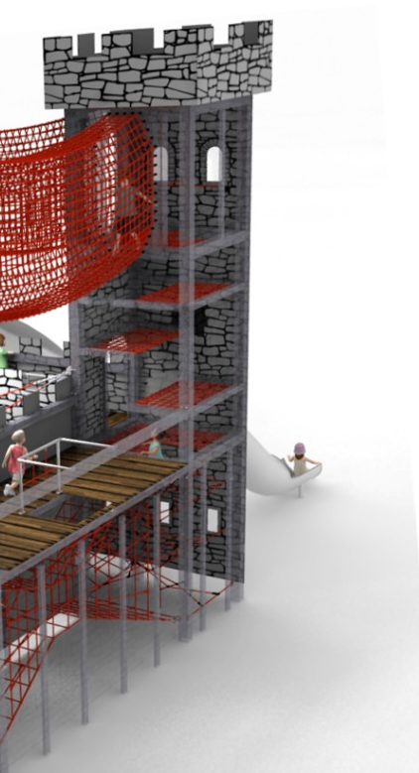
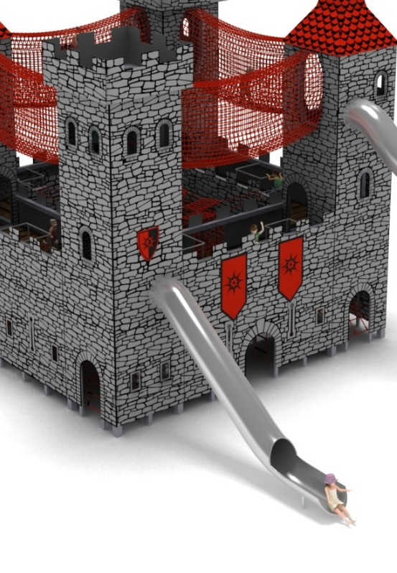

4. Tower with slide with curves with starting section at 6.2m.
The interior of the tower consists of an hourglass-shaped entrance grid leading to the first level of play and a spiral net designed around the axis of the tower leading to the 2nd level of play.
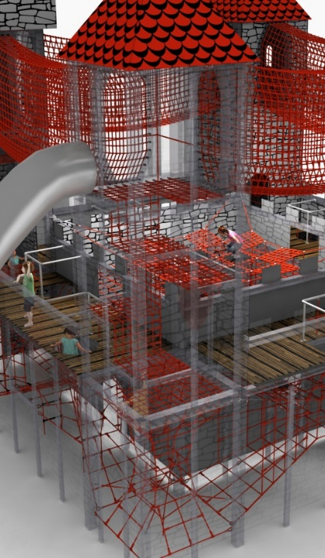
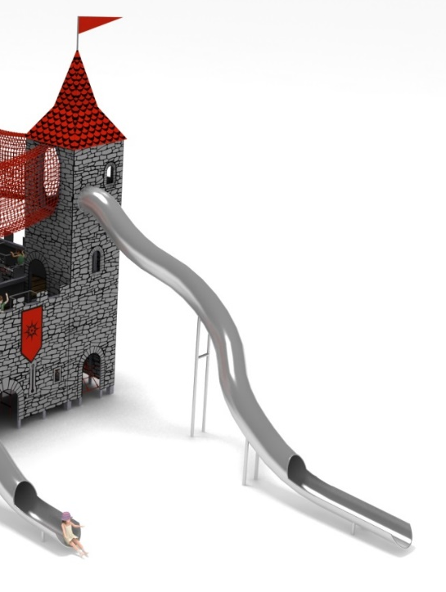

5. Two rope passages between the towers in the shape of a horizontal hourglass to allow communication between the towers, passage to the central net and access to first level of play.
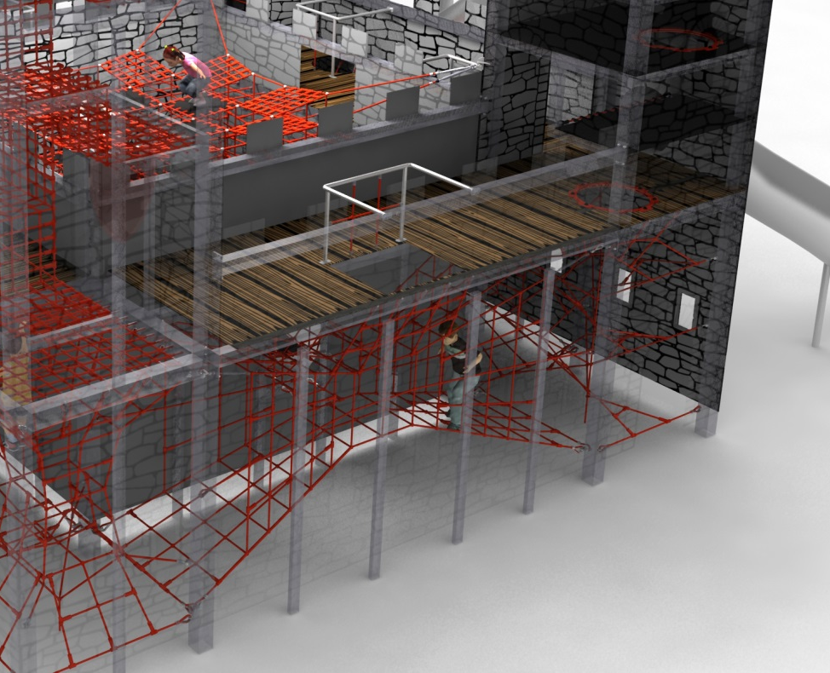

6. Two rope passages between the towers constructed of 8 rope triangles to allow communication between the towers and access to first level of play.
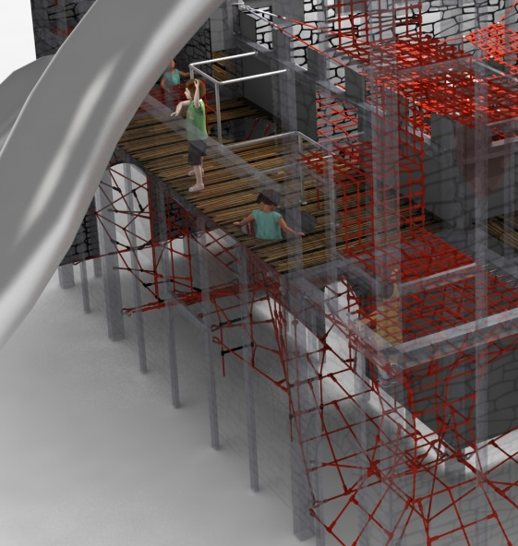

7. The central net, which consists of 84 cubes and horizontal nets to communicate with the passages between the towers. The walls of the cubes are alternately filled with rope nets or rubber mats, creating an infinite combination of passages within the network.
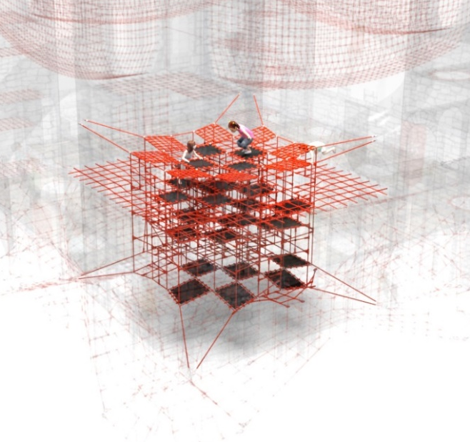
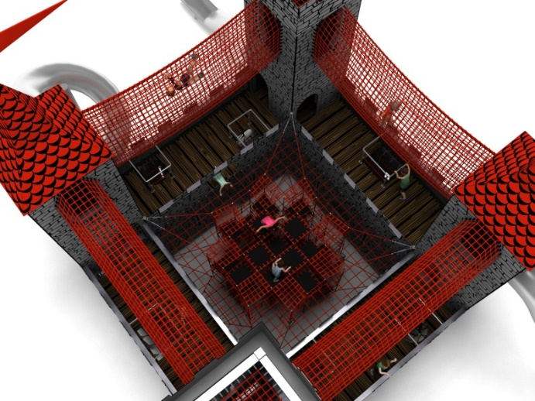

8. Four rope tunnels suspended 8.1m high, 1.9m x 0.9m and 5m long.
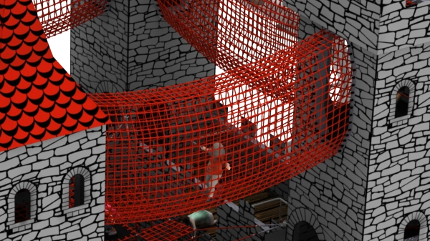

Adjustment of the tension of the device is made possible by hot-dip galvanised turnbuckles. The nets are made of polyamide rope, braided, glued reinforced with galvanised steel strings. Rope diameter is 18 mm. The elements connecting the ropes to each other are made of plastic and aluminium. Elements connecting the ropes to the pole are made of stainless steel or hot-dip galvanised steel. Decorative elements made of HPL board. Used 8mm thick rubber mats reinforced with 4 layers of plastic mesh. Slides entirely made of stainless steel. Slide tube made of 2.5mm sheet. Internal tube diameter 78cm.

The fall area of the equipment should be made on a surface in accordance with PN EN 1176- 1:2017. The possibility of access by heavy construction equipment is required for the installation.
For the safety of children and the quality of the equipment, it is required that the equipment is certified in accordance with standards PN EN 1176-1:2017, PN EN 1176-3:2017, PN EN 1176-11:2014-11 issued by a system accredited by the National Accreditation Centre or the national accreditation body of the other Member States in accordance with Regulation (EC) No 765/2008 of the European Parliament and of the Council of the European Union."
członkowskich, zgodnie z Rozporządzeniem Parlamentu Europejskiego i Rady Unii Europejskiej (WE) nr 765/2008”.

