PRODUCT CARD APPLE
Cat. no. 1229

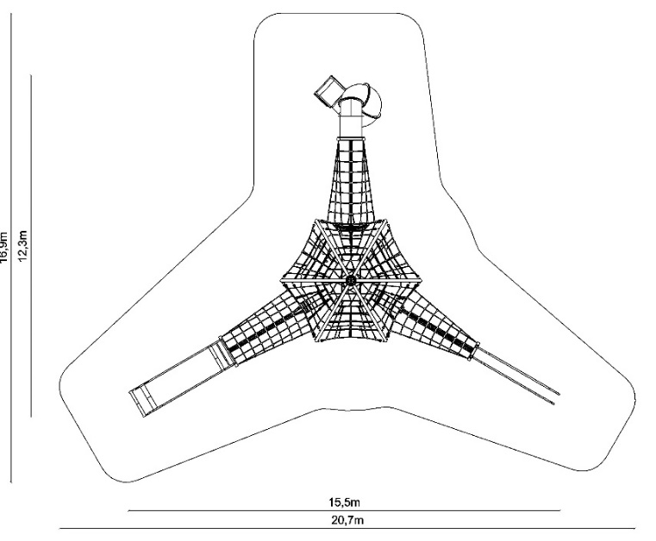

Device dimensions:
Length: 15.5 m
Width: 12.3 m
Height: m
Minimum space: 20.7 m x 16.9 m
Age group: 5 to 14 years
Foundation depth: 1.0 m
Free fall height: 3.0 m
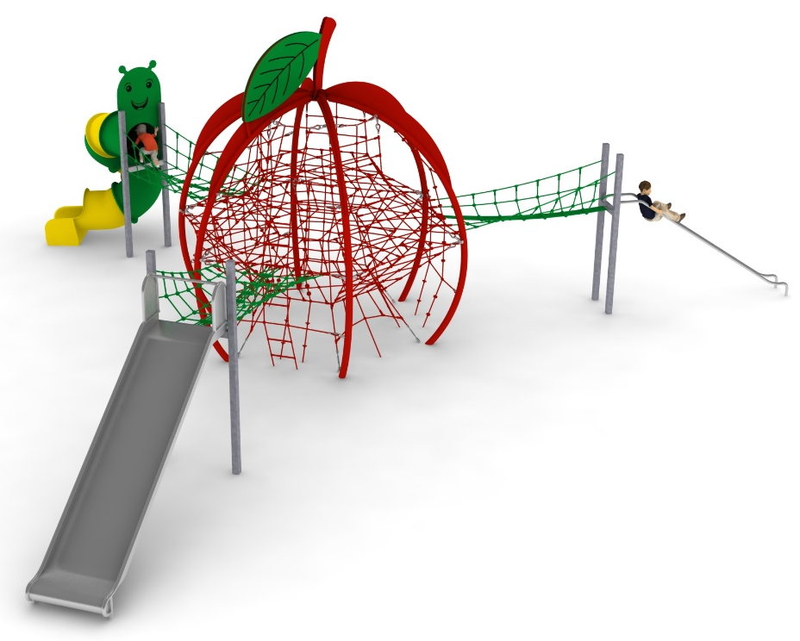

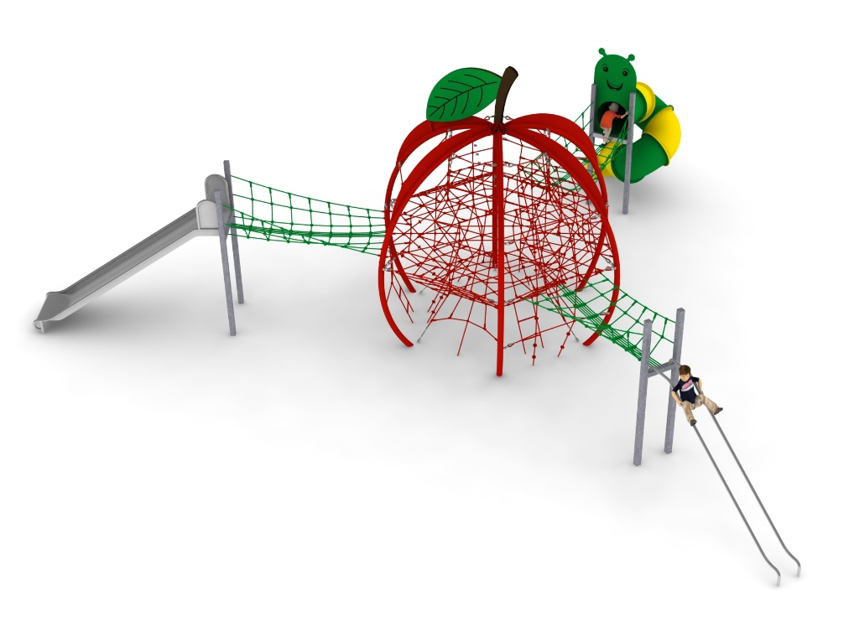

Device description.
A device resembling an apple fruit. The device is kept in red and green colours. Additional decorative elements are made of HPL board with an external application and a thickness of 10mm.

The device consists of the following devices:
- Device TEMISTO cat. no. 414,
- Addition PIPE SLIDE cat. no. 414b,
- Addition TUBE SLIDE cat. no. 414i,
- Addition WIDE SLIDE cat. no. 414m.

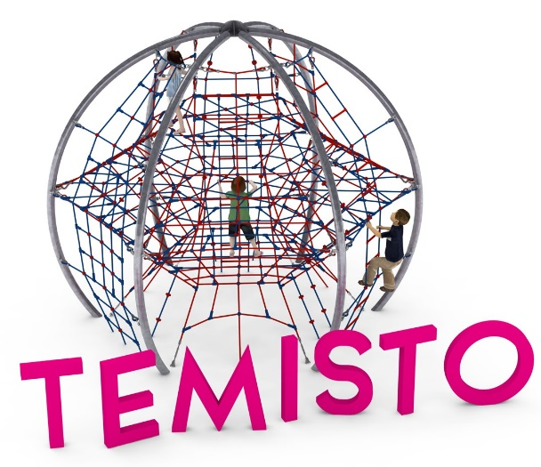
1. Device TEMISTO cat. no. 414

Device dimensions:
Length: 5.1 m
Width: 4.4 m
Height: 4.3m
Minimum space: Ø 9.1m
Age group: 5 to 14 years
Foundation depth: 1.0 m
Free fall height: 3.0 m

Guidelines for materials and technology of construction of the device.
The TEMISTO is a spherical device with a diameter of 5.1m and a height of 4.4m. The structure is formed by six steel arches, with a bending radius of R=2500mm, made of 108mm diameter tubes and anchored in the ground with reinforced concrete feet. The structure is protected against corrosion by hot-dip galvanising and powder coating. The steel structure is spanned by three levels of rope nets placed at heights of 1, 2 and 3m above ground level. Each of the six side walls is built up with rope walls that cause the rope structure to take on a quasi-ball shape. Tension adjustments are made possible by turnbuckles, which are protected against corrosion by hot-dip galvanising. The net is made of polyamide rope, braided, glued reinforced with galvanised steel strings. The rope diameter is 18 mm. The elements connecting the ropes to each other are made of plastic and aluminium.

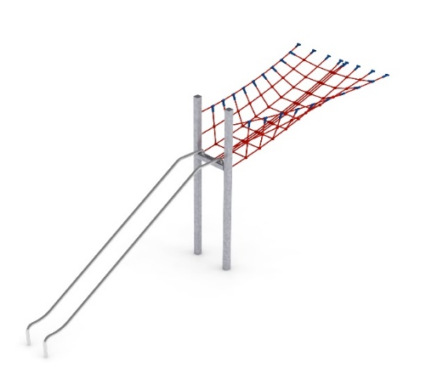
2. Addition PIPE SLIDE cat. no. 414b

Device dimensions:
Length: 6.5 m
Width: 1.7 m
Height: 3.0 m
Minimum space: TEMISTO space + 32.7 m²
Age group: 5 to 14 years
Foundation depth: 1.0 m
Free fall height: 2.0 m

Guidelines for materials and technology of construction of the device.
The main element of the add-on is a tubular slide made entirely of 0H18N9 grade acid-resistant steel. The tube slide is formed by two curved tubes with a diameter of 42.4 mm. The beginning of the starting section is 2 m above ground level. The structural elements of the addition are made of 100x100 mm square tube, which are protected against corrosion by hot-dip galvanisation. The foundations are made as reinforced concrete footings founded at a depth of 1m. The passage connecting the slide to the pyramid is V-shaped and made of polyamide rope, braided, glued reinforced with galvanised steel strings. The rope diameter is 18 mm. The elements connecting the ropes to each other are made of plastic, stainless steel and aluminium.

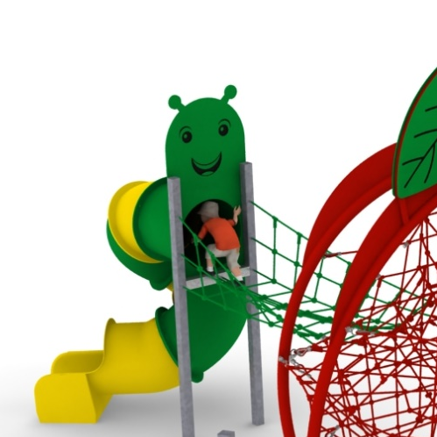
3. Addition TUBE SLIDE cat. no. 414i
Device dimensions:
Length: 5.3 m
Width: 2.5 m
Height: 3.0 m
Minimum space: TEMISTO+ space 33.8 m²
Age group: 5 to 14 years
Foundation depth: 1.0 m
Free fall height: 2.0 m

Guidelines for materials and technology of construction of the device.
The main element of the addition is a spiral tube slide made of polyethylene. The start of the starting section is 2.15 m above ground level. The structural elements of the addition are made of 100x100 mm square tube, which are protected against corrosion by hot-dip galvanising. The addition is enhanced with a graphic imitating a worm. The graphic on both sides is made of 10mm thick HPL board. The foundations are made as reinforced concrete footings founded at a depth of 1m. The passage connecting the slide to the pyramid is U-shaped and made of polyamide rope, braided, glued reinforced with galvanised steel strings. The rope diameter is 18 mm. The elements connecting the ropes to each other are made of plastic and aluminium.

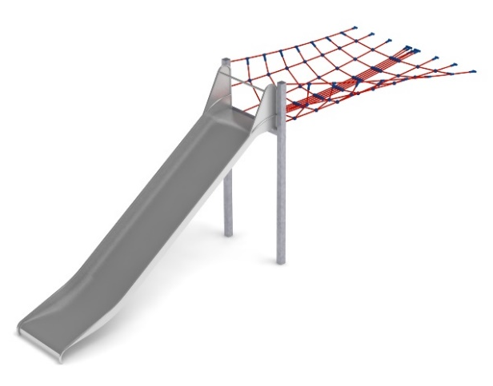
4. Addition WIDE SLIDE cat. no. 414m

Device dimensions:
Length: 6.9 m
Width: 1.7 m
Height: 3.25 m
Minimum space: TEMISTO space + 40.8m²
Age group: 5 to 14 years
Depth of foundation: 1.0 m
Free fall height: 2.25 m

Guidelines for materials and technology of construction of the device.
The main element of the addition is a slide made entirely of 0H18N9 grade acid-resistant steel. The start of the launching section is 2.25m above ground level. The width of the slide is 1m. The structural elements of the addition are made of 100x100 mm square tube, which are protected against corrosion by hot-dip galvanising. The foundations are made as reinforced concrete footings founded at a depth of 1m. The passage connecting the slide to the pyramid is made of polyamide rope, braided, glued reinforced with galvanised steel strings. The diameter of the rope is 18 mm. The elements connecting the ropes to each other are made of plastic and aluminium.

The fall area of the equipment should be made on a surface in accordance with PN EN 1176- 1:2017. The possibility of access by heavy construction equipment is required for the installation.
For the safety of children and the quality of the equipment, it is required that the equipment is certified in accordance with standards PN EN 1176-1:2017, PN EN 1176-3:2017, PN EN 1176-11:2014-11 issued by a system accredited by the National Accreditation Centre or the national accreditation body of the other Member States in accordance with Regulation (EC) No 765/2008 of the European Parliament and of the Council of the European Union."

