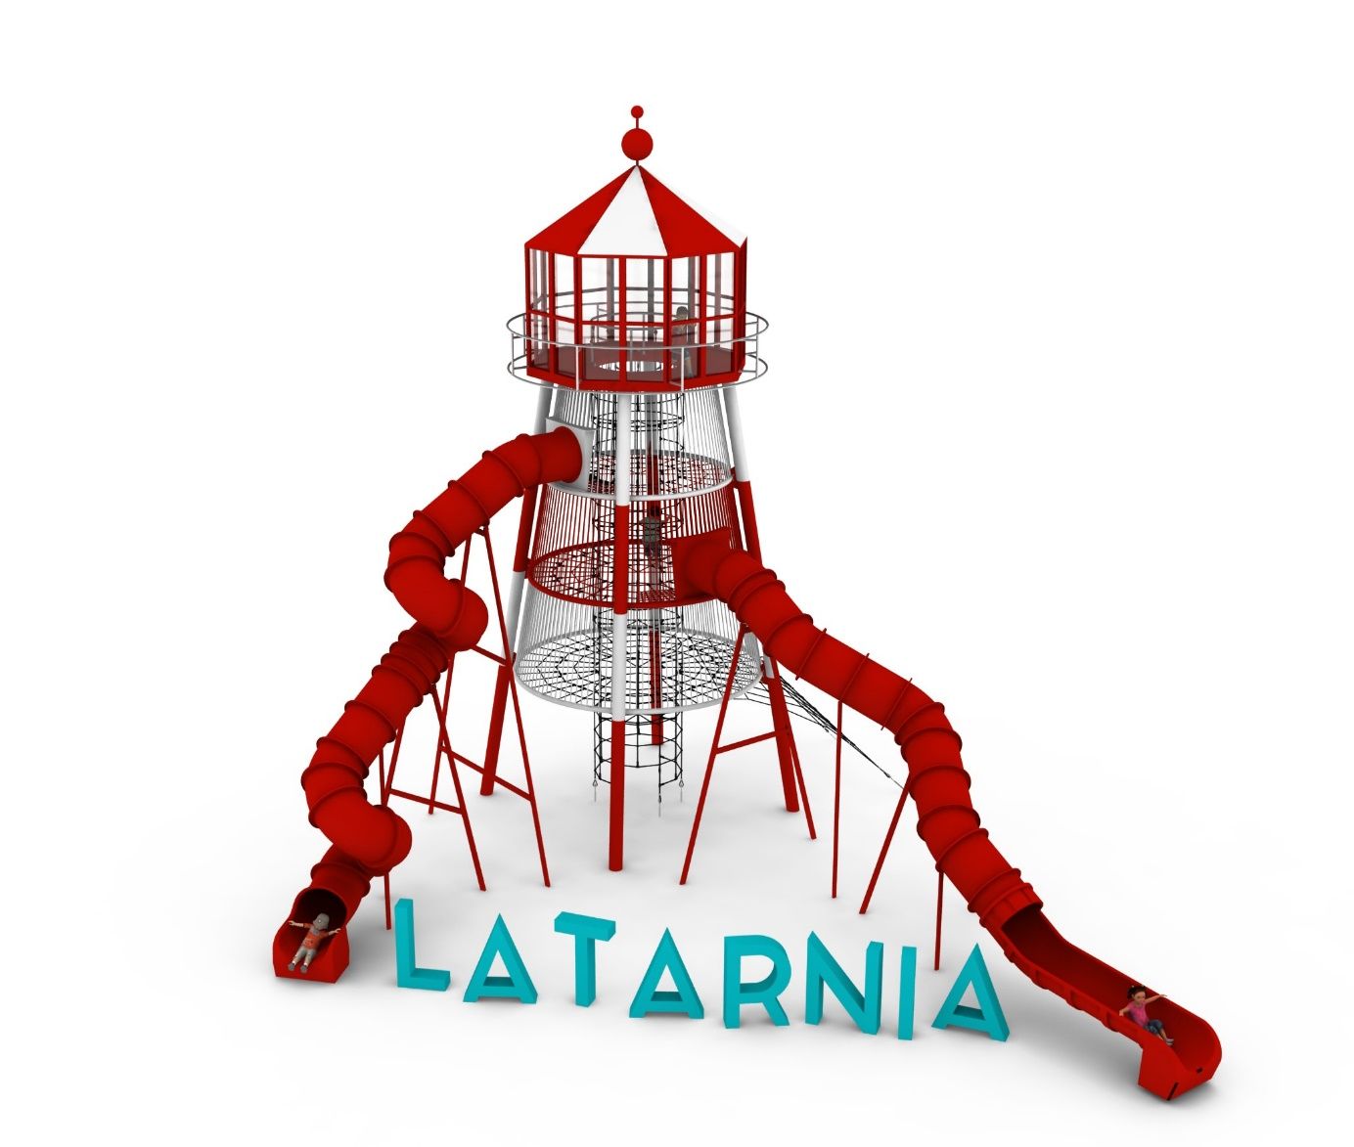
PRODUCT CARD LIGHTHOUSE
Cat. no. 1336

Device dimensions:
Length: 14.6 m
Width: 12.7 m
Height: 11.8m
Minimum space: 18.9m x 16.4m
Age group: 5 to 14 years
Free fall height: 2.5 m
Foundation depth: 1.0 m

Device description.
A lighthouse-like device with the character of a lookout tower. The whole toy is in the red, white and black colour scheme.

Guidelines for materials and technology of construction of the device.
Supporting structure made of hot-dip galvanized and powder-coated steel. The interior of the tower made entirely of ropes built with 3 horizontal platforms at heights of 2.5m, 4.2m, 5.9m and a vertical shaft located in the center of the device. The interior of the shaft is completed with rope mezzanines to facilitate communication and protect users from falling. At the top of the tower, a lookout point is made in the shape of a lighthouse. The roof and floor of the viewpoint are made of 10 mm thick HPL board for outdoor use. The walls are made of polycarbonate min. 6 mm. The construction material of the lookout point is hot-dip galvanised and powder-coated steel. A decorative balustrade made entirely of stainless steel is attached to the wheel of the viewpoint. Access to the tower is provided by:
- internal shaft with a diameter of 1.5m
- an external entrance in the shape of a slice of a pyramid.
The main attraction of the tower is 2 long downhill slides made of polyethylene:
- slide with two turns with access from the 2nd floor of a tower with a launch section at a height of 4.3m and a length of about 11m
- curly slide with access from the 3rd floor of the tower with a launch section at a height of 6.0m and a length of about 15m.
The rope platform has been intentionally heavily compacted at the slide launch areas to facilitate user access.

Rope play elements are made of polyamide, braided, glued rope with a diameter of 18mm. The ropes are made of galvanized steel strings, twisted into six strands, each of which is braided with polyamide fiber glued into it. The elements connecting the ropes to each other are made of aluminum, stainless steel and plastic.

The fall area of the equipment should be made on a surface in accordance with PN EN 1176- 1:2017. The possibility of access by heavy construction equipment is required for the installation.

For the safety of children and the quality of the equipment, it is required that the equipment is certified in accordance with standards PN EN 1176-1:2017, PN EN 1176-3:2017, PN EN 1176-11:2014-11 issued by a system accredited by the National Accreditation Centre or the national accreditation body of the other Member States in accordance with Regulation (EC) No 765/2008 of the European Parliament and of the Council of the European Union."

