PRODUCT CARD CAPSULE
Cat. no. 1227

Device dimensions:
Length: 18.3 m
Width: 11.4 m
Height: 8.3 m
Free fall height: 2.0 m
Age group: 5 to 14 years
Foundation depth: 1.0m
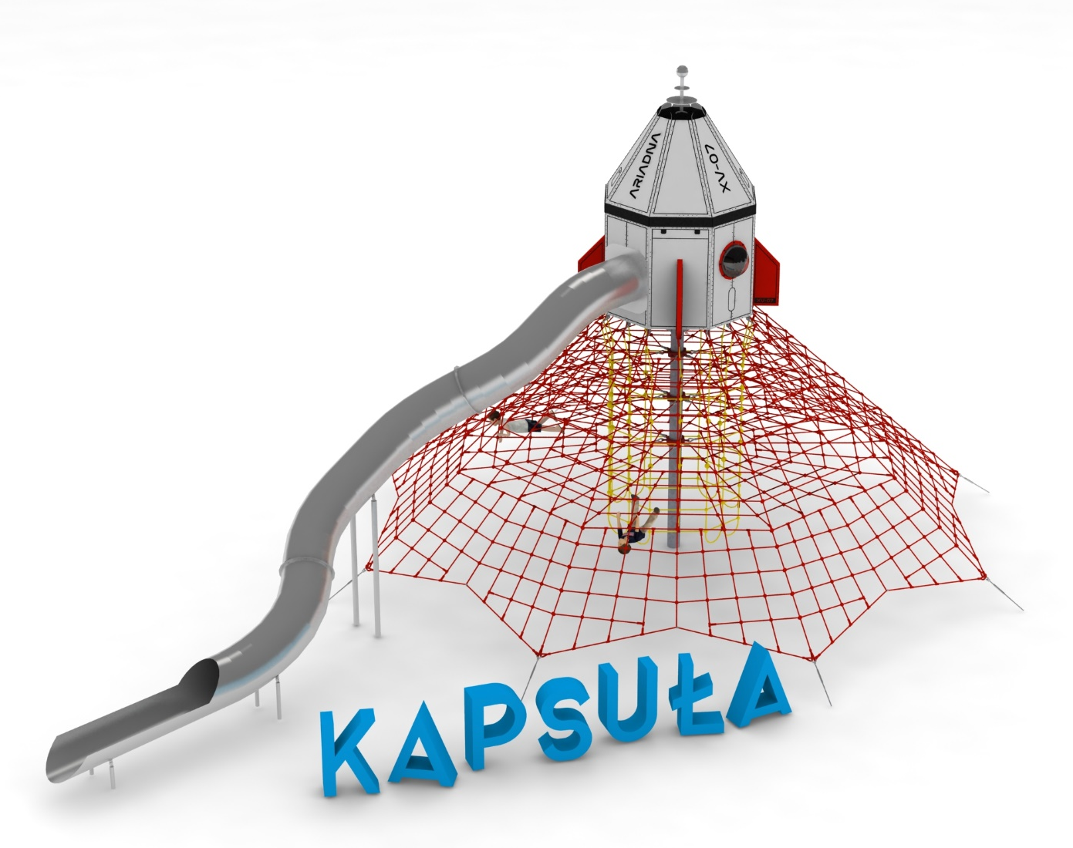
Minimum space: 21.8m x 14.5m

Device description.
The theme of the device is a space capsule situated on top of a rope pyramid. Main components:
- 4.5-metre high rope pyramid
- A space capsule perched on top of the device
- Tube slide with a starting height of 5.0m

a) 4.5-metre high rope pyramid.

Guidelines for materials and technology of construction of the device.
The main structural element is a 4.5-metre steel pole with a diameter of 219.1 mm, which is protected against corrosion by hot-dip galvanisation. The rope structure is formed by eight main ropes anchored in the ground with reinforced concrete feet. Tension adjustments are made by hot-dip galvanised turnbuckles. Six rope walls are stretched between adjacent supporting ropes. Additional attractions include horizontal rope planes at heights of 2.0, 2.8 and 3.6m and an internal rope shaft with a diameter of 2.4m. The net is made of polyamide, braided, glued rope reinforced with galvanised steel strings. The diameter of the rope is 18 mm. The elements connecting the ropes to each other are made of plastic and aluminium. The elements connecting the ropes to the pole are made of stainless steel and cast steel. The steel is protected against corrosion by being painted with chlorine rubber paint.

b) Space capsule.
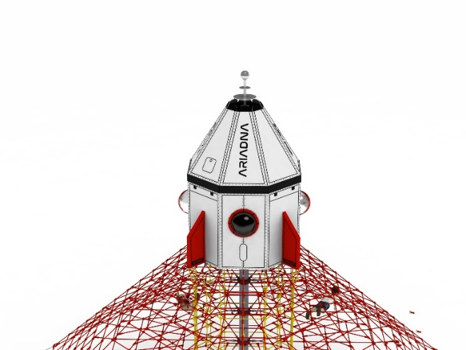
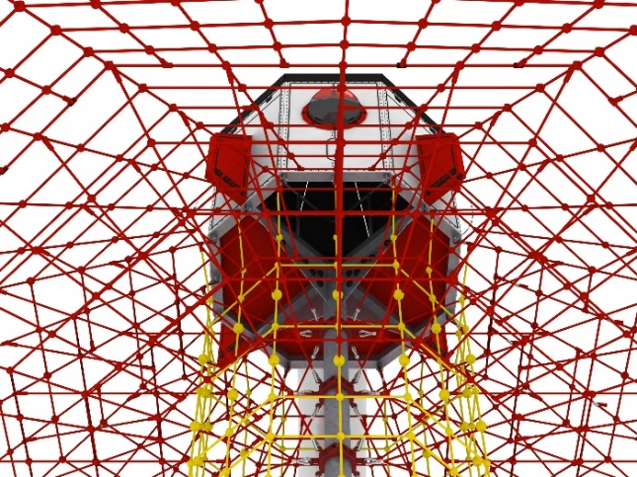

Guidelines for materials and technology of construction of the device.
The main structural elements are steel yokes with a section of 100 x 100mm. The structure is protected against corrosion by hot-dip galvanising. The structure is clad with 12mm thick HPL boards imitating a space capsule. The interior of the house is equipped with:
- a stainless steel balustrade with rope infill allowing users to move freely from the pyramid to the interior of the capsule
- a launching platform for sliding at a height of 0.3m
- 2 polycarbonate filled windows to provide light inside the house.

- Tube slide with a starting height of 5.0m

Guidelines for materials and technology of construction of the device.
Slide made entirely of stainless steel. Slide starting section at a height of 5.0m. Thickness of sheet used for production 2.5mm. Tube diameter Ø780. Supports in the exit part Ø88.9x4.0mm anchored in the ground 600mm. Diameter of the finishing pipes of the exit part and supports of the exit part Ø33.7x2.0mm, anchored in the ground 600mm. The slide consists of three modules connected by hoops.
The fall area of the equipment should be made on a surface in accordance with PN EN 1176- 1:2017. The possibility of access by heavy construction equipment is required for the installation.
For the safety of children and the quality of the equipment, it is required that the equipment is certified in accordance with standards PN EN 1176-1:2017, PN EN 1176-3:2017, PN EN 1176-11:2014-11 issued by a system accredited by the National Accreditation Centre or the national accreditation body of the other Member States in accordance with Regulation (EC) No 765/2008 of the European Parliament and of the Council of the European Union."

