PRODUCT CARD ALHENA
Cat. no. 423

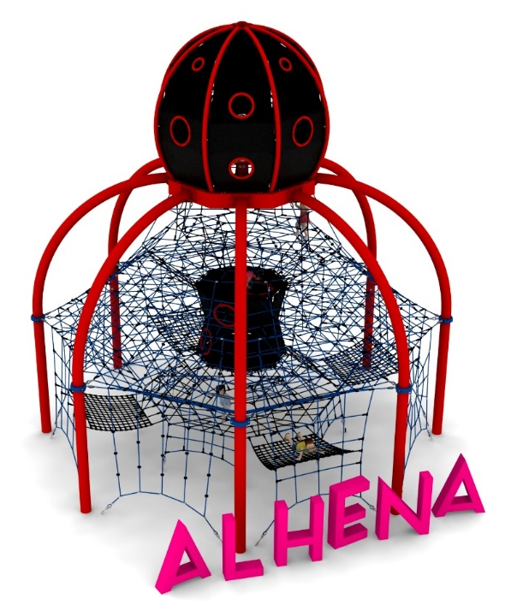

Device dimensions:
Length: 9.3 m
Width: 9.3 m
Height: 9.4 m
Minimum space: Ø 14.1 m
Age group: 5 to 14 years old
Free fall height: 3.0 m
Foundation depth: 1.0 m

Guidelines for materials and technology of construction of the device.
The main structural element is steel arches made of 219.1 mm diameter pipe. The device is anchored in the ground with reinforced concrete footings. The structure is protected against corrosion by hot-dip galvanizing and powder coating. A rope jacket is attached to the steel structure, using clamps made of cast steel. The rope jacket consists of:
- an external mesh that allows movement on the outside of the structure
- 6 horizontal floors at heights of 1.45m, 2.05m, 2.9m, 3.75m, 4.6m and 5.45m allowing users to move inside the structure
- an hourglass in the center of the structure made of reinforced rubber mats equipped with transition holes located on different sides of the device
- a rope funnel located at the bottom of the device allowing users to enter the structure from inside the net
- 4 rope hammocks at the bottom of the device with approximate dimensions of 2m x 1.6m.

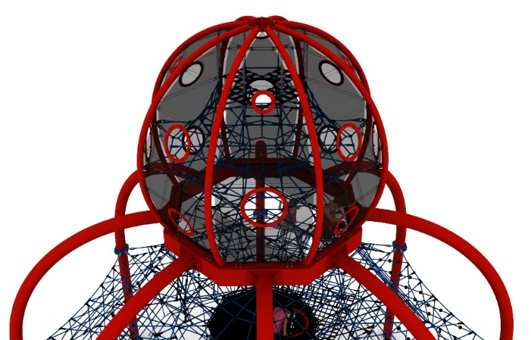
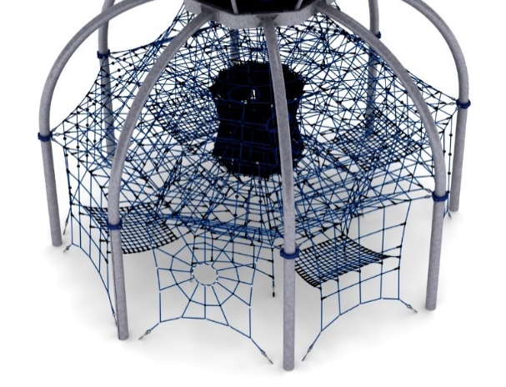

On top of the steel arches is installed an additional steel structure in the shape of a sphere, which is filled with an independent spatial rope network. The sphere is encased in reinforced rubber mats decorated with polycarbonate windows of various sizes, providing vantage points for users.
Adjustment of the device's tension is made possible by hot-dip galvanized turnbuckles. The nets are made of polyamide rope, braided, glued reinforced with galvanized steel strings. The diameter of the rope is 18 mm. Elements connecting ropes to each other are made of plastic and aluminum. Elements connecting the ropes to the pole are made of stainless steel and cast steel painted with chlorine rubber. Decorative elements are made of HPL board.

The fall area of the equipment should be made on a surface in accordance with PN EN 1176- 1:2017. The possibility of access by heavy construction equipment is required for the installation.
For the safety of children and the quality of the equipment, it is required that the equipment is certified in accordance with standards PN EN 1176-1:2017, PN EN 1176-3:2017, PN EN 1176-11:2014-11 issued by a system accredited by the National Accreditation Centre or the national accreditation body of the other Member States in accordance with Regulation (EC) No 765/2008 of the European Parliament and of the Council of the European Union."

