PRODUCT CARD WHALE
Cat. no. 1222

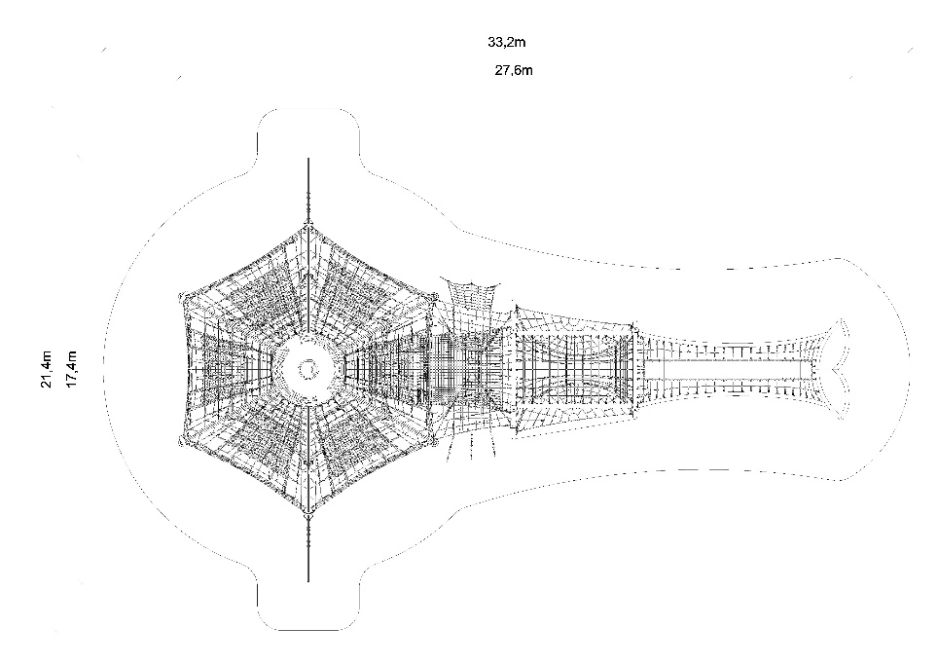

Device dimensions:
Length: 27.6 m
Width: 17.4 m
Height: 7.2 m
Minimum space: 33.2m x 21.4m
Age group: 5 to 14 years
Free fall height: 3.0 m
Depth of foundation: 1.0 m

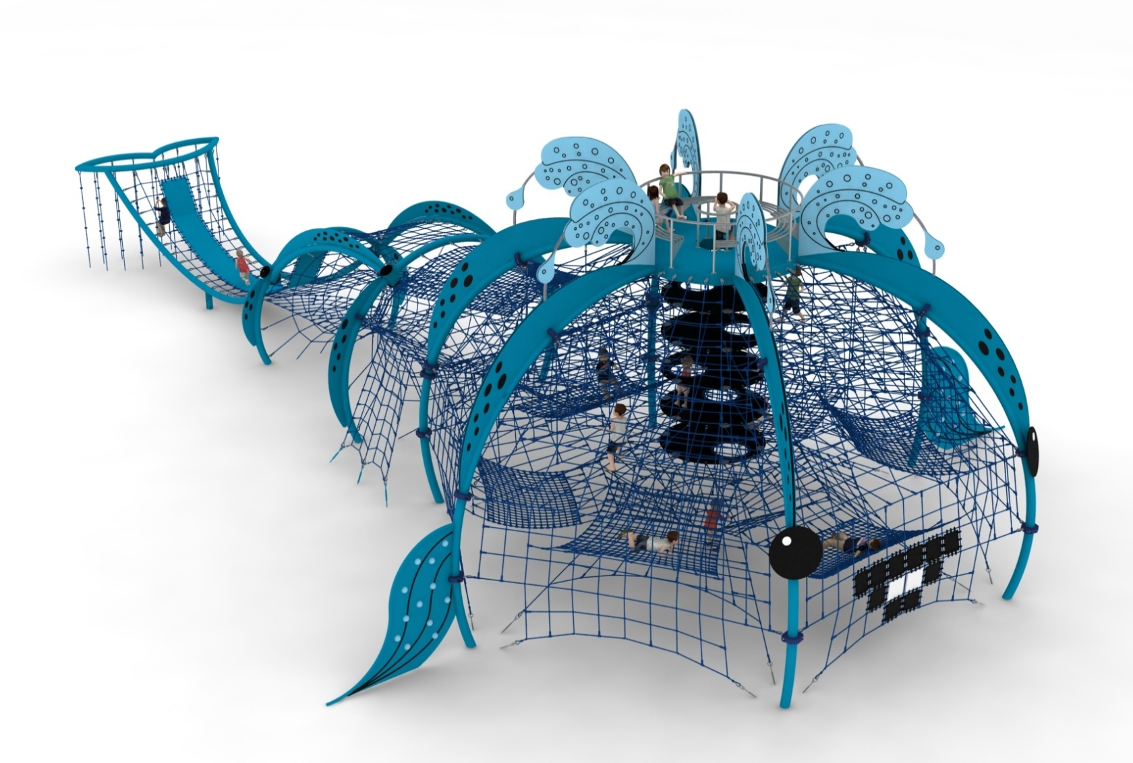

Device description.
A device reminiscent of a whale. The whole device is decorated in marine colours.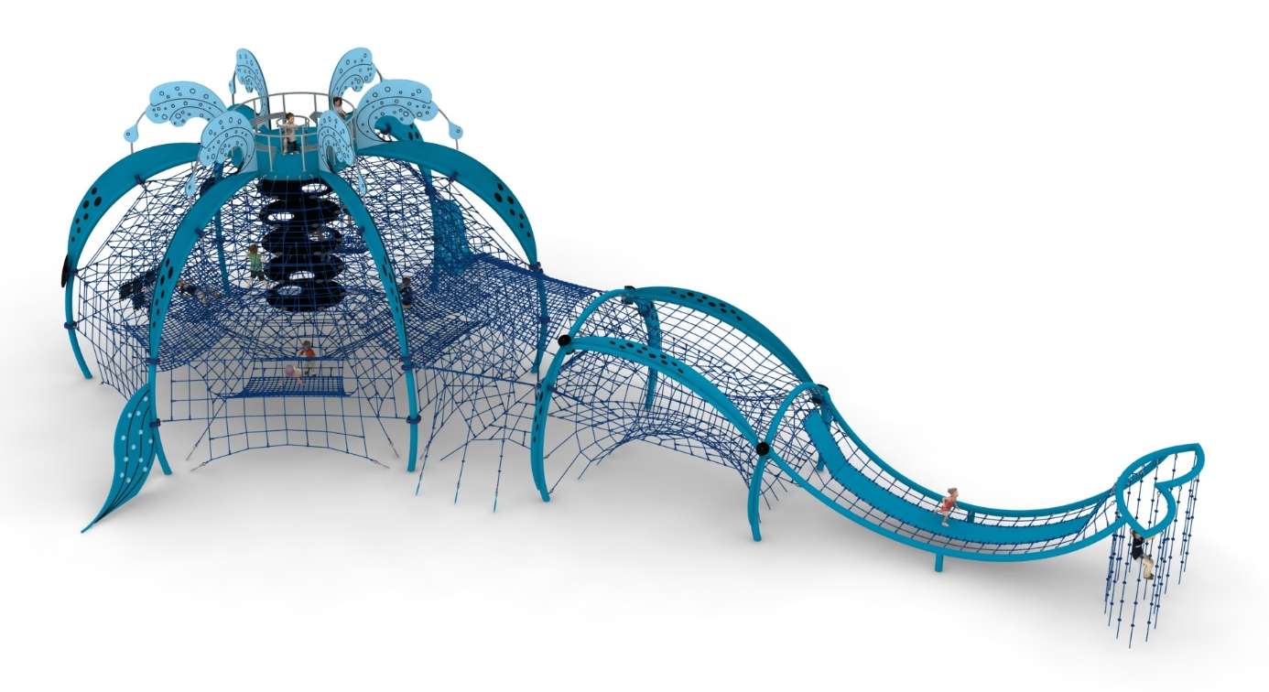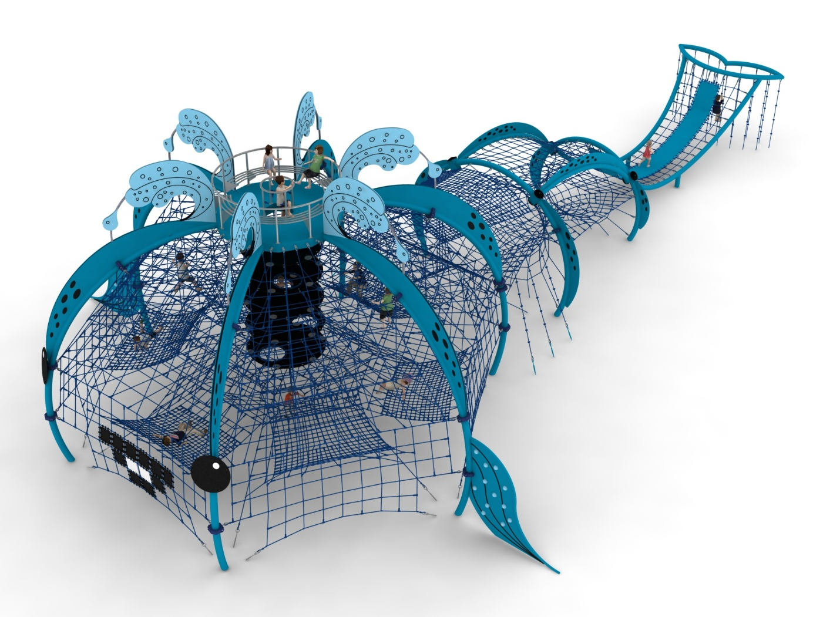

Guidelines for materials and technology of construction of the device.
The whale is devided into three sections corresponding to the body parts: head, thorax, tail.

Head.
The head is a dome constructed on a hexagonal base. The main structural element is 6 steel arches made from a 168.3mm diameter tube. The arches are fixed at the top to a platform made of 100mm x 200mm steel yoke and at the bottom in the ground with reinforced concrete feet. The structure is protected against corrosion by hot-dip galvanising and powder coating. A cable jacket is attached to the steel structure by means of clamps made of cast steel. The cable jacket consists of:
- six main walls fixed between the steel arches
- 4 horizontal floors at heights of 3.0m, 3.75m, 4.5m and 5.25m to allow users to move around inside the structure.

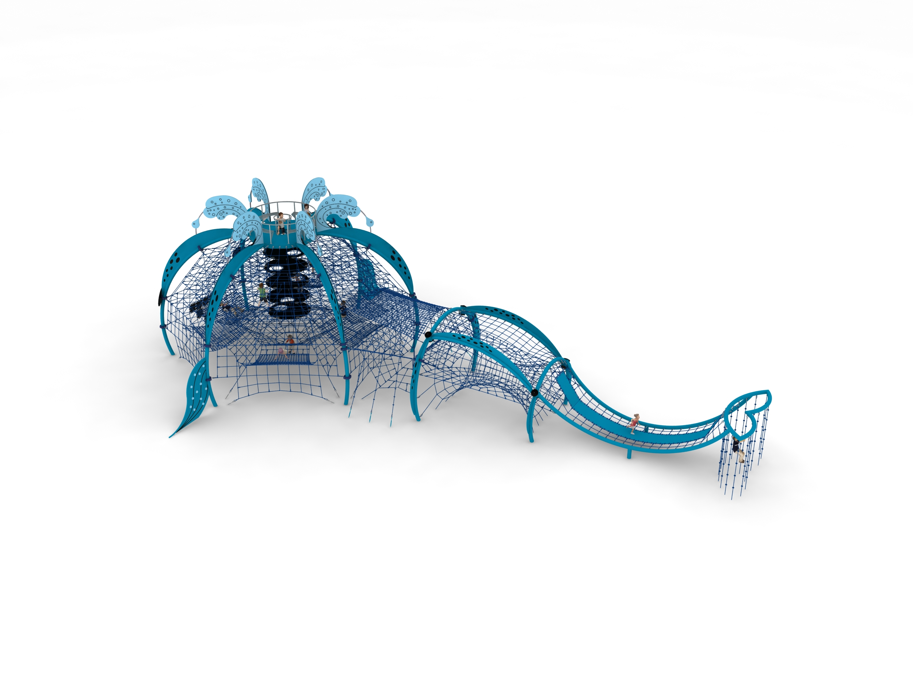

- rope-rubber shaft. The shaft allows users to ascend from the bottom of the structure, along reinforced rubber mats with a diameter of 2m, to the very top of the unit. The rubber mats are fitted with transition holes located at various points on the wheel.

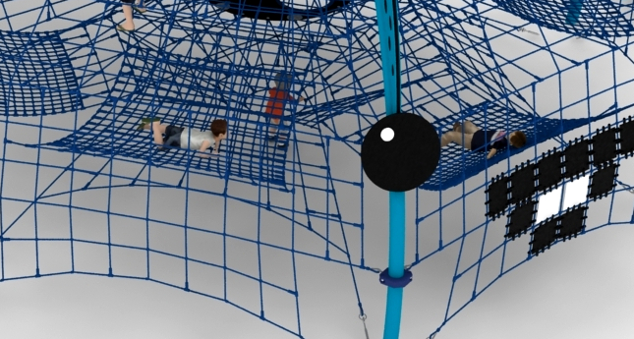

- 6 rope hammocks fixed at various heights with approximate dimensions of 3m x 2.5m

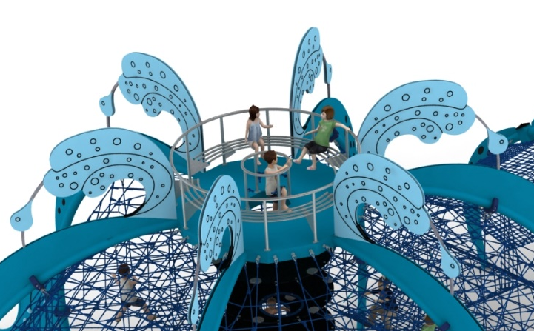
On top of the unit is a steel platform clad on both sides with HPL on both sides. Bolted to the platform is a circular bench with an external diameter of 3m, made entirely of stainless steel. The bench is clad on the outside with HPL panels imitating the gushing water of a whale's nose.

Additional visual decorations include:
- HPL plates on the tops of the tubes imitating whale skin
- eyes of the whale made of HPL
- mouth and teeth made of reinforced rubber matting
- two side fins with climbing grips, which, in addition to their decorative function, also serve as classic climbing walls.

2. Thorax.
The thorax consists of two parts: front and rear. The main structural elements are steel arches made of 168.3 mm diameter tube, fixed in the ground with reinforced concrete feet. The structure is protected against corrosion by hot-dip galvanising and powder coating. A cable jacket is attached to the steel structure.

Front part (closer to the head).
The main attraction is a net stretched between the head and the steel arch consisting of 10 triangular-shaped nets made of ropes. The nets are arranged in different planes and meet each other at one of the vertices. To the circle of the main mesh, perpendicular to the steel arch, an additional rope mesh made up of:
- an upper dense mesh of no more than 120 x 120mm and approximate dimensions of 4.1 x 3.4m
- a diagonal rope truss to allow access to the upper net
- 3 climbing ropes allowing access to the top net

Rear part (at the tail).
The main attraction is a horizontal tunnel with a diameter of 1.1 - 3.6m and a length of 5m. In the middle of the tunnel two horizontal rope grids in the shape of half an ellipse are installed. Above the tunnel, a rope lattice is stretched along the upper horizontal steel arches to enable overhead communication. As an additional decorative element, HPL panels imitating whale skin are installed along the upper steel arches.

3. Tail.
The structural element consists of 168.3 mm diameter tubes, fixed in the ground with reinforced concrete footings. The structure is protected against corrosion by hot-dip galvanising and powder coating. A cable truss is installed between the arches. The centre of the truss is filled with a reinforced rubber mat 0.7m wide and 8mm thick. There are 18 climbing ropes attached to the whale's fin to imitate dripping water.
Adjustment of the tension of the device is made possible by hot-dip galvanised turnbuckles. The nets are made of polyamide rope, braided, glued reinforced with galvanised steel strings. Rope diameter is 18 mm. The elements connecting the ropes to each other are made of plastic and aluminium. Elements connecting the ropes to the pole are made of stainless steel and cast steel painted with chlorine rubber.
The fall area of the equipment should be made on a surface in accordance with PN EN 1176- 1:2017. The possibility of access by heavy construction equipment is required for the installation.
For the safety of children and the quality of the equipment, it is required that the equipment is certified in accordance with standards PN EN 1176-1:2017, PN EN 1176-3:2017, PN EN 1176-11:2014-11 issued by a system accredited by the National Accreditation Centre or the national accreditation body of the other Member States in accordance with Regulation (EC) No 765/2008 of the European Parliament and of the Council of the European Union."

