PRODUCT CARD MEGAJUMBO
Cat. no. 421

Device dimensions:  Length: 10.2m  Width: 10.0m  Height: 5.5m  Minimum space: a circle with a diameter of 13.5m  Age group: 5 to 14 years old  Foundation depth: 1.0 m  Free fall height: 2.3 m  Minimum total length of rope used to manufacture the device: 1200m | 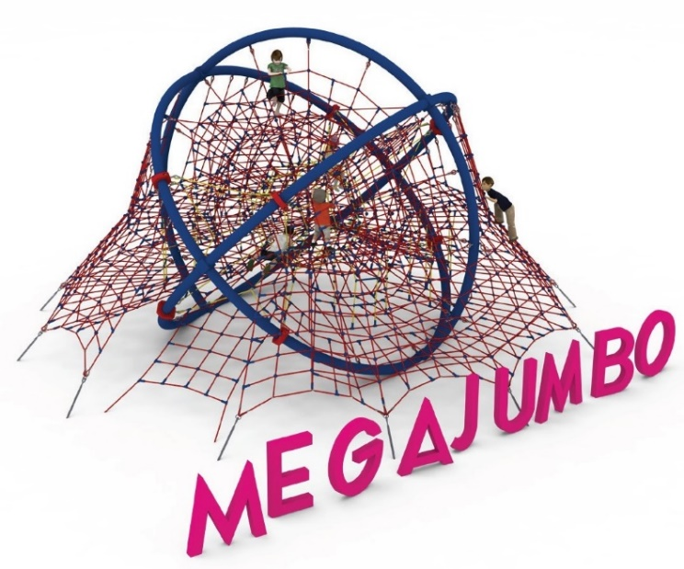
Guidelines for materials and technology of construction of the device.
The MEGA JUMBO device is a device consisting of a steel structure in the shape of a sphere, a spatial rope net located inside the steel structure, two rope entrances allowing access to the device from the front and rear of the device, a rope jacket extending beyond the outline of the steel structure, two rope floors, and climbing ropes and ladders connecting the upper floors with the lower floors. The minimum amount of rope used to manufacture the device is 1200m.
The steel structure is composed of eleven steel arches with a radius of about 3.2m bent from 168.3 diameter pipes, connected to each other at six nodes at 90 degrees. The steel structure is protected against corrosion by hot-dip galvanizing and additionally powder coated. The rope elements are made of polyamide, braided, glued ropes of 18mm diameter, connected by connectors made of aluminum, stainless steel and plastic. Connections of the rope net to the steel structure are provided by hot-dip galvanized shackles or clamps made of cast steel painted with chlorine-rubber enamel. The tension of the rope part is provided by hot-dip galvanized turnbuckles anchored in the ground. The foundation of the steel structure is made as reinforced concrete footings.

The fall area of the equipment should be made on a surface in accordance with PN EN 1176- 1:2017. The possibility of access by heavy construction equipment is required for the installation.
For the safety of children and the quality of the equipment, it is required that the equipment is certified in accordance with standards PN EN 1176-1:2017, PN EN 1176-3:2017, PN EN 1176-11:2014-11 issued by a system accredited by the National Accreditation Centre or the national accreditation body of the other Member States in accordance with Regulation (EC) No 765/2008 of the European Parliament and of the Council of the European Union."

