PRODUCT CARD LIVIA
Cat. no. 1225
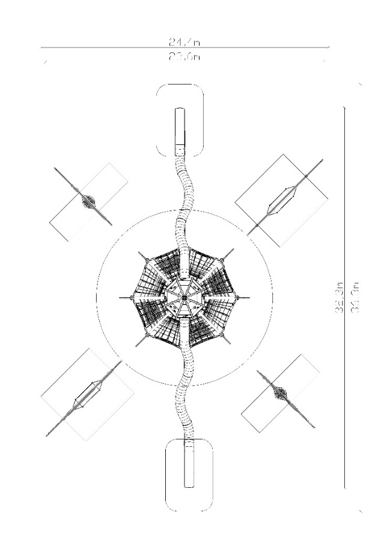

Device dimensions:
Length: 32.3 m
Width: 23.6 m
Height: 10.5 m
Minimum space: 36.3m x 24.4m
Age group: 5 to 14 years
Free fall height: 3.0 m
Depth of foundation: 1.0 m

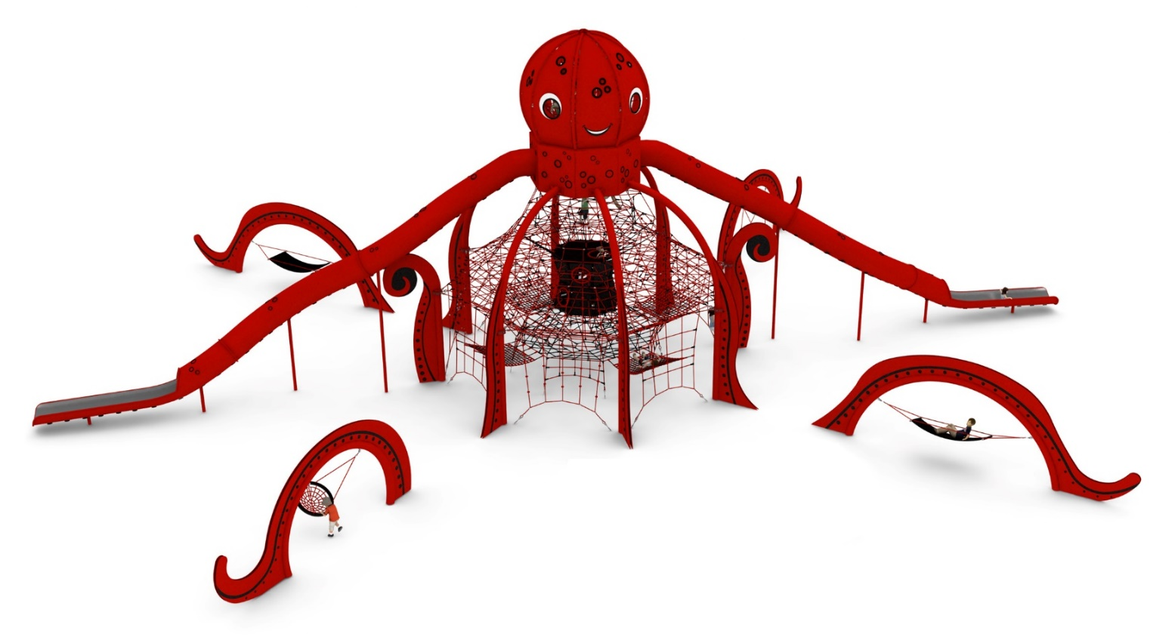

Device description.
A device reminiscent of an octopus. The whole device is kept in the red and black colour scheme.

Guidelines for materials and technology of construction of the device.
The main structural element is steel arches made of 219.1 mm diameter pipe. The unit is anchored in the ground with reinforced concrete footings. The structure is protected against corrosion by hot-dip galvanising and powder coating. A cable jacket is attached to the steel structure by means of clamps made of cast steel. The cable jacket consists of:

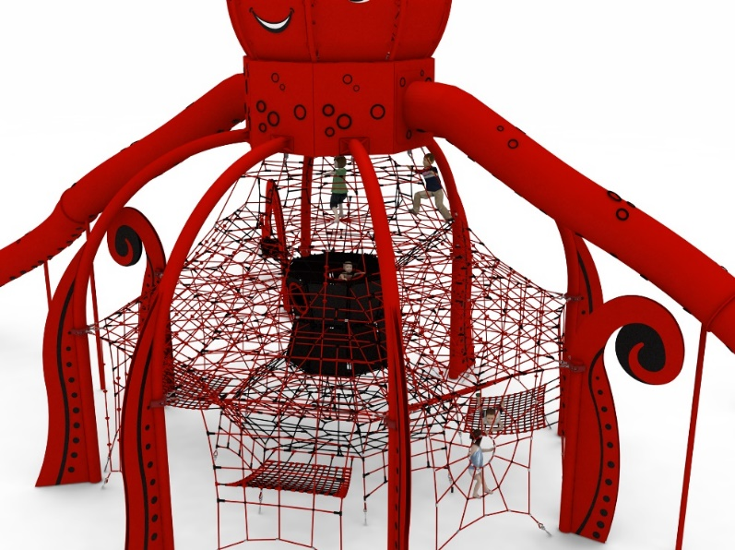
- an external net allowing users to move around the outside of the structure
- 6 horizontal floors at heights of 1.45m, 2.05m, 2.9m, 3.75m, 4.6m and 5.45m allowing users to move around inside the structure
- an hourglass in the centre of the structure made of reinforced rubber mats with transition holes located on different sides of the device
- a rope funnel located at the bottom of the apparatus allowing access to the structure from inside the net
- 4 rope hammocks at the bottom of the apparatus with approximate dimensions of 2m x 1.6m.

An additional steel structure imitating the neck and head of an octopus is installed on top of the steel arches.
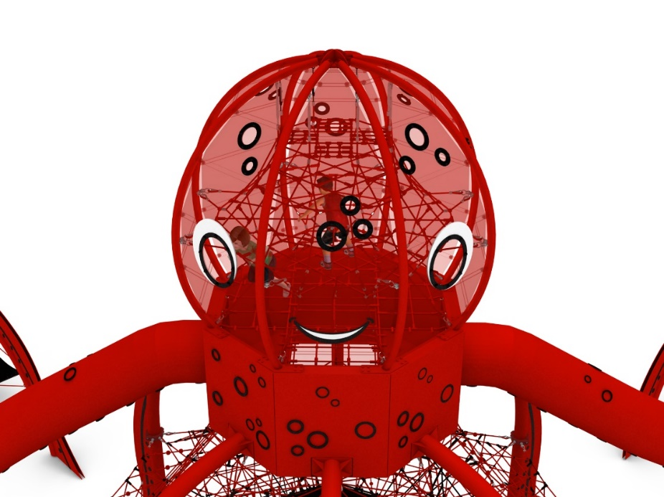

The neck is formed by 3 horizontal rope planes allowing access to the octopus head. In the lower part, two slides are installed, made entirely of stainless steel, painted and veneered according to the presented pattern. The starting part of the slide is located at a height of 6.3m. Pipe diameter Ø780.
The head is an independent, spatial rope net. The head is enclosed with reinforced rubber mats decorated with polycarbonate windows of various sizes, providing view points for users.

Two types of swings imitating the arms of an octopus are situated on the outside of the device.
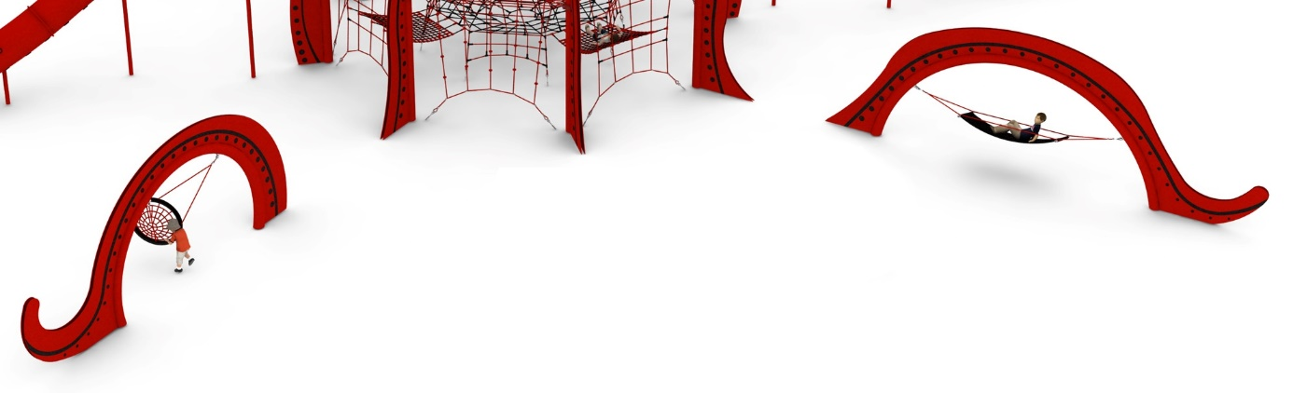
Structure made of 219.1mm tube, decorated on both sides with HPL. 2 tentacles equipped with "stork's nest" type seat. , 2 with hammocks made of reinforced rubber.

Adjustment of the tension of the device is made possible by hot-dip galvanised turnbuckles. The nets are made of polyamide rope, braided, glued reinforced with galvanised steel strings. Rope diameter is 18 mm. The elements connecting the ropes to each other are made of plastic and aluminium. Elements connecting the ropes to the pole are made of stainless steel and cast steel painted with chlorine rubber. Decorative elements made of HPL board.

The fall area of the equipment should be made on a surface in accordance with PN EN 1176- 1:2017. The possibility of access by heavy construction equipment is required for the installation.
For the safety of children and the quality of the equipment, it is required that the equipment is certified in accordance with standards PN EN 1176-1:2017, PN EN 1176-3:2017, PN EN 1176-11:2014-11 issued by a system accredited by the National Accreditation Centre or the national accreditation body of the other Member States in accordance with Regulation (EC) No 765/2008 of the European Parliament and of the Council of the European Union."

