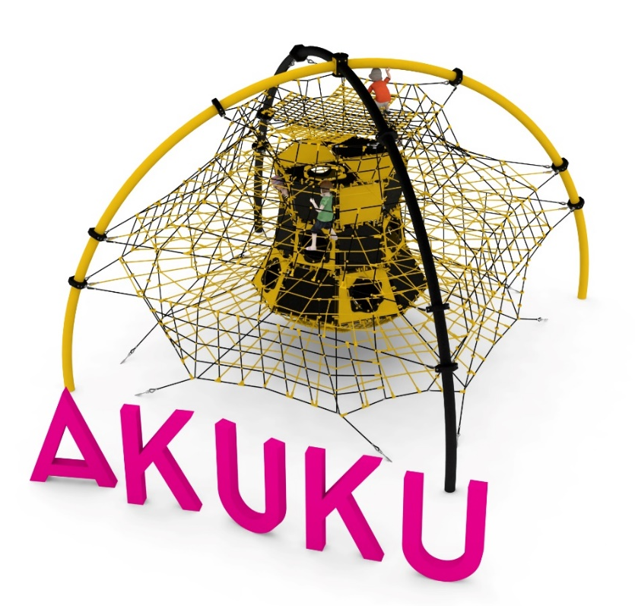
PRODUCT CARD OF AKUKU
Cat. no. 422

Device dimensions:
Length: 7.2m
Width: 7.2m
Height: 5.5m
Minimum space: 12.1m x 12.1m
Age group: 5 to 14 years old
Foundation depth: 1.0 m
Free fall height: 3.0 m

Guidelines for materials and technology of construction of the device.
AKUKU is a device consisting of a dome-shaped steel structure and a spatial rope net inside the steel structure. The steel structure consists of 4 curved steel arches made of 168.3 diameter pipe. The steel structure is protected against corrosion by hot-dip galvanizing and powder coating. A rope net is attached to the steel structure by clamps made of cast steel. The spatial rope net consists of:
- 4 external walls of differentiated construction
- 5 horizontal planes (the highest floor filled with a dense network creating hammocks for users)
- a rope shaft fixed in the center of the structure. The shaft is filled with reinforced rubber mats 10mm thick. The shaft, through designed passages on different sides of the structure, allows movement between floors and walls
- a hammock at the bottom of the unit, which, in addition to the obvious function of lying down, makes it possible to get into the shaft from the bottom of the structure.
The rope elements are made of polyamide, braided, bonded ropes with a diameter of 18mm, connected with fittings made of aluminum, stainless steel and plastic. Connection of the rope net to the clamps is provided by stainless steel eyebolts. The tension of the rope part is provided by hot-dip galvanized turnbuckles. The foundation of the steel structure is made as reinforced concrete footings.

The fall area of the equipment should be made on a surface in accordance with PN EN 1176- 1:2017. The possibility of access by heavy construction equipment is required for the installation.
For the safety of children and the quality of the equipment, it is required that the equipment is certified in accordance with standards PN EN 1176-1:2017, PN EN 1176-3:2017, PN EN 1176-11:2014-11 issued by a system accredited by the National Accreditation Centre or the national accreditation body of the other Member States in accordance with Regulation (EC) No 765/2008 of the European Parliament and of the Council of the European Union."

