PRODUCT CARD HOUSE OF CARDS
Cat. no. 1219

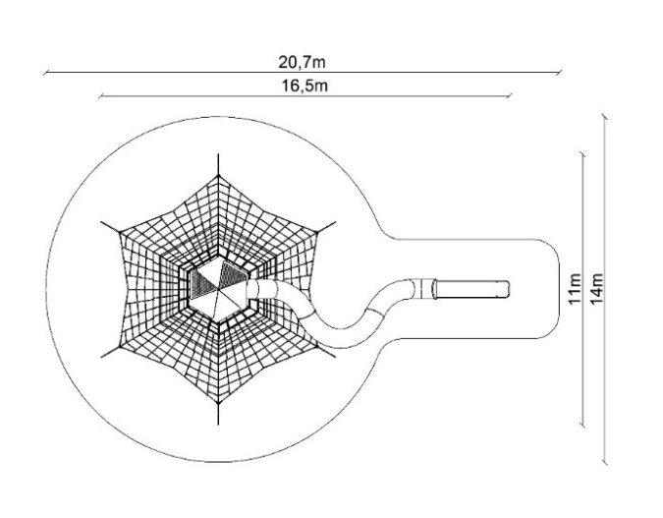

Device dimensions:
Length: 16.5 m
Width: 11.0 m
Height: 8.4 m
Free fall height: 1.7 m
Age group: 5 to 14 years
Foundation depth: 1.0 m
Minimum space: 20.7 x 14 m

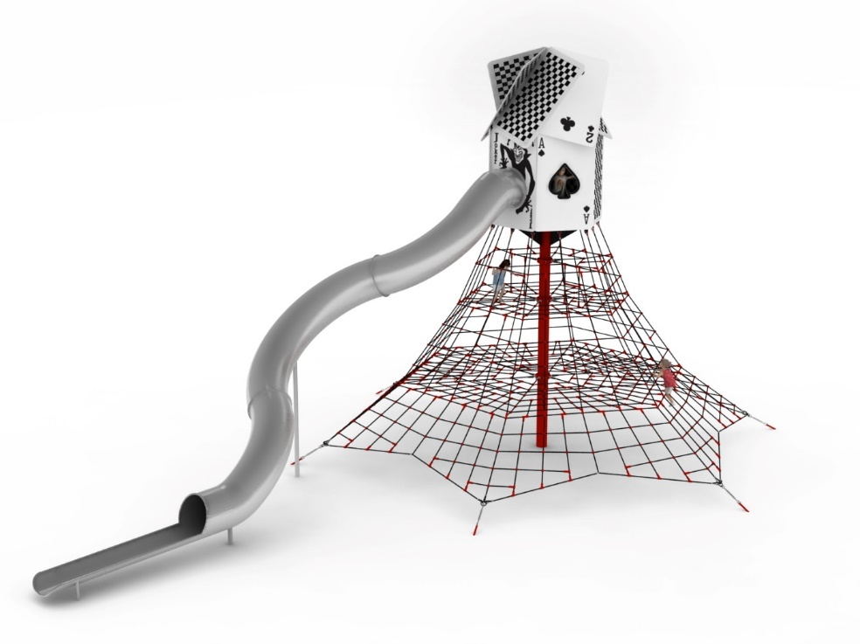

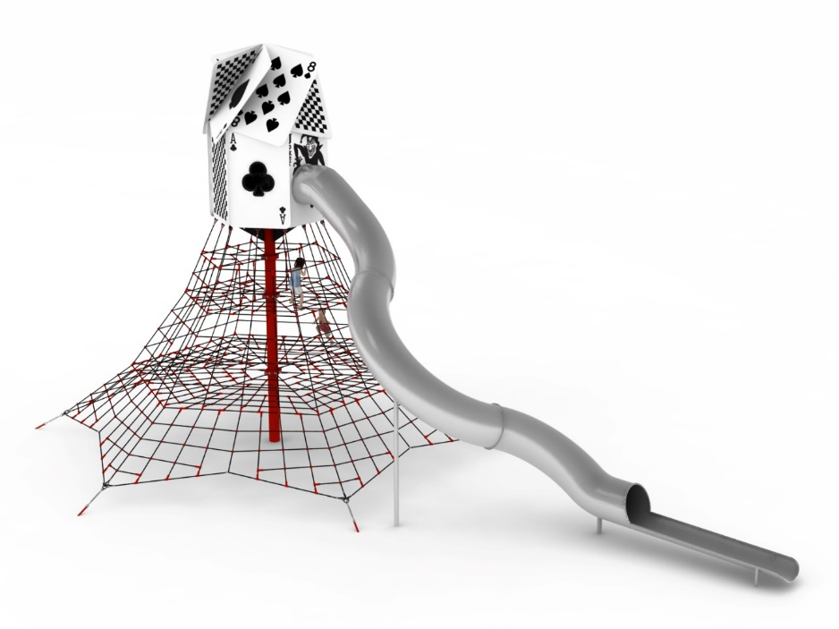

Device description.
The theme of the device is a house of cards situated on top of a rope pyramid. The whole device is kept in a black and red colour scheme. Main components:
1) 5-metre rope pyramid
2) House of cards located on top of the device.
3) Tubular slide with a starting height of 5.3m.

1. Rope pyramid 5 m.
The main structural element is a 5-metre steel pole with a diameter of 219.1 mm, which is protected against corrosion by hot-dip galvanising and powder coating. The rope structure consists of six main ropes anchored in the ground with reinforced concrete feet. Tension adjustments are made by hot-dip galvanised turnbuckles. Six rope walls are stretched between adjacent supporting ropes. An additional attraction are the horizontal rope planes at heights of 1.6, 3.2 and 4.1m. The net is made of polyamide rope, braided, glued reinforced with galvanised steel strings. The rope diameter is 18 mm. The elements connecting the ropes to each other are made of plastic and aluminium. The elements connecting the ropes to the pole are made of stainless steel and cast steel. The cast steel is protected against corrosion by being painted with chlorine rubber paint.

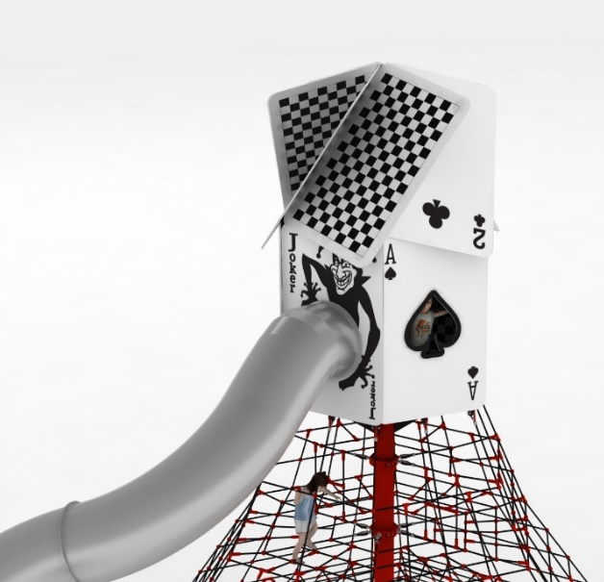
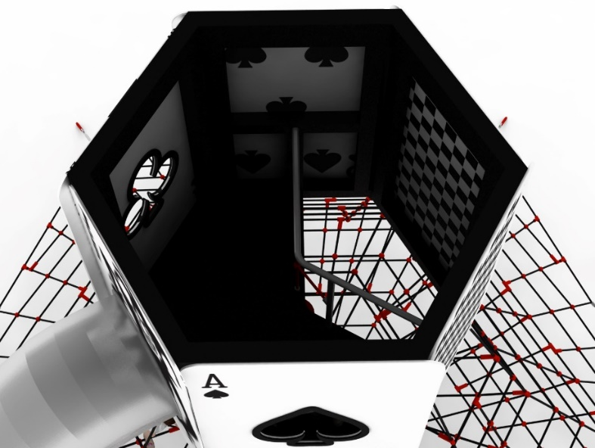
2. House of cards.

The main structural elements are steel yokes with a section of 100 x 100mm. Structure protected against corrosion by hot-dip galvanising and powder coating. The hut is clad with 13mm thick HPL boards imitating playing cards. Interior of house fitted with:
- stainless steel balustrade with rope infill allowing users to move freely from the pyramid to the inside of the house
- starting platform for sliding at a height of 0.3m
- 2 polycarbonate filled windows to provide light inside the house.

3. Tube slide
Slide made entirely of stainless steel, grade 0H18N9. Slide starting section at a height of 5.3m. Total slide length 13.1m. Ground finish of the slide.

The fall area of the equipment should be made on a surface in accordance with PN EN 1176- 1:2017. The possibility of access by heavy construction equipment is required for the installation.
For the safety of children and the quality of the equipment, it is required that the equipment is certified in accordance with standards PN EN 1176-1:2017, PN EN 1176-3:2017, PN EN 1176-11:2014-11 issued by a system accredited by the National Accreditation Centre or the national accreditation body of the other Member States in accordance with Regulation (EC) No 765/2008 of the European Parliament and of the Council of the European Union."

