PRODUCT CARD STADIUM
Cat. no. 426

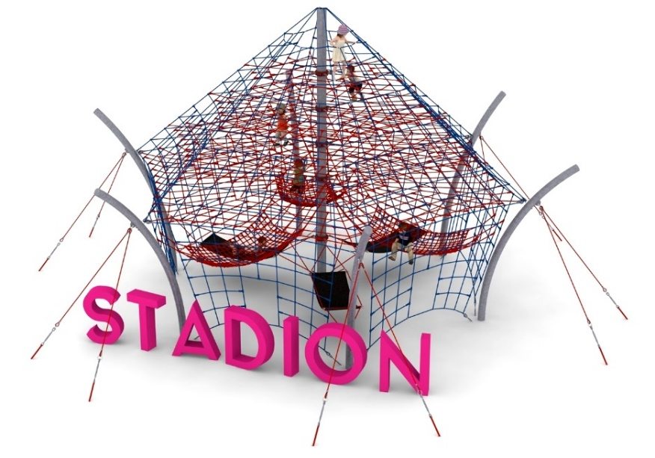

Device dimensions:
Length: 14.3 m
Width: 13.7 m
Height: 7.0m
Minimum space: 17.3m x 16.6m
Age group: 5 to 14 years old
Foundation depth: 1.0m
Free fall height: 3.0 m

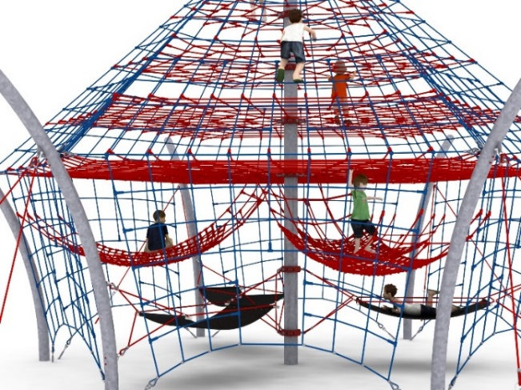
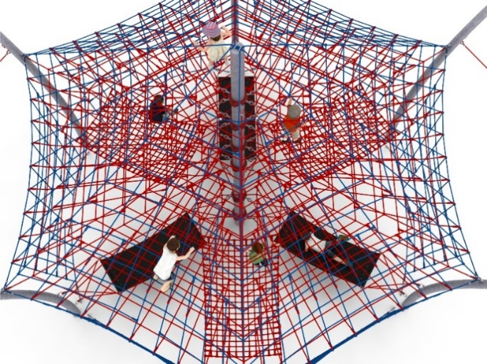

Device description
The device consists of a 7-meter mast seated in the center and six curved steel arches seated around the perimeter of the device. A net consisting of six rope walls is stretched over the structure. Additional attractions include horizontal rope planes at heights of 3.0m, 3.85m, 4.70m and 5.55m, as well as 6 hammocks suspended from the lower part of the device, which serve a play and recreational function. 3 hammocks made of reinforced rubber, suspended at a height of 1m with dimensions of 2m x 0.9m with access from the ground, and 3 rope hammocks suspended at a height of 1.5m with dimensions of 2.3m x 1.5m with access from the main rope network.

Guidelines for materials and technology of construction of the device.
The main structural element is a steel column with a diameter of 219.1mm and side columns with a diameter of 168.3 protected against corrosion by hot-dip galvanizing. Foundations are made as reinforced concrete footings founded at a depth of 1 m. Rope structure attached to steel poles with turnbuckles allowing tension correction. The net is made of POLYIAMID, PLATED, Glued rope reinforced with galvanized steel strings. The diameter of the rope is 18 mm. The elements connecting the ropes to each other are made of plastic and aluminum. The elements connecting the ropes to the pole are made of stainless steel and cast steel. The cast steel is protected against corrosion by being painted with chlorine-rubber paint.

Optional painting.
The structure of the device at the request of the customer can be painted by powder or "wet" spray painting according to RAL.

The fall area of the equipment should be made on a surface in accordance with PN EN 1176- 1:2017. The possibility of access by heavy construction equipment is required for the installation.
For the safety of children and the quality of the equipment, it is required that the equipment is certified in accordance with standards PN EN 1176-1:2017, PN EN 1176-3:2017, PN EN 1176-11:2014-11 issued by a system accredited by the National Accreditation Centre or the national accreditation body of the other Member States in accordance with Regulation (EC) No 765/2008 of the European Parliament and of the Council of the European Union."

