PRODUCT CARD IVO
Cat. no. 425

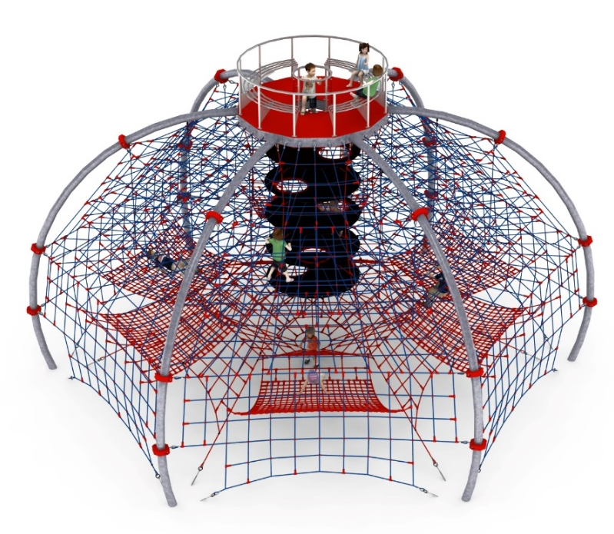

Device dimensions:
Length: 12.3 m
Width: 10.7 m
Height: 7.2 m
Minimum space:
16.9 m diameter circle
Age group: 5 to 14 years old
Free fall height: 3.0 m
Foundation depth: 1.0 m

Guidelines for materials and technology of construction of the device.
The main structural element is 6 steel arches made of 168.3mm diameter pipe. The arches are attached at the top to a platform made of 100mm x 200mm steel yoke, and at the bottom in the ground with reinforced concrete feet. The structure is protected against corrosion by hot-dip galvanizing. A rope jacket is attached to the steel structure, using clamps made of cast steel. The rope jacket consists of:
- six main walls fixed between steel arches
- 4 horizontal floors at heights of 3.0m, 3.75m, 4.5m and 5.25m allowing users to move inside the structure
- rope and rubber shaft. The shaft allows users to climb from the bottom of the structure, along reinforced rubber mats with a diameter of 2m, to the very top of the device. The rubber mats are equipped with transition holes located at various points of the wheel.
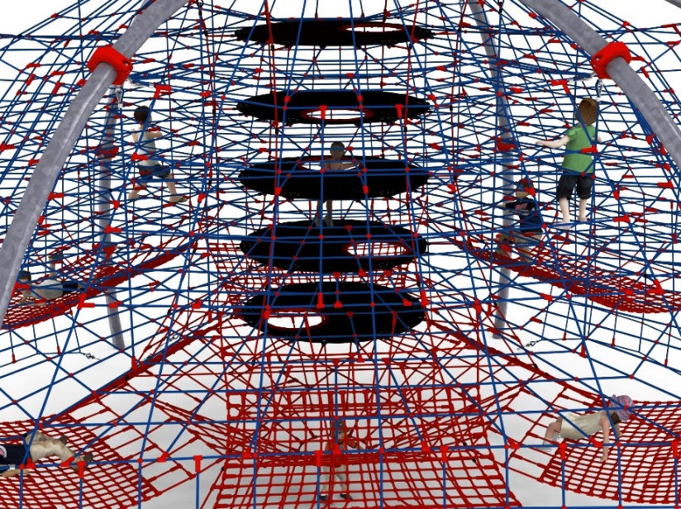

- 6 rope hammocks fixed at different heights with approximate dimensions of 3m x 2.5m

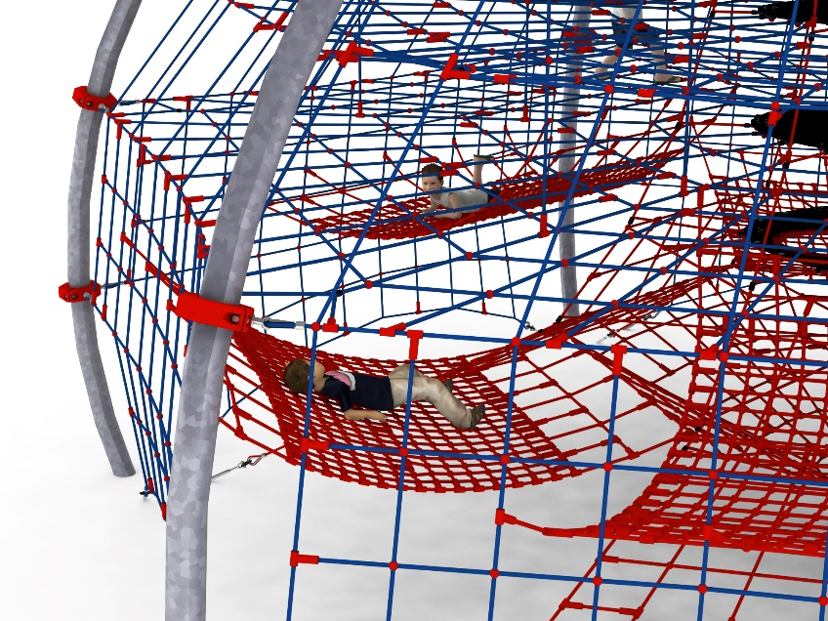

Mounted on top of the device is a steel platform clad on both sides with HPL. Bolted to the platform is a circular bench with an outside diameter of 3m, made entirely of stainless steel.

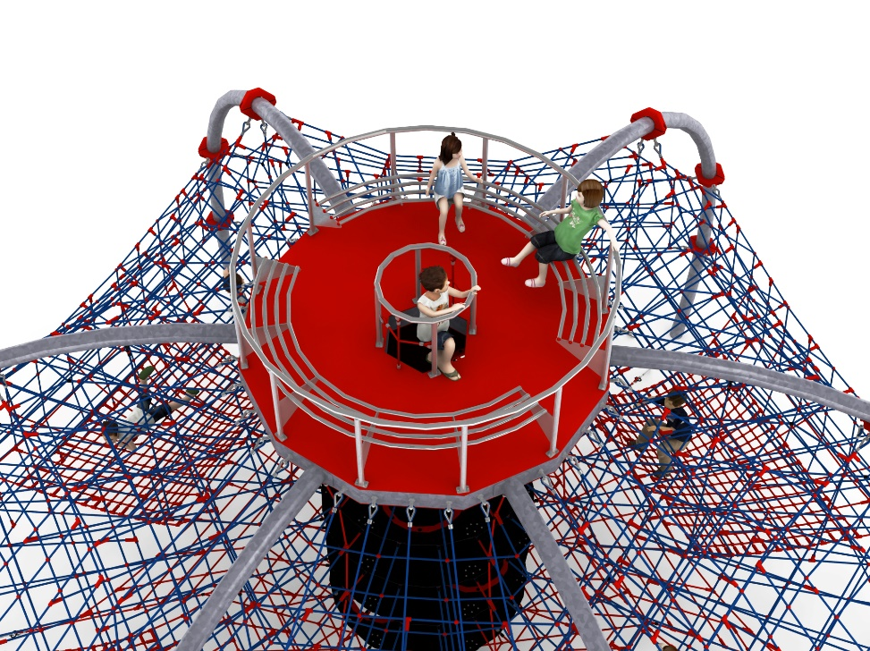

Adjustment of the device's tension is made possible by hot-dip galvanized turnbuckles. The nets are made of polyamide rope, braided, glued reinforced with galvanized steel strings. The diameter of the rope is 18 mm. Elements connecting ropes to each other are made of plastic and aluminum. The elements connecting the ropes to the pole are made of stainless steel and cast steel painted with chlorine rubber.

Optional painting.
The structure of the device at the request of the customer can be painted by powder or "wet" spray painting according to RAL.

For aesthetic reasons and to maintain the flexibility of the structure, it is unacceptable to use additional supporting structures inside the device structure.

The fall area of the equipment should be made on a surface in accordance with PN EN 1176- 1:2017. The possibility of access by heavy construction equipment is required for the installation.
For the safety of children and the quality of the equipment, it is required that the equipment is certified in accordance with standards PN EN 1176-1:2017, PN EN 1176-3:2017, PN EN 1176-11:2014-11 issued by a system accredited by the National Accreditation Centre or the national accreditation body of the other Member States in accordance with Regulation (EC) No 765/2008 of the European Parliament and of the Council of the European Union."

