PRODUCT CARD TEMISTO
Cat. no. 414

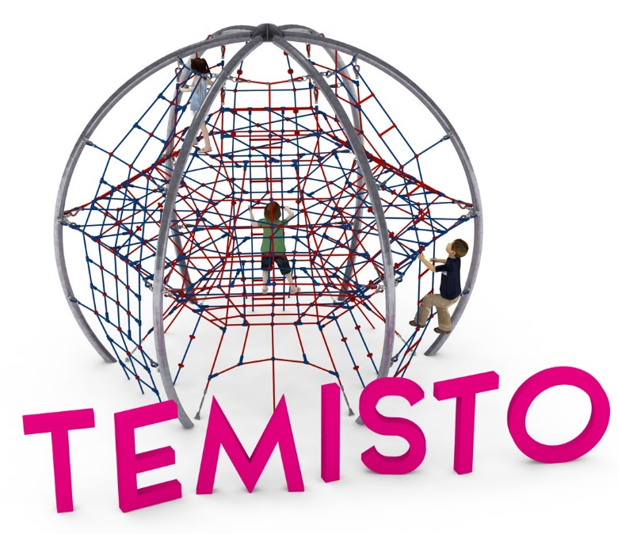

Device dimensions:
Length: 5.1 m
Width: 4.4 m
Height: 4.3m
Minimum space: Ø 9.1m
Age group: 5 to 14 years old
Foundation depth: 1.0 m
Free fall height: 3.0 m

Guidelines for materials and technology of construction of the device.
TEMISTO device is a sphere-shaped device with a diameter of 5.1m and a height of 4.4m. The structure is formed by six steel arches, with a bending radius of R=2500mm, made of 108mm diameter pipes and anchored in the ground with reinforced concrete footings. The structure is protected against corrosion by hot-dip galvanizing. On the steel structure are stretched three levels of rope nets placed at heights of 1, 2 and 3m above ground level. Each of the six side walls is built up with rope walls, which cause the rope structure to take on a quasi-ball shape. Tension adjustment is made possible by turnbuckles, which are protected from corrosion by hot-dip galvanizing. The net is made of polyamide rope, braided, glued reinforced with galvanized steel strings. The diameter of the rope is 18 mm. The elements connecting the ropes to each other are made of plastic and aluminum.

Optional painting.
The structure of the device at the request of the customer can be painted by powder or "wet" spray painting according to RAL.

The fall area of the equipment should be made on a surface in accordance with PN EN 1176- 1:2017. The possibility of access by heavy construction equipment is required for the installation.
For the safety of children and the quality of the equipment, it is required that the equipment is certified in accordance with standards PN EN 1176-1:2017, PN EN 1176-3:2017, PN EN 1176-11:2014-11 issued by a system accredited by the National Accreditation Centre or the national accreditation body of the other Member States in accordance with Regulation (EC) No 765/2008 of the European Parliament and of the Council of the European Union."

