PRODUCT CARD SYKORAKS
Cat. no. 418

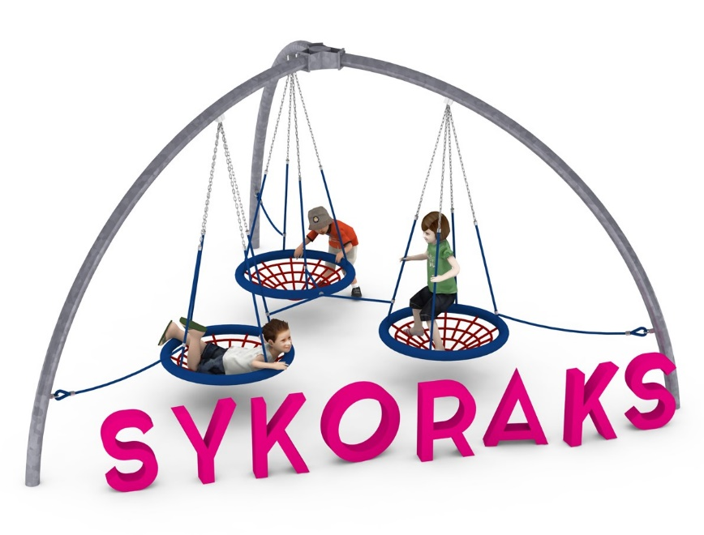

Device dimensions:
Length: 4.9 m
Width: 4.4 m
Height: 2.7 m
Free fall height: 0.9 m
Age group: 0 to 14 years old
Foundation depth: 0.8 m
Minimum space: 8.1 x 7.4 m.

Guidelines for materials and technology of construction of the device.
SYKORAKS is a device consisting of three steel arches bent from 108.0mm diameter pipes, joined at the top node. The resulting structure resembles a three-armed dome. All components made of black steel are protected from corrosion by hot-dip galvanizing. Three stork's nest type seats with a diameter of 95cm are suspended to the steel structure. The seats are suspended on chains made of stainless steel. Double-bearing stainless steel slings are responsible for connecting the chains to the steel structure. The seats are connected to each other and the steel structure by ropes of 18mm diameter, preventing the seats from swinging. The ropes are made of polyamide, reinforced with steel strings. The foundation is made as reinforced concrete footings.

Optional painting.
The structure of the device at the request of the customer can be painted by powder or "wet" spray painting according to RAL.

The fall area of the equipment should be made on a surface in accordance with PN EN 1176- 1:2017. The possibility of access by heavy construction equipment is required for the installation.
For the safety of children and the quality of the equipment, it is required that the equipment is certified in accordance with standards PN EN 1176-1:2017, PN EN 1176-3:2017, PN EN 1176-11:2014-11 issued by a system accredited by the National Accreditation Centre or the national accreditation body of the other Member States in accordance with Regulation (EC) No 765/2008 of the European Parliament and of the Council of the European Union."

