PRODUCT CARD ROCKET
Cat. no. 405
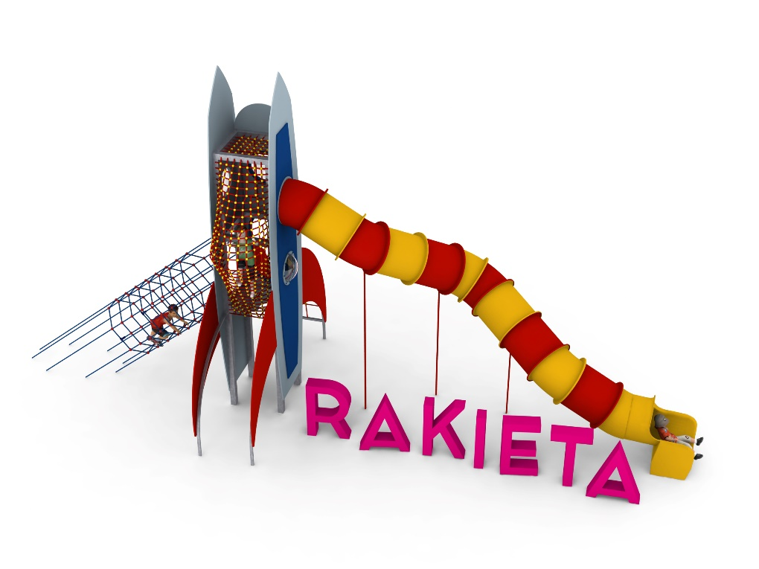

Device dimensions:
Length: 12,1m
Width: 4.1m
Height: 6.3m
Free fall height: 2m
Age group: 5 to 14 years old
Foundation depth: 1.0m
Minimum space: 15.6m x 7.1m

Guidelines for materials and technology of construction of the device.
The main structural element is the tower, made of square steel pipes with sides of 100 mm, which are protected against corrosion by hot-dip galvanizing. The foundations are made as reinforced concrete footings founded at a depth of 1 m. Access to the device is provided by two entrances: a tunnel and a side entrance. The tube slide is made of polyethylene. The beginning of the launching section is located at a height of 3.6 m. The tower enclosure is made of 10 mm thick HPL panels. Communication between levels is provided by a rope crossing. Polypropylene ropes reinforced with galvanized steel strings were used. The diameter of the rope is 16 mm. The elements connecting the ropes to each other are made of plastic and aluminum. The elements connecting the ropes to the pole are made of stainless steel.

The fall area of the equipment should be made on a surface in accordance with PN EN 1176- 1:2017. The possibility of access by heavy construction equipment is required for the installation.
For the safety of children and the quality of the equipment, it is required that the equipment is certified in accordance with standards PN EN 1176-1:2017, PN EN 1176-3:2017, PN EN 1176-11:2014-11 issued by a system accredited by the National Accreditation Centre or the national accreditation body of the other Member States in accordance with Regulation (EC) No 765/2008 of the European Parliament and of the Council of the European Union."

