PRODUCT CARD NAOS
Cat. no. 406

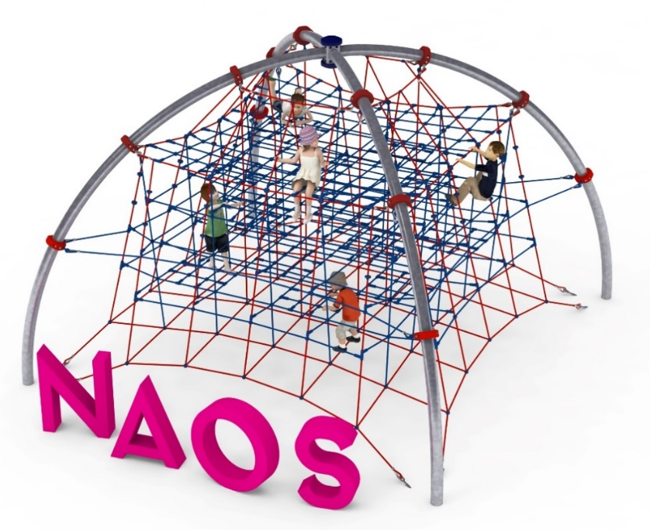

Device dimensions:
Length: 5.8 m
Width: 5.8 m
Height: 4.2 m
Minimum space: 9.7x 9.7 m
Age group: 5 to 14 years old
Foundation depth: 0.8m
Free fall height: 3.0 m
Length of rope used: 480 m

Guidelines for materials and technology of construction of the device.
The main structural element is two crossed semicircles made of steel pipe with a diameter of 139.7 mm. They are protected from corrosion by hot-dip galvanizing. Inside the structure is stretched a spatial rope net, which consists of five planes. The rope net is attached to the structure with clamps made of cast steel. The clamps are protected against corrosion by being painted with chlorinated rubber paints. The attachment of the space net to the foundations is provided by hot-dip galvanized turnbuckles, which allow the net's tension to be corrected. The foundations are made as reinforced concrete footings founded at a depth of 0.8 m. The rope used is 18 mm in diameter and is braided, glued, reinforced with steel and made of polyamide. The elements connecting the ropes to each other are made of polyamide, aluminum or stainless steel.

Optional painting.
The structure of the device at the request of the customer can be painted by powder or "wet" spray painting according to RAL.

The fall area of the equipment should be made on a surface in accordance with PN EN 1176- 1:2017. The possibility of access by heavy construction equipment is required for the installation.
For the safety of children and the quality of the equipment, it is required that the equipment is certified in accordance with standards PN EN 1176-1:2017, PN EN 1176-3:2017, PN EN 1176-11:2014-11 issued by a system accredited by the National Accreditation Centre or the national accreditation body of the other Member States in accordance with Regulation (EC) No 765/2008 of the European Parliament and of the Council of the European Union."

