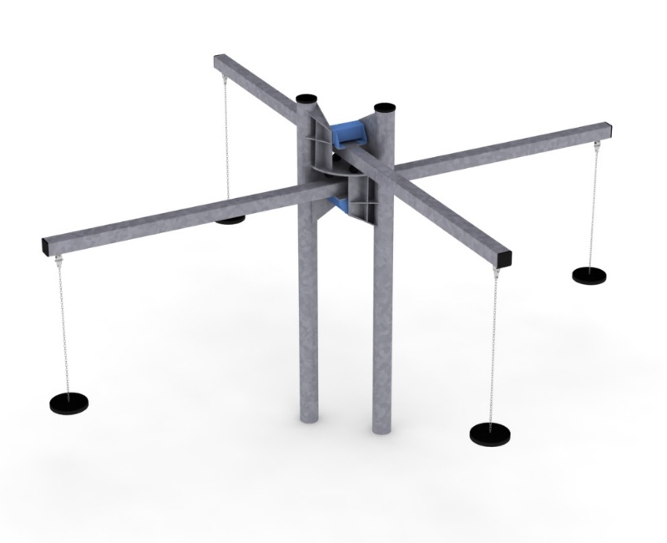
PRODUCT CARD NAMAKA
Cat. no. 609

Swing dimensions:
Length: 5.4 m
Width: 5.1 m
Height: 3.0 m
Minimum space:10.5 x 10.1 m
Age group: 3 to 14 years
Free fall height: 2,0 m
Depth of foundation: 1.0 m

Guidelines for materials and technology of construction of the device.
The NAMAKA device is a swinging and swaying device. It consists of two Type 6 swings (according to PN-EN 1176-6:2009) whose main beams are set at right angles to each other. The main beams are made of 120x120 square tubes. The beams are fixed to steel columns made of tubes of diameter 168.3. The steel structure is made of S235 steel protected against corrosion by hot-dip galvanising. Swaying of the upper beams is ensured by ROSTA damping elements, which at the same time limit the swaying of the beams. Additional sway-limiting elements are rubber buffers. Rubber seats are suspended from the beams by stainless steel chains. The chains are attached to the structure by means of stainless steel bearing slings. The beams are fixed at a height of 2.3 and 2.8m. The foundation is made as reinforced concrete footings at a depth of 1.0m. The height of the unit is 3.0m.
The fall area of the device should be made on a surface in accordance with EN 1176-1:2017.

