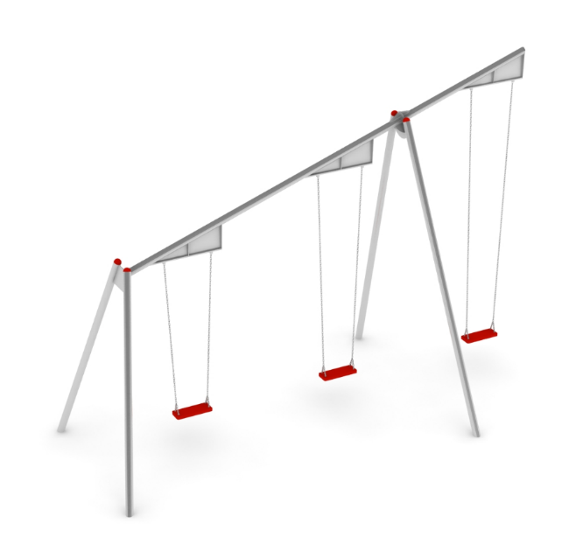
PRODUCT CARD MAB
Cat. no. 608

Swing dimensions:
Length: 5.9 m
Width: 2.5 m
Height: 4.4 m
Minimum space: 10.5 x 5.9 m
Age group: 0 to 14 years
Free fall height: 2,3 m
Foundation depth: 0.7 m.

Guidelines for materials and technology of construction of the device.
The MAB is a device used for swinging. It consists of three swings with a single axis of rotation, hanging to an overhead beam. The device is divided into two sections, with the first section containing the swing with the longest strings. The sections are separated from each other by an intermediate ditch. The structure is made of 88.9 diameter tubes made of 0H18N9 grade acid-resistant steel. The seats are connected to the structure by stainless steel chains fastened to bearing slings. The seats are made of a steel insert covered with EPDM rubber. Swings are mounted at heights of 2.5, 3.2 and 3.9m. Foundations made as reinforced concrete footings.
The fall area of the equipment should be made on a surface in accordance with PN EN 1176- 1:2017.

