PRODUCT CARD KONOPUS
Cat. no. 401

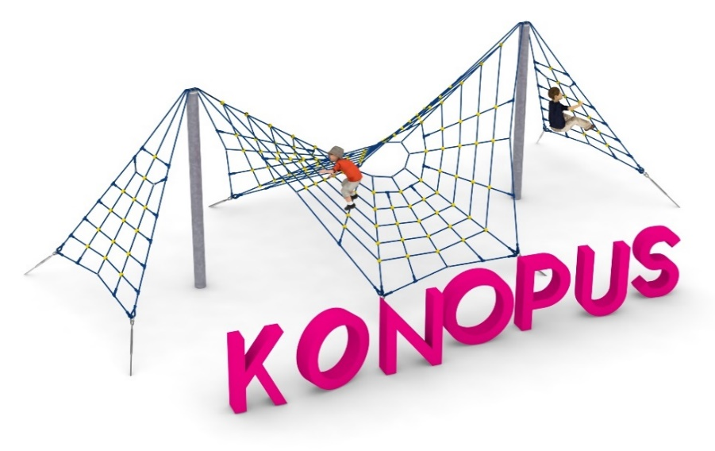

Device dimensions:
Length: 10.0 m
Width: 6.0 m
Height: 3.0 m
Minimum space: 13.0 x 9.0 m
Age group: 5 to 14 years old
Foundation depth: 1.0 m
Free fall height: 3.0 m

Guidelines for materials and technology of construction of the device.
The device consists of two 168.3 mm diameter steel poles anchored in the ground with reinforced concrete footings, on which a spiderweb-shaped rope structure is tensioned. The steel elements are protected from corrosion by hot-dip galvanizing. As an additional attraction, two triangular rope walls go off to the sides and are anchored in the ground with hot-dip galvanized anchor plates. The turnbuckles that allow tension adjustment are protected from corrosion by hot-dip galvanizing. The rope used is 18 mm in diameter and is braided, glued, reinforced with steel and made of polyamide. The elements connecting the ropes to each other are made of polyamide, aluminum or stainless steel.

Optional painting.
The structure of the device at the request of the customer can be painted by powder or "wet" spray painting according to RAL.

The fall area of the equipment should be made on a surface in accordance with PN EN 1176- 1:2017. The possibility of access by heavy construction equipment is required for the installation.
For the safety of children and the quality of the equipment, it is required that the equipment is certified in accordance with standards PN EN 1176-1:2017, PN EN 1176-3:2017, PN EN 1176-11:2014-11 issued by a system accredited by the National Accreditation Centre or the national accreditation body of the other Member States in accordance with Regulation (EC) No 765/2008 of the European Parliament and of the Council of the European Union."

