PRODUCT CARD KAPELLA
Cat. no. 412

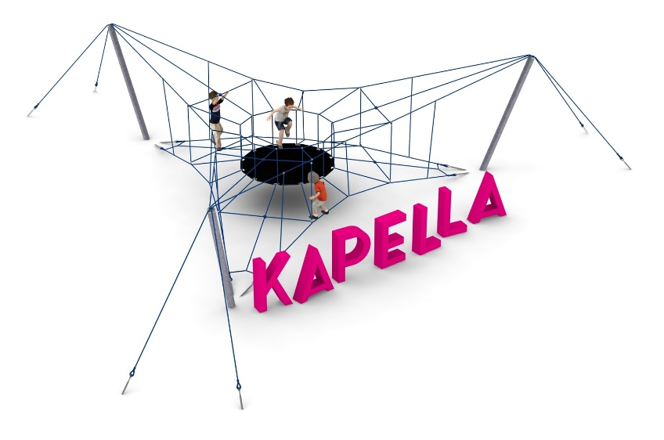

Device dimensions:
Length: 14.3 m
Width: 12.4 m
Height: 2.6 m
Minimum space: 16.1 x 14.4 m
Age group: 5 to 14 years old
Foundation depth: 1.0 m
Free fall height: 2.6 m

Guidelines for materials and technology of construction of the device.
KAPELLA is a device consisting of three steel poles, a rubber mat inside the rope structure, a rope structure. The steel structure is composed of three steel poles made of 139.7 mm diameter pipe. The steel structure is protected against corrosion by hot-dip galvanizing. The rope parts are made of polyamide, braided, glued ropes of 18mm diameter, connected by connectors made of aluminum, stainless steel and plastic. The tension of the rope part is provided by turnbuckles anchored in the ground. The turnbuckles are protected against corrosion by hot-dip galvanizing. The membrane is 10 mm thick and is reinforced with four layers of polyamide mesh. The foundation of the steel structure is made as reinforced concrete footings.

Optional painting.
The structure of the device at the request of the customer can be painted by powder or "wet" spray painting according to RAL.

The fall area of the equipment should be made on a surface in accordance with PN EN 1176- 1:2017. The possibility of access by heavy construction equipment is required for the installation.
For the safety of children and the quality of the equipment, it is required that the equipment is certified in accordance with standards PN EN 1176-1:2017, PN EN 1176-3:2017, PN EN 1176-11:2014-11 issued by a system accredited by the National Accreditation Centre or the national accreditation body of the other Member States in accordance with Regulation (EC) No 765/2008 of the European Parliament and of the Council of the European Union."

