PRODUCT CARD GUGS
Cat. no. 413
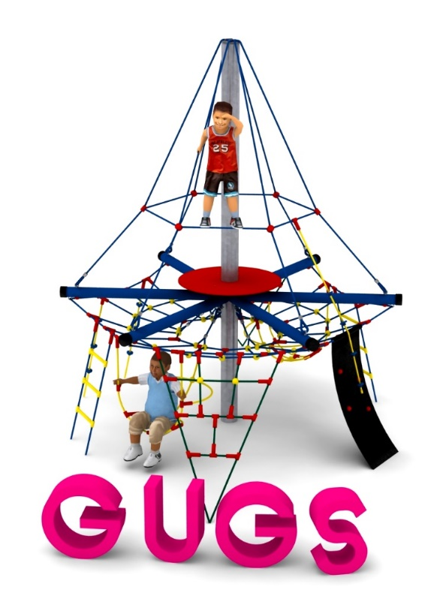

Device dimensions:
Length: 4.0 m
Width: 3.5 m
Height: 3.7 m
Minimum space: Ø 7.8 m
Age group: 5 to 14 years old
Foundation depth: 1.0 m
Free fall height: 1.5 m

Guidelines for materials and technology of construction of the device.
GUGS is a device consisting of a centrally located steel pole with a diameter of 168.3 mm, to which 6 horizontal steel beams with a diameter of 101.6 mm are attached. Below the plane defined by the horizontal beams, a horizontal grid is suspended, constituting the playing surface. Attached to the horizontal grid are nets, ladders, ropes and climbing rubber, which provide an additional play attraction. Steel structure protected from corrosion by hot-dip galvanizing. Above the plane determined by the horizontal mesh, a platform made of HPL board is fixed. The ropes used for the device have a diameter of 16 mm and are made of polypropylene, additionally reinforced with steel strings. All fasteners are made of stainless steel. A reinforced concrete footing is responsible for connecting the pole to the ground.

The fall area of the equipment should be made on a surface in accordance with PN EN 1176- 1:2017. The possibility of access by heavy construction equipment is required for the installation.
For the safety of children and the quality of the equipment, it is required that the equipment is certified in accordance with standards PN EN 1176-1:2017, PN EN 1176-3:2017, PN EN 1176-11:2014-11 issued by a system accredited by the National Accreditation Centre or the national accreditation body of the other Member States in accordance with Regulation (EC) No 765/2008 of the European Parliament and of the Council of the European Union."

