PRODUCT CARD GEMMA
Cat. no. 1403

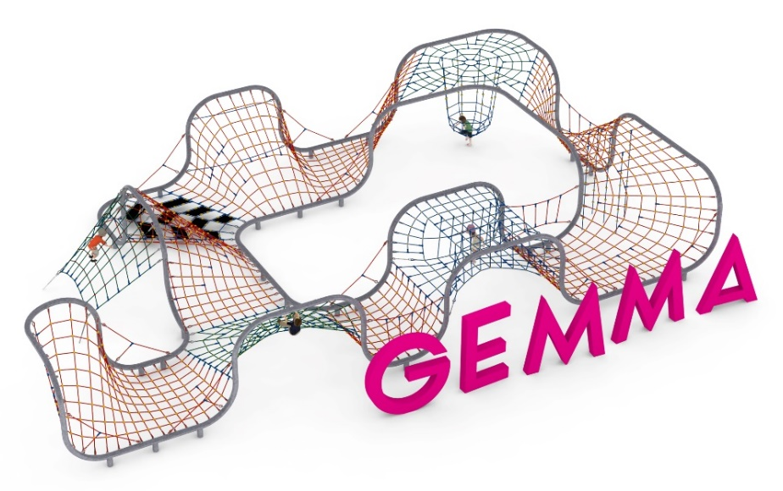

Device dimensions:
Length: 19.0 m
Width: 11.2 m
Height: 3.0 m
Minimum space: 23.9 x 16.1 m
Age group: 3 to 14 years old
Free fall height: 2.9 m
Foundation depth: 1.0 m

Guidelines for materials and technology of construction of the device.
The main structural element is a steel frame made of 139.7 mm diameter pipe, which is protected against corrosion by hot-dip galvanizing. The frame is formed by interconnected straight or bent pipes at different angles. A rope structure is stretched on the support structure thus created. Additional attractions are: rope basket , 0.5x0.5 m mats - 9pcs, climbing ropes - 5pcs, vertical rope walls of different shapes and a net stretched between the ground and the upper pipe of the structure. The rope structure is made of polyamide rope, braided, glued reinforced with galvanized steel strings. The diameter of the rope is 18 mm. The elements connecting the ropes to each other are made of plastic and aluminum. The elements connecting the ropes to the frame are made of stainless steel. The device is anchored in the ground with reinforced concrete feet.

Optional painting.
The structure of the device at the request of the customer can be painted by powder or "wet" spray painting according to RAL.

The fall area of the equipment should be made on a surface in accordance with PN EN 1176- 1:2017. The possibility of access by heavy construction equipment is required for the installation.
For the safety of children and the quality of the equipment, it is required that the equipment is certified in accordance with standards PN EN 1176-1:2017, PN EN 1176-3:2017, PN EN 1176-11:2014-11 issued by a system accredited by the National Accreditation Centre or the national accreditation body of the other Member States in accordance with Regulation (EC) No 765/2008 of the European Parliament and of the Council of the European Union."

