PRODUCT CARD ATRIA
Cat. no. 407

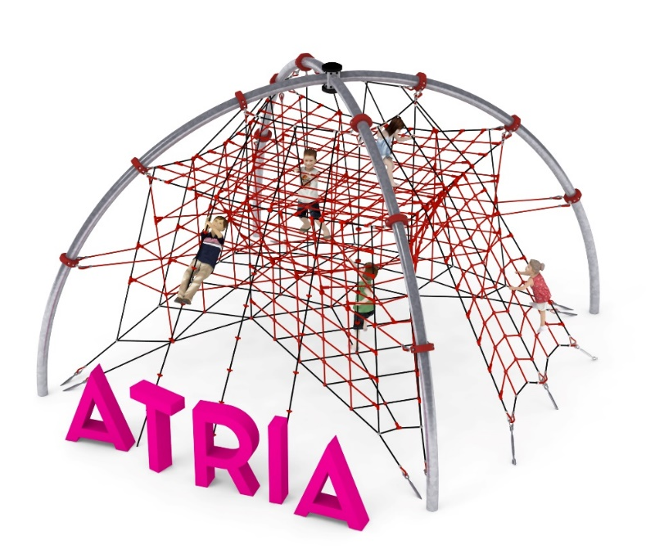

Device dimensions:
Length: 6.2 m
Width: 6.2 m
Height: 4.2 m
Minimum space: 9.7x 9.7 m
Age group: 5 to 14 years old
Foundation depth: 0.8m
Free fall height: 3.0 m

Guidelines for materials and technology of construction of the device.
The device consists of two steel half-circles crossed with each other between which a spatial cable structure is tensioned. The supporting structure is made of 139.7mm diameter pipes and is protected against corrosion by hot-dip galvanizing. The rope structure is formed by five levels, which are connected by vertical ropes and together form a spatial rope network. An additional attraction is the three climbing ropes running from the highest level to the ground. The ropes are equipped with six climbing stones apiece. The unit is also equipped with an entrance, which is made in the shape of a truss and runs from the ground level to the highest level. The foundations are made as reinforced concrete footings founded at a depth of 0.8m. The rope structure is anchored in the ground with turnbuckles that allow tension correction. The turnbuckles are protected against corrosion by hot-dip galvanizing. The play elements are made of polyamide, plaited, glued rope with a diameter of 18mm. Elements connecting ropes to each other are made of polyamide, aluminum or stainless steel. Elements connecting ropes to the pole are made of cast steel and stainless steel. The cast steel is protected against corrosion by painting with chlorine rubber paints.

Optional painting.
The structure of the device at the request of the customer can be painted by powder or "wet" spray painting according to RAL.

The fall area of the equipment should be made on a surface in accordance with PN EN 1176- 1:2017. The possibility of access by heavy construction equipment is required for the installation.
For the safety of children and the quality of the equipment, it is required that the equipment is certified in accordance with standards PN EN 1176-1:2017, PN EN 1176-3:2017, PN EN 1176-11:2014-11 issued by a system accredited by the National Accreditation Centre or the national accreditation body of the other Member States in accordance with Regulation (EC) No 765/2008 of the European Parliament and of the Council of the European Union."

