PRODUCT CARD ZEPPELIN
Cat. no. 1209

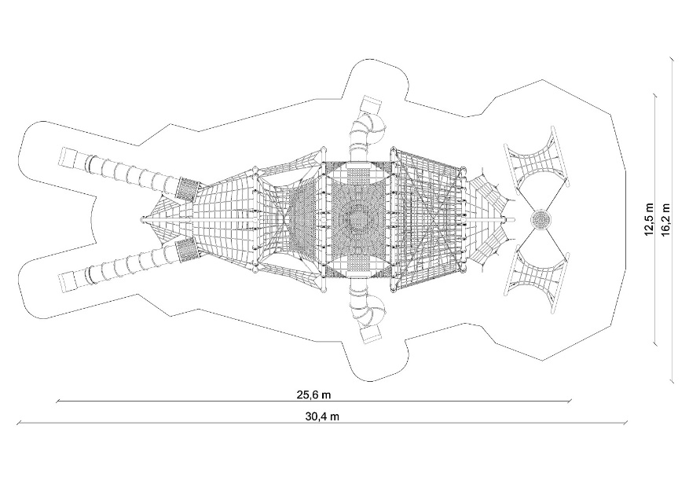
Device dimensions:
Length: 25.6 m
Width: 12.5 m
Height: 5.6 m
Minimum space: 30.4 x 16.2 m
Age group: 5 to 14 years
Free fall height: 3.0 m
Foundation depth: 1.0 m

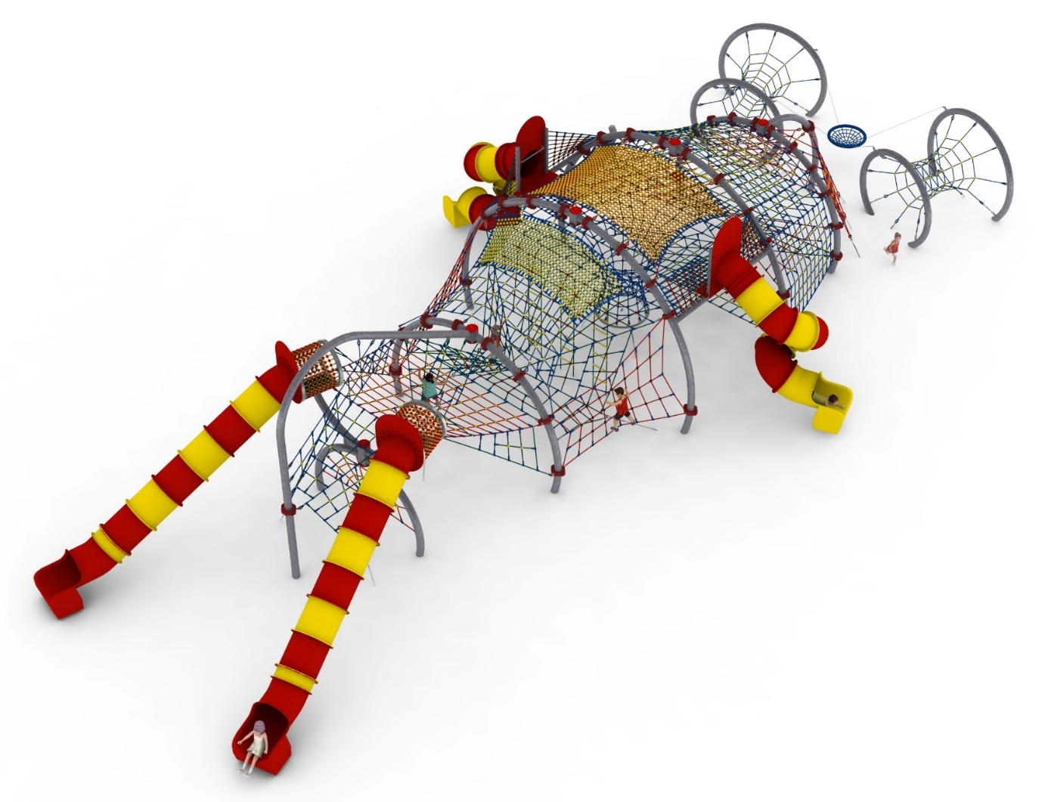

Device description.
A device referring in appearance to an aircraft called a ZEPPELIN.

Guidelines for materials and technology of construction of the device.
The main structural elements are steel arches made of 168.3 mm diameter pipe. The arches are fixed in the ground with reinforced concrete footings. The structure is protected against corrosion by hot-dip galvanisation. A cable jacket is attached to the steel structure by means of clamps made of cast steel. The rope sheath consists of seven sections:

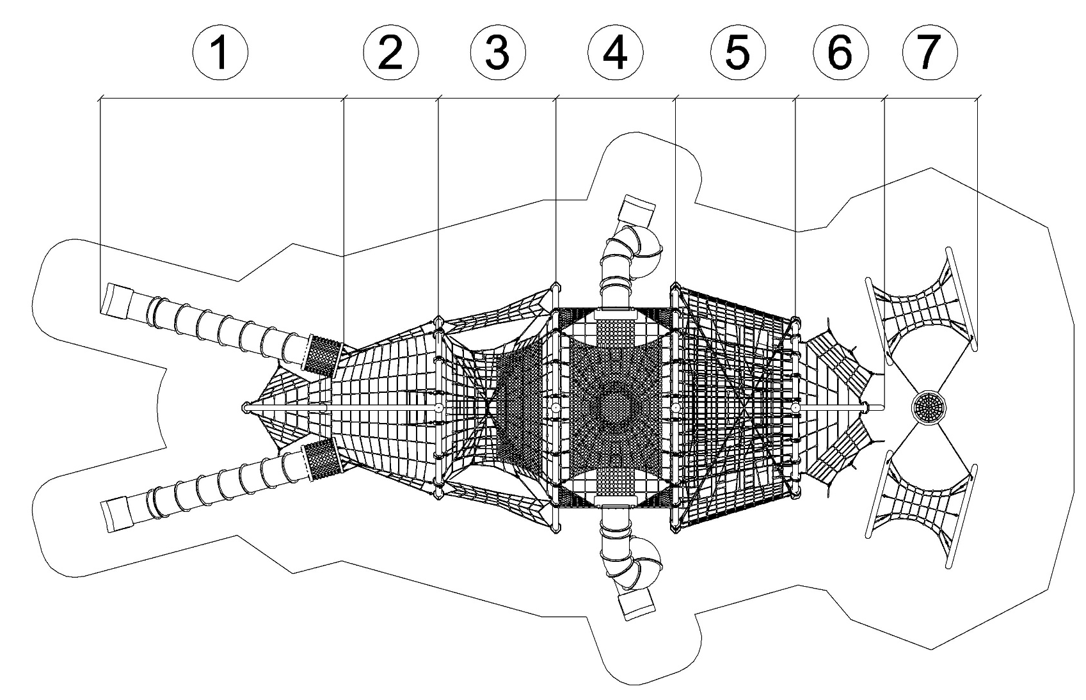

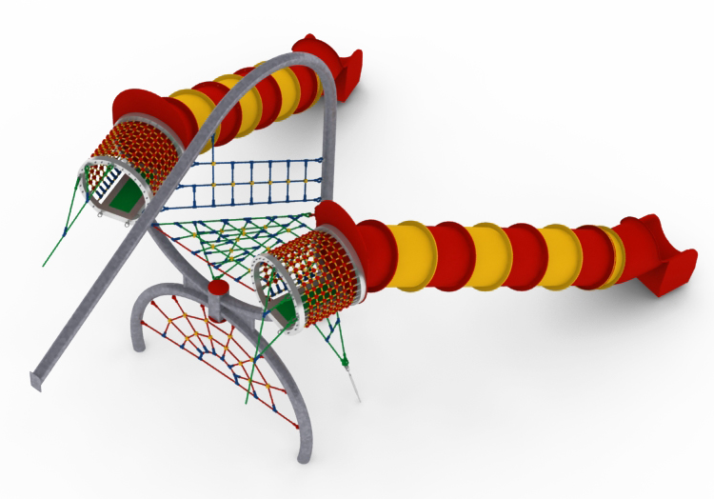
SECTION 1
Section 1 consists of 3 rope nets:
1. A lower flat net spanning around the lower arch. The net has the shape of a semicircle with a base of 2.8m and a height of 1.2m
2. A middle net consisting of three triangular nets. One spanning between the upper arch and the platform grid of the second section, and two slanting ones allowing access from the "0" level.
3. An upper net in the shape of a trapezoid measuring 3.5 x 0.7m, stretched between the upper arch.

The main attraction of the first section is the two straight slides made of polyethylene. Height of the starting section is 3m. Length of the downhill section is minimum 4.5m. The starting section of the slides consists of a platform and two steel arches made of hot-dip galvanised square pipes. The platform is additionally lined with a polyurethane surface. A dense rope net with a mesh no larger than 120 x 120mm is installed between the arches.

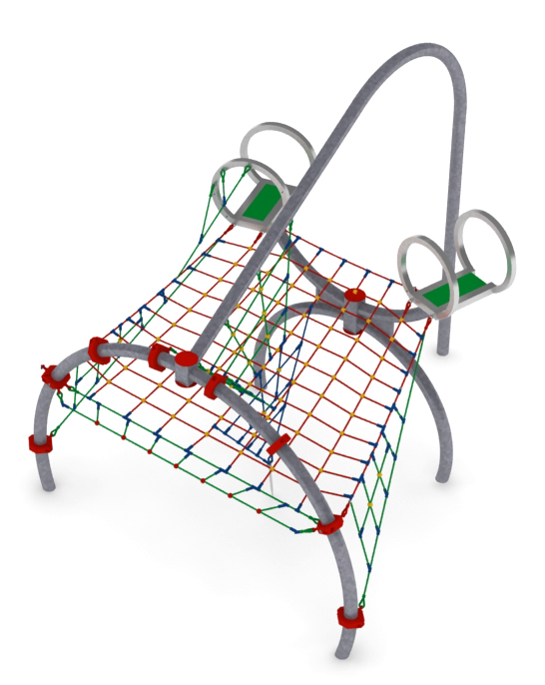
SECTION 2
Section two consists of six nets:
1. A main platform net in the shape of an isosceles tarpezoid with base dimensions of 4.4m and 3.1m and a height of 3.2m.
2. Two triangular nets installed between the steel arches and the platform net, allowing communication from level "0".
3. A vertical triangular net installed between the platform net and the ground with a tension adjustment in the form of a turnbuckle.
4. Two cable nets installed perpendicular to each other, stretched between the steel arches and the net.

SECTION 3
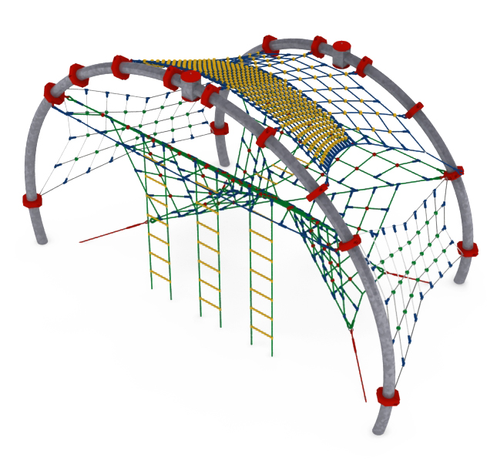
The third section consists of 8 elements:
1. A main net stretched between steel arches, which is made up of 8 triangular nets installed in different planes, meeting at one of the vertices.
2. A horizontal ladder 2m long attached to the main net.
3. Three vertical ladders 2.9m long attached to the main net.
4. An upper net of approximate dimensions 4.4 x 3.2m installed around the top of the steel arches. The net is divided into two parts. With a dense mesh of no more than 120 x 120mm and a sparse mesh of no more than 420 x 420mm.
5. Two side rope trusses with approximate dimensions of 3.2 x 2.4m.

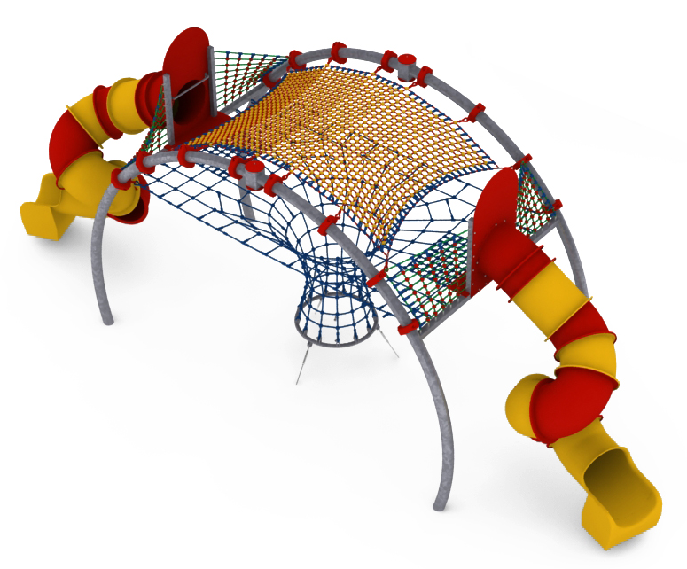
SECTION 4
The fourth section consists of six nets:
- the main bottom net in the form of a flat, horizontal rope truss passing into a shaft extending to 'level 0'. The shaft is completed with mezzanines to prevent users from falling. Adjustment of the tension of the net is made possible by hot-dip galvanised turnbuckles.
- the upper, stretched around the top of the steel arches, in the form of a dense lattice with a mesh no larger than 120 x 120mm and approximate dimensions of 4.4 x 3.1m.
- 4 dense nets installed between the slide substructure and the steel arches to provide safety barriers for users using the slides.

The main attraction of the fourth section is the two full loop slides made of polyethylene. The height of the launch section is 3m.

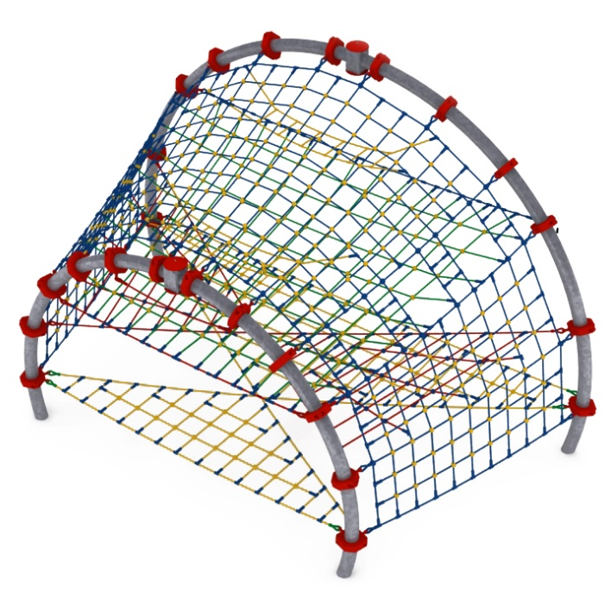
SECTION 5
The fifth section consists of six elements:
- two horizontal nets installed at heights of 0.6m and 1.4m. The two nets form two triangles connected by their vertices, installed alternately between steel arches.
- a horizontal net in the form of an isosceles trapezoidal rope lattice with bases of 6.7m and 4.7m and a height of 3.3m
- a rope truss completely surrounding section 5. The truss is stretched between the steel arches. Additional openings are made at the level of the trapezoidal net to allow communication. - two horizontal rope ladders, approximately 2.7m long, suspended from the surrounding mesh, at the top of the unit.

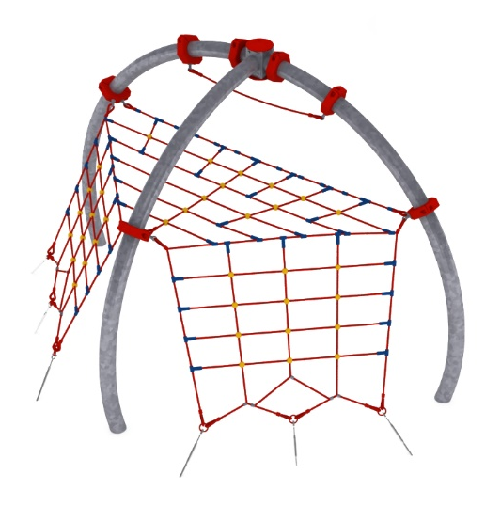
SECTION 6
The sixth section consists of three grids:
- a horizontal triangular grid at a height of 2.2m
- two trapezoidal nets suspended from the triangular net allowing communication from "level 0". Tension correction is provided by galvanised turnbuckles.

SECTION 7
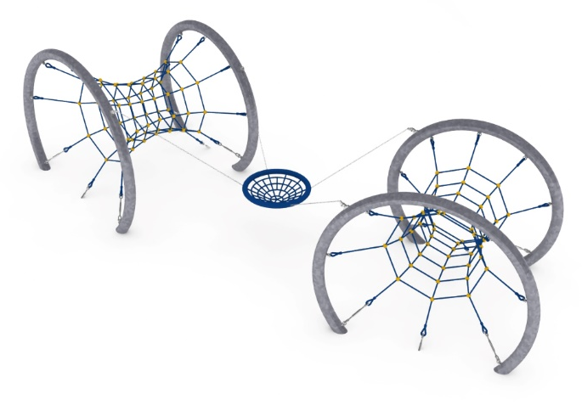
The seventh section consists of three elements:
- two horizontal tunnels, 0.9-2.7m in diameter, stretched between steel arches. Tension adjustment is provided by hot-dip galvanised turnbuckles. The tunnels mimic the engines of an airship.
- A 1m diameter stork's nest installed between the arches of the tunnels. Seat mounted on bearing-mounted slings.

Rope sheathing technology.
Adjustment of the tension of the device is made possible by hot-dip galvanised turnbuckles. The nets are made of polyamide rope, braided, glued reinforced with galvanised steel strings. Rope diameter is 18 mm. The elements connecting the ropes to each other are made of plastic and aluminium. Elements connecting the ropes to the pole are made of stainless steel and cast steel painted with chlorine rubber.

The fall area of the equipment should be made on a surface in accordance with PN EN 1176- 1:2017. The possibility of access by heavy construction equipment is required for the installation.
For the safety of children and the quality of the equipment, it is required that the equipment is certified in accordance with standards PN EN 1176-1:2017, PN EN 1176-3:2017, PN EN 1176-11:2014-11 issued by a system accredited by the National Accreditation Centre or the national accreditation body of the other Member States in accordance with Regulation (EC) No 765/2008 of the European Parliament and of the Council of the European Union."

