PRODUCT CARD SHIP WALKIRIA
Cat. no. 1216
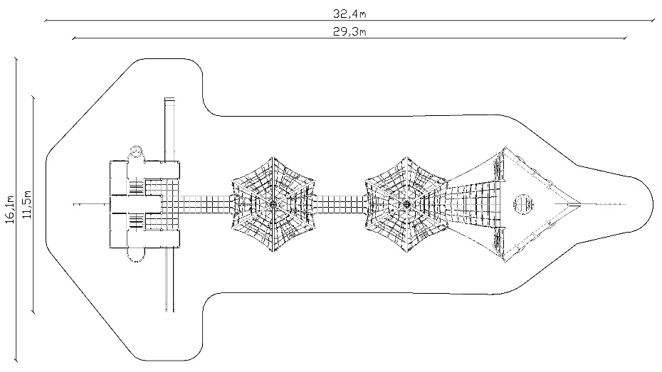

Device dimensions:
Length: 29.3m
Width: 11.5m
Height: 5.8m
Free fall height: max. 3m
Age group: 5 to 14 years
Foundation depth: 1.0m
Minimum space: 32.4m x 16.1m

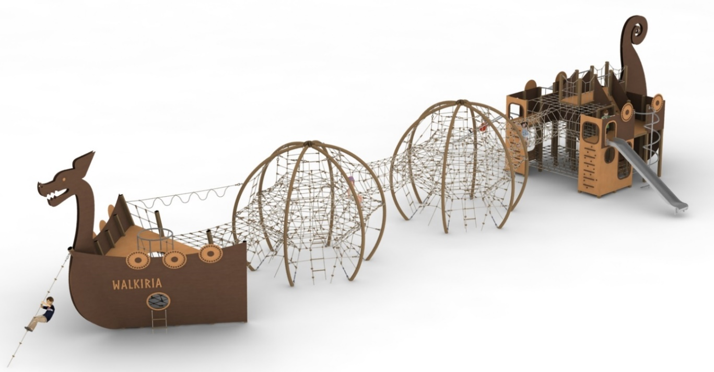

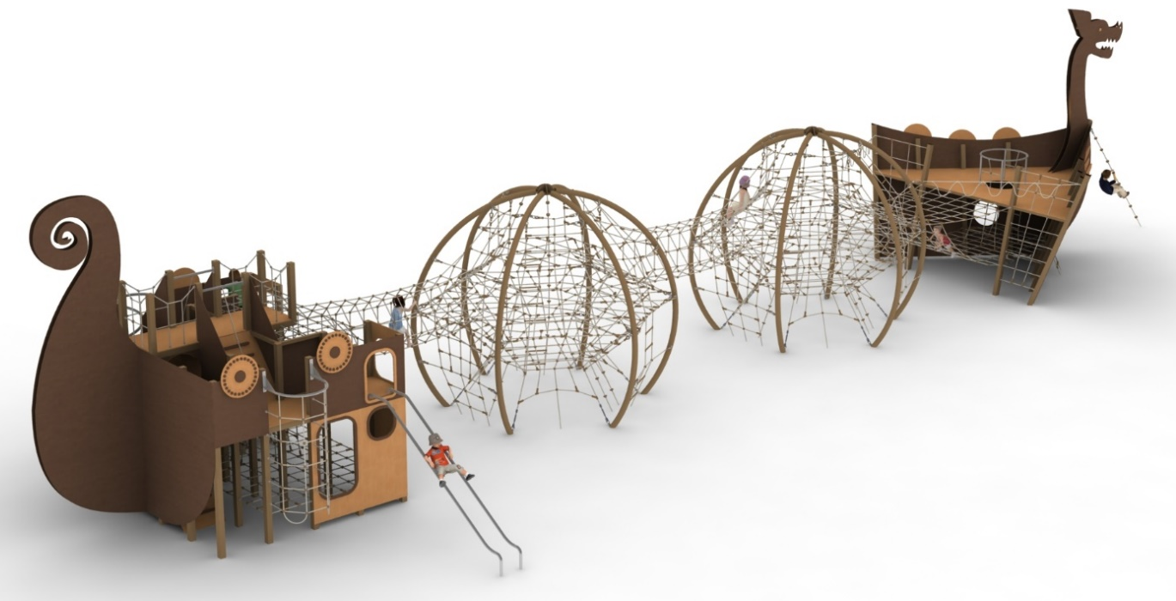
Device description.
A device that looks like a Viking ship. The ship consists of: bow, stern and centre section. The vessel's body and structure are made in colours imitating wood. Ropes and connectors made in a colour imitating natural sisal rope (beige).

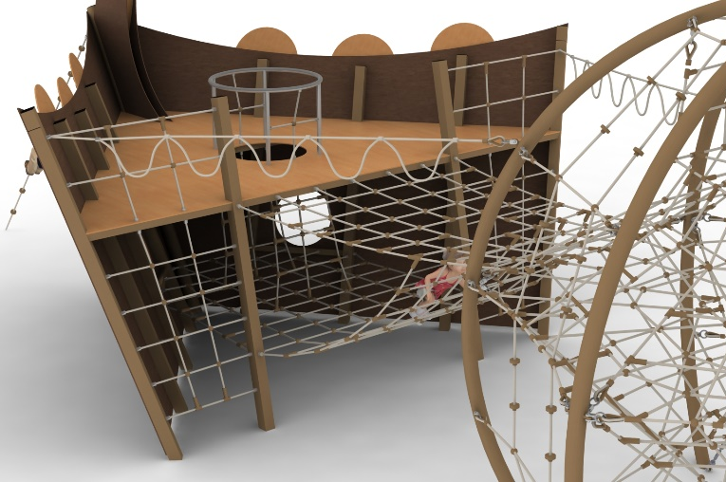
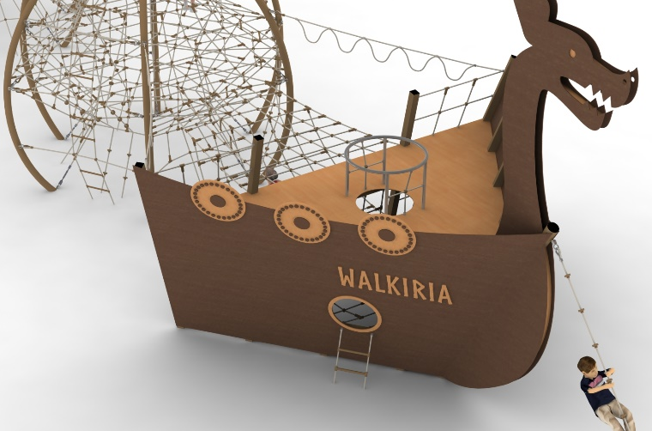
Bow.
The main structural elements are 100 x 100mm square steel columns and a 168.3mm diameter circular column. The structure is protected against corrosion by hot-dip galvanising and painting with acrylic lacquer or powder coating. The foundations are made as reinforced concrete footings. Overall dimensions of the bow section: 6.2m x 5.6m x 5.8m. The play section is made up of two floors at heights of 0.7m and 2m. The entire bow and the platform at a height of 2m made of 12mm thick HPL. Lower level made of rope netting with mesh no larger than 0.4m x 0.4m. The lower floor is connected to the upper floor by a rope shaft terminating at the top with a circular stainless steel balustrade. Additional external access to the lower floor is provided by two rope ladders. A climbing rope with handles is attached to the front of the ship. The front of the ship is decorated with a dragon's head, characteristic of Viking ships, with a steel structure and HPL sides with a total height of 5.8m. The bow and the middle section are connected by two types of gangways. The first is a rope platform 2.5m wide and 2.8m long allowing access to both bow planes. The second connection is formed by ropes fixed on the outside of the ship with handles for hand-over-hand passage in a hanging position. The rope play elements are made of polyamide, spliced, glued rope with a diameter of 18mm. The ropes are made of galvanised steel strings, twisted into six strands, each of which is braided with polyamide fibre glued into it. The elements connecting the ropes to each other are made of aluminium, stainless steel and plastic. The elements connecting the ropes to the pole are made of aluminium and stainless steel.

Middle section.
The central part consists of two sphere-shaped structures with a diameter of 5m and a height of 4.3m, connected by a rope tunnel with a length of 3m and a diameter of 1m. The main structural element of the sphere is round tubes with a diameter of 108mm. The structure is protected against corrosion by hot-dip galvanising and painting with acrylic lacquer or powder coating . Foundations are made as reinforced concrete footings. The ball is filled with a rope net of various shapes and sizes with different walls, which makes the game even more attractive. The ends of the net terminate in turnbuckles allowing the tension to be adjusted. Safety is ensured by 3 horizontal nets at heights of 1, 2 and 3m. The amount of rope used for each ball is at least 260mb. The rope play elements are made of POLYIAMID, spliced, glued rope with a diameter of 18mm. The ropes are made of galvanised steel strings, twisted into six strands, each of which is braided with polyamide fibre glued into it. The elements connecting the ropes to each other are made of aluminium, stainless steel and plastic. The elements connecting the ropes to the pole are made of aluminium and stainless steel.
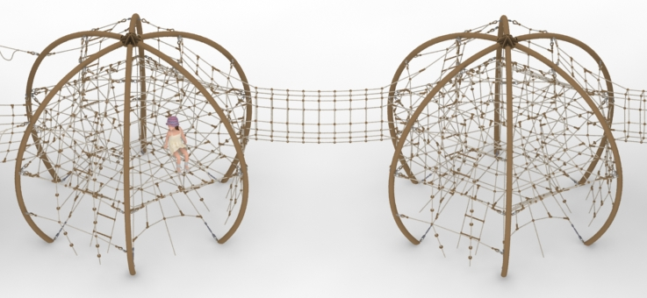

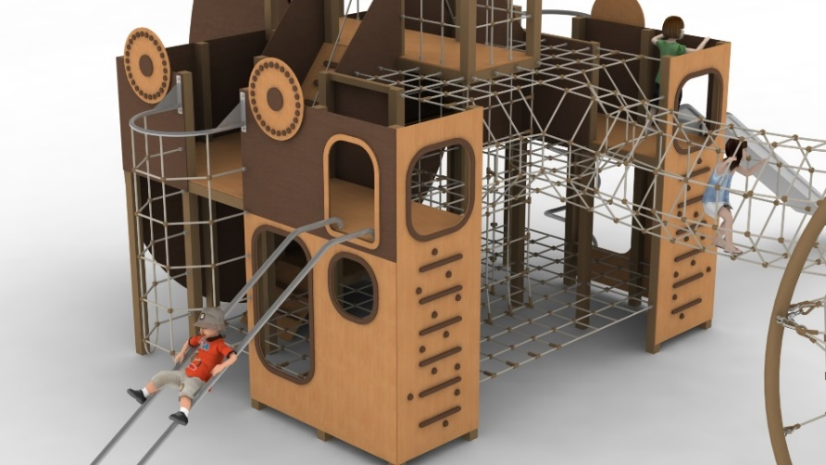
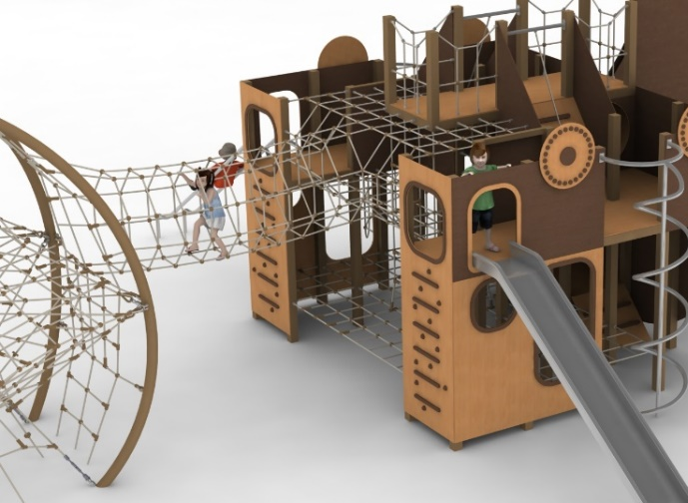
Stern.
The stern consists of a 100 x 100mm square tube steel structure measuring 3.7 x 4.6m with a superstructure in the form of a captain's bridge and dragon's tail with a total height of 5.6m. Structure protected against corrosion by hot-dip galvanising and painting with acrylic lacquer or powder coating . The foundations are made as reinforced concrete footings. The stern section allows play on three floors. The first floor is made of a rope net with a mesh no larger than 0.4 x 0.4m and designed at a height of 0.5m. It is accessed by a double-sided entrance at the rear of the vessel made of HPL. The second level is designed at a height of 2m and is connected to the lower floor by a cable shaft located inside the structure. The middle part of the second floor is made of ropes and the side parts in the form of platforms are made of 13mm thick HPL. At the rear of the vessel there is a tubular passageway allowing movement from the left side of the vessel to the right. The third floor is the captain's bridge, located at a height of 3m, accessed by two ramps located on either side of the vessel with a rope for support. Externally, the port side of the vessel is equipped with a 2m high launching section slide and a stainless steel fire tube. The right side of the stern is equipped with a stainless steel tube slide with a launching section at a height of 2m, and a rope climbing entrance suspended from a hot-dip galvanised steel structure. Both sides of the vessel are decorated with shields made of HPL. The front of the stern additionally provides access to the middle floor by climbing entrances made of climbing stones and HPL crossbars. The central rope section of the middle floor has three functions:
- connects the first platform with the second platform by means of a rope shaft,
- connects the port side of the stern with the starboard side by means of a 1m diameter rope tunnel
- connects the stern section with the middle section by a 3m long, 1m diameter rope tunnel. The rope play elements are made of polyamide rope, spliced, glued with a diameter of 18mm. The ropes are made of galvanised steel strings, twisted into six strands, each of which is braided with polyamide fibre glued into it. The elements connecting the ropes to each other are made of aluminium, stainless steel and plastic.

The fall area of the equipment should be made on a surface in accordance with PN EN 1176- 1:2017. The possibility of access by heavy construction equipment is required for the installation.
For the safety of children and the quality of the equipment, it is required that the equipment is certified in accordance with standards PN EN 1176-1:2017, PN EN 1176-3:2017, PN EN 1176-11:2014-11 issued by a system accredited by the National Accreditation Centre or the national accreditation body of the other Member States in accordance with Regulation (EC) No 765/2008 of the European Parliament and of the Council of the European Union."

