PRODUCT CARD SHIP KASZALOT
Cat. no. 1215

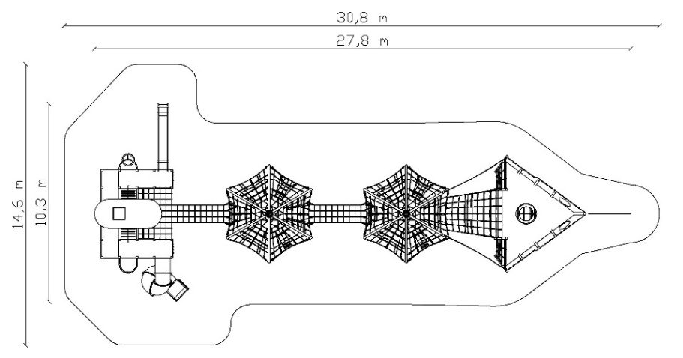
Device dimensions:
Length: 27.8m
Width: 10.3m
Height: 5.8m
Free fall height: max. 3m
Age group: 5 to 14 years
Foundation depth: 1.0m
Minimum space: 30.8m x 14.6m

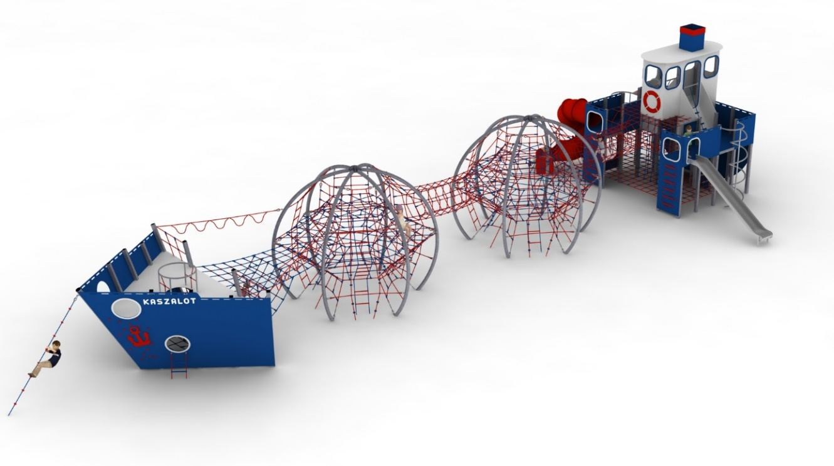

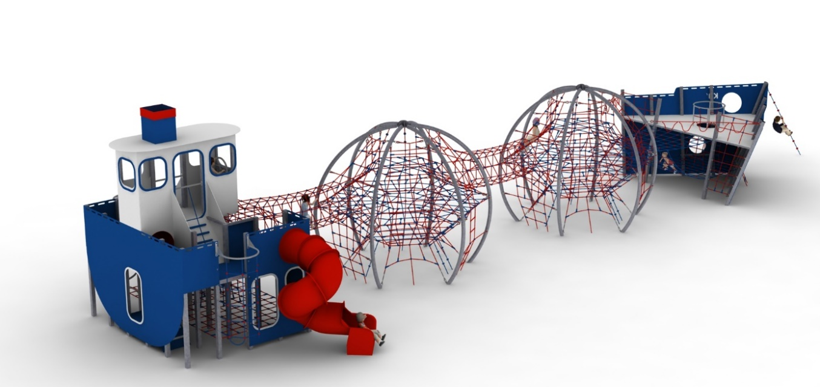

Device description.
A device shaped like a transport vessel. The vessel consists of: bow, stern and centre section. The style of the vessel is in nautical colours: blue, grey and red.

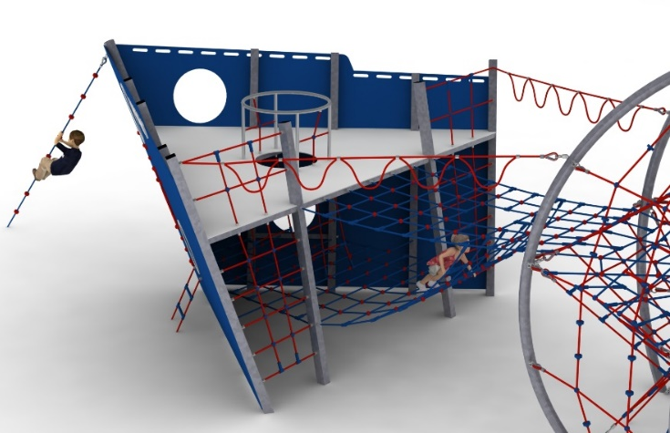
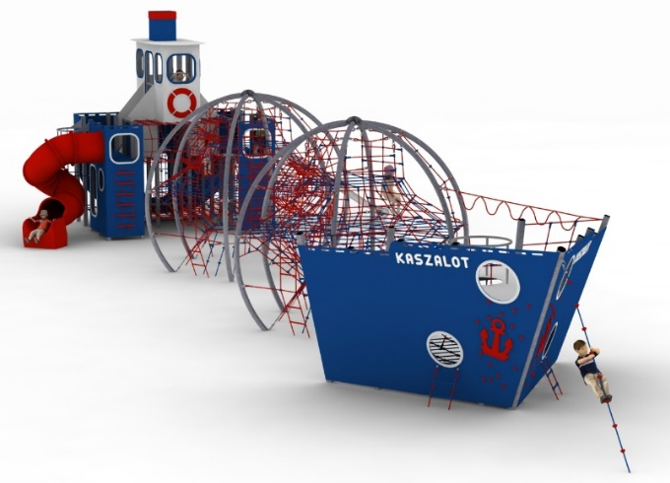
Bow.

The main structural elements are 100 x 100mm square steel columns and a 168.3mm diameter circular column. The structure is protected against corrosion by hot-dip galvanising. The foundations are made as reinforced concrete footings. Overall dimensions of the bow section: 6m x 4.7m x 3m. The play section consists of two floors at heights of 0.7m and 2m. The entire bow and the platform at a height of 2m made of 12mm thick HPL. Lower level made of rope netting with mesh no larger than 0.4m x 0.4m. The lower and upper levels are connected by a rope shaft terminated at the top with a circular stainless steel balustrade. Access to the upper level is additionally provided by two external climbing entrances located on the ship's sides. The entrances are formed by climbing stones and an anchor made of HPL. An additional external entrance to the lower floor is provided by two rope ladders. A climbing rope with handholds is attached to the front of the vessel. The bow and middle section are connected by two types of gangways. The first is a rope bridge, 2.5m wide and 2.8m long, allowing access to both bow planes. The second connection is formed by ropes fixed on the outside of the ship with handles for hand-over-hand passage in a hanging position. The rope play elements are made of polyamide, spliced, glued rope with a diameter of 18mm. The ropes are made of galvanised steel strings, twisted into six strands, each of which is braided with polyamide fibre glued into it. The elements connecting the ropes to each other are made of aluminium, stainless steel and plastic. The elements connecting the ropes to the pole are made of aluminium and stainless steel.

Middle section.
The central part consists of two sphere-shaped structures with a diameter of 5m and a height of 4.3m, connected by a rope tunnel with a length of 3m and a diameter of 1m. The main structural element of the sphere is round tubes with a diameter of 108mm. The structure is protected against corrosion by hot-dip galvanising. Foundations are made as reinforced concrete footings. The ball is filled with a rope net of various shapes and sizes with different walls, which makes the game even more attractive. The ends of the net terminate in turnbuckles allowing the tension to be adjusted. Safety is ensured by 3 horizontal nets at heights of 1, 2 and 3m. The amount of rope used for each ball is at least 260mb. The rope play elements are made of POLYIAMID, spliced, glued rope with a diameter of 18mm. The ropes are made of galvanised steel strings, twisted into six strands, each of which is braided with polyamide fibre glued into it. The elements connecting the ropes to each other are made of aluminium, stainless steel and plastic. The elements connecting the ropes to the pole are made
of aluminium and stainless steel.
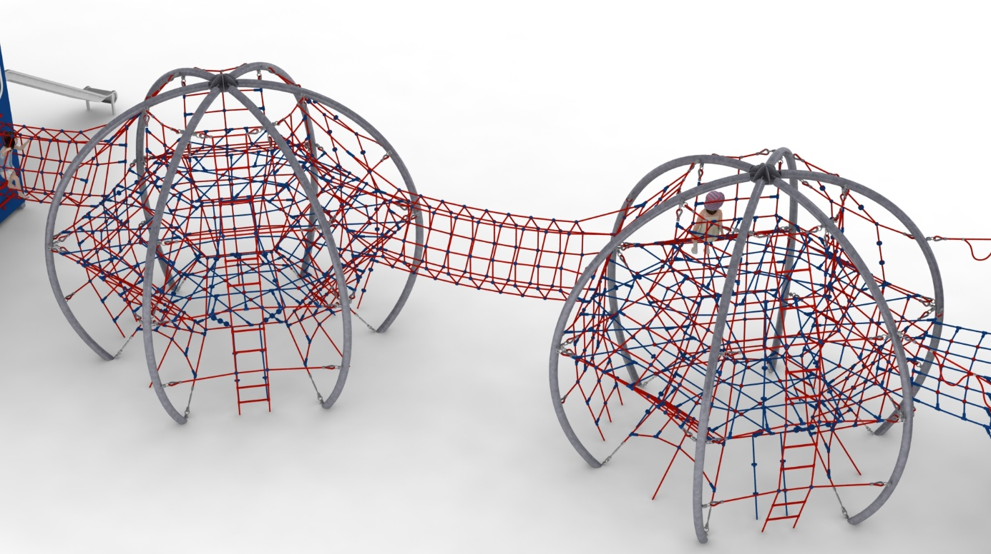

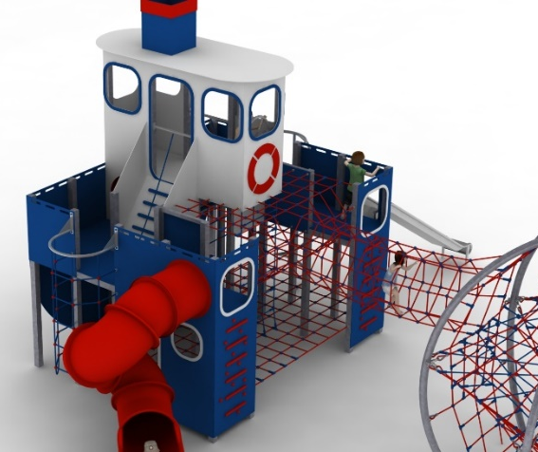
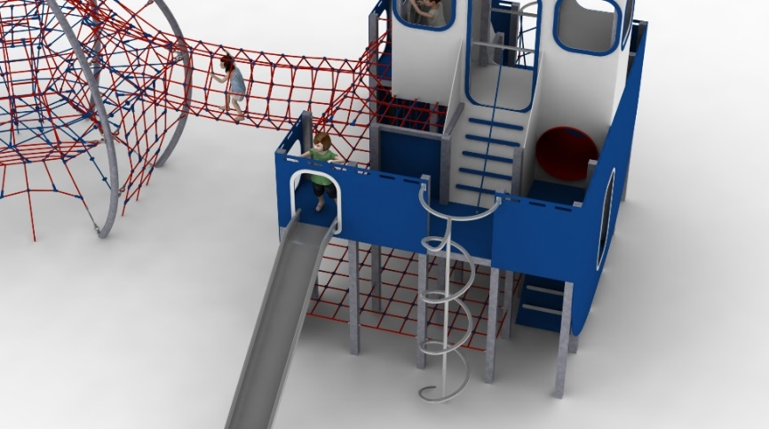
Stern.
The stern consists of a 100 x 100mm square tube steel structure measuring 3.7 x 4.6m with a superstructure in the form of a captain's bridge with a total height of 5.8m. The structure is protected against corrosion by hot-dip galvanising. The foundations are made as reinforced concrete footings. The stern section allows play on three floors. The first floor is made of a rope net with a mesh no larger than 0.4 x 0.4m and designed at a height of 0.5m. It is accessed by a double-sided entrance at the back of the vessel made of HPL. The second level is designed at a height of 2m and is connected to the lower floor by a cable shaft located inside the structure. The middle part of the second floor is made of ropes and the side parts in the form of platforms are made of 13mm thick HPL. At the rear of the vessel there is a tubular passageway allowing movement from the left side of the vessel to the right. The third floor is the captain's bridge, located at a height of 3m, accessed by two ramps located on either side of the vessel with a rope for support. The captain's bridge is equipped with a stainless steel steering wheel and external attributes in the form of a chimney and lifebuoy made of HPL. The entire stern and platforms are made of 13mm thick HPL. Externally, the left side of the vessel has a slip with a launching section at 2m and a fire tube made of stainless steel. The right side of the stern is equipped with a tube slide, curved, made of polyethylene, with a launching section at a height of 2m, and a rope climbing entrance suspended from a hot-dip galvanised steel structure. The stern front additionally provides access to the middle floor by climbing entrances made of climbing stones and HPL crossbars. The central rope section of the middle floor has three functions:
- connects the first platform with the second platform by means of a rope shaft,
- connects the port side of the stern with the starboard side by means of a 1m diameter rope tunnel
- connects the stern section with the middle section by a 3m long, 1m diameter rope tunnel. The rope play elements are made of polyamide rope, spliced, glued with a diameter of 18mm. The ropes are made of galvanised steel strings, twisted into six strands, each of which is braided with polyamide fibre glued into it. The elements connecting the ropes to each other are made of aluminium, stainless steel and plastic.

The fall area of the equipment should be made on a surface in accordance with PN EN 1176- 1:2017. The possibility of access by heavy construction equipment is required for the installation.
For the safety of children and the quality of the equipment, it is required that the equipment is certified in accordance with standards PN EN 1176-1:2017, PN EN 1176-3:2017, PN EN 1176-11:2014-11 issued by a system accredited by the National Accreditation Centre or the national accreditation body of the other Member States in accordance with Regulation (EC) No 765/2008 of the European Parliament and of the Council of the European Union."

